**THE UNIVERSITY OF ZAMBIA  
SCHOOL OF NATURAL SCIENCES  
DEPARTMENT OF COMPUTER STUDIES**



**DEVELOPMENT OF A STUDENT RESULT PROCESSING SYSTEM**Noah`s Ark School as a Case Study

By  
**Maxwell Chewe**

**CSC 4004 Final Year Project**A thesis submitted in partial fulfillment of the requirements for the  
award of a Bachelor’s Degree of Computer Science

Supervisor: Mr. Mofya Phiri  
**Aug 2020**

**DECLARATION**I, the undersigned, hereby declare that the Student Result Processing System is my own work, that it has not been submitted for any degree or examination in any other university to my knowledge, and that all sources I have used or quoted have been indicated and acknowledged by complete references.

**AUTHOR:**  
**NAME:** MAXWELL CHEWE  
**SIGNATURE:** ____________________________

**SUPERVISOR:**  
**NAME:** MR. MOFYA PHIRI  
**SIGNATURE:** _____________________________

**ACKNOWLEDGEMENTS**

I would like to thank my supervisor Mr. Mofya Phiri for his guidance during the course of the project. I would also like to thank all the members of staff at the Department of Computer Science. I would also like to thank Mr. Noah Phiri, the head teacher at the Noah`s Ark School for his support and welcoming spirit.

Finally, I would also like to thank all teachers and students who participated in my project at Noah`s Ark School, their information was vital for obtaining the requirements.

**DEDICATION**

To my family and friends, for supporting, loving, and encouraging me over the years.

**ABSTRACT**

This research paper investigates the challenges that primary and secondary school teachers in Zambia often face in analyzing student results and producing student report cards, using Noah`s Ark School in Lusaka as a case study. In addition, it also looks at the challenges that these primary and secondary schools often face in managing students’ records, classes, grades, attendance, subjects, mid-term results and end of term results. From investigations and research regarding primary and secondary schools in other countries that are more advanced, most teachers find it easy to produce reports cards and analyze student performance when they use Student Result Processing Software. To this effect a Student Result Processing System was developed.

**TABLE OF CONTENTS**

**DECLARATION...................................................................................................................**ii

**ACKNOWLEDGEMENTS.................................................................................................**iii

**DEDICATION......................................................................................................................**iv

**ABSTRACT...........................................................................................................................**v **1 Introduction .......................................................................................................................**1 1.1 Background **...............................................................................................................**2  
 1.2 Problem Statement **....................................................................................................**3  
 1.3 Research Question **.....................................................................................................**3  
 1.4 Aims **..........................................................................................................................**3  
 1.5 Objectives and Scope **................................................................................................**3

1.5.1 Objectives **....................................................................................................**3

1.5.2 Scope**............................................................................................................**4  
 1.6 Novelty **......................................................................................................................**4

1.6.1 Summary**......................................................................................................**5  
**2 Preliminaries .....................................................................................................................**5 **3 Literature Review .............................................................................................................**7

3.1 Related Topics **..........................................................................................................**7

3.2 Related Technology **..................................................................................................**8

3.3 Further Technologies **..............................................................................................**11

3.4 Similar Systems **......................................................................................................**12  **4 Methodology ....................................................................................................................**26

4.1 Introduction **............................................................................................................**26

4.2 Participatory Incremental Model(PIP Model) **........................................................**28

4.3 Problems of the Existing System **............................................................................**30

4.4 Analysis of the Existing System **.............................................................................**30

4.5 Analysis of the Proposed System **...........................................................................**30

4.6 System Requirements **.............................................................................................**31

4.6.1. Functional Requirements **.........................................................................**31

4.6.2. Non-Functional Requirements **.................................................................**33

4.6.3 Hardware and Operating System Requirement**.........................................**35

4.7 System Design **........................................................................................................**36

4.7.1 Purpose of System Design **.......................................................................**36

4.7.2 Program Design **.......................................................................................**36

4.7.3 Functional Decomposition of Result Processing System **........................**37

4.7.4 Program Specification Flowchart **............................................................**41

4.7.5 Use Cases **.................................................................................................**51

4.7.6 Database Specification **.............................................................................**53 **5 Project Feasibility ...........................................................................................................**63

**6 Results and Discussion ...................................................................................................**64

**7 System Testing** **..............................................................................................................**127

7.1 Introduction **..........................................................................................................**127

7.2 Test Cases **.............................................................................................................**128**8 Conclusion .....................................................................................................................**133

**9 Schedule .........................................................................................................................**134

**10 Appendices ..................................................................................................................**135  10.1 Appendix 1 **.........................................................................................................**135  10.2 Appendix 2 **.........................................................................................................**136

**11 List of figures ..............................................................................................................**159

**12 List of tables ................................................................................................................**162

**13 References ...................................................................................................................**163

1 Introduction

Computers have positively affected our lives in many ways. Computers gather information and quickly turn it into a product that consumers want. Computer systems and applications are an essential key for large businesses or organizations to stay in business.  
According to Stair and Reynolds (2018), information has real value and in order  
to stay competitive, organizations must make use of information systems. An information system must allow people to communicate instantly with one another, allow customers to make purchases online using portable devices, allow project members dispersed globally to collaborate on a single project effectively, allow financial institutions to manage billions of dollars, and allow manufacturers and suppliers to keep track of their inventory and distribute goods faster.  
Information systems will continue to change businesses and the way we live. Many corporate leaders are using technology to manage every aspect of their organization, from product creation to customer service.  
Information systems have changed the way lessons are administered, it is now possible for educators to administer lessons online because of information systems. Information systems have also made it possible for students to register for courses online and enabled teachers to publish results online, thus designing and developing a student result processing and management system can be considered to be of great importance.

1.1 Background

The internet has brought evolution in almost every field, it has changed the way of teaching. It has brought about activities such as e-learning, e-library and online portals where teachers and students communicate, and share information.

Student result declaration and processing are amongst the most important activities within an educational institution, since all other activities depend on it. Hence implementing a Student Result Processing System can be declared a significance result. This Student Result Processing System will have three users:

* Head Teacher
* Teacher
* Student

The head teacher has administrative role, he/she can configure the grading pattern, add teachers and change his/her password. The head teacher can also view the student results and merit lists for both end of term and mid-term results. The head teacher also has the ability to add, view or update student details, subjects, and classes. The teacher can view or update end of term and mid-term results for students who belong to his/her class. The teacher can also view results of all students who belong to another class and their performance but can`t edit their results. The teacher can also view merit lists for both end of term and mid-term results as well as add student attendance and change password. The student can view his/her results and print results. The student can also change his/her password.

The Student Result Processing System will work as a tool to reduce manual analysis of results. It will be used to analyze the student performance by automatically generating Report cards and Merit lists.

The system will enable student performance in a particular subject or all the subjects to be expressed. It will also keep track of the total number of published mid-term and end of term results and will enable teachers to easily access student results.

1.2 Problem Statement

Teachers in most primary and secondary schools in Zambia record student`s results manually in a report book or report card and results have to be analyzed manually in order to access student performance. This manual process of analyzing results and writing results in a report book causes a lot of problems such as duplication of results, loss of results when files are being carried around, wrong calculations during computation and omission of results which are encountered frequently. Therefore, a computerized result processing system is required that would ensure that results are processed faster, without delays and with fewer errors.

1.3 Research Question

In addressing this problem, the following is the main research question: “Is it possible to develop an automated Student Result Processing system that will be able to automatically analyze student results and generate student report cards thereby enabling teachers to properly assess student performance?”

1.4 Aims

The aim of this project was to create an automated Student Result Processing System for primary and secondary schools which would enable automatic production of report cards and reduce manual analysis of student results as it would automatically assess student performance.

1.5 Objectives and Scope

1.5.1 Objectives

The objectives of this project were to:

1. Design software for processing students results as well as managing classes, attendance, subjects, teachers and student`s information.

(b) Implement the design in (a) above

**1.5.2 Scope**

This research work was concentrated on result processing. The result processing system contains student portal where all registered students can view their results individually from internet enabled devices. It also contains teacher portal where teachers can add and remove results and head teacher portal which is the main portal of the system.

The scope of the system was confined to only to Head teacher, students and regular teachers. The design did not include any parent portal. Given the limited time of developing and designing the Student Result Processing System, it was necessary to not include the parent portal in the design as it would have taken a longer time to develop the system.

**1.6 Novelty**

The main objective of this paper was to create a computerized Student Result Processing System which would automatically produce student report cards and reduce manual analysis of student results as it would automatically analyze student performance. Even though many researchers have worked on Learning Management Systems, very few researchers reported about Student Result Processing. Student Result Processing is the main criteria for designing the automated Student Result Processing System. The few researchers who reported on student result processing took into consideration the manual ways of producing reports and analyzing results and found that it took a very long time to analyze results and produce reports manually. This data was very useful in the design of Student Result Processing Systems.

The researchers studied the time taken to manually analyze results and produce reports for different schools and concluded that the replacement of some of the manual process of analysis with web-based systems reduces the total time required for analyzing results and producing reports by 75-90%, as has been the result of several real cases. The results demonstrate and confirm the usefulness of Developing a Student Result Processing System, which reduces time and increases productivity, which is the main contribution of this paper.

**1.6.1 Summary**

Section 2 of this paper discusses some fundamental concepts required to discuss the problem at hand that are not common to all people in the field but key to explaining the work. In section 3 we discuss the related literature. Section 4 discusses the methodology that was used to carry out the project. Section 5 discusses possible challenges, their mitigation and feasibility of the project. In Section 6, we discuss the output results of the student result processing system. Section 7, discusses the test results of the system. Finally, in section 8 we make a conclusion of the whole project.

**2 Preliminaries**

The aim of this project was to build a multi-user Student Result Processing system that has three users: Head Teacher, Teacher and Student. The head teacher has the most privileges to this system and can add teachers and assign classes to teachers. The head teacher can also can add, view or update student details, subjects, and classes as well as configure grading pattern. The head teacher can also view merit list for both mid-term and end of term results and can also view or print student report cards. The head teacher also has the ability to change his/her password. The teacher has lesser privileges than the head teacher and can add or update mid-term as well as end of term results of students that belong to his/her class. The teacher can also view merit list for both mid-term and end of term results. The teacher also has the ability to add student attendance information as well as change his/her password. The student has the least privileges to this system and can view his/her results, print report card and change his/her password.

The incremental model was utilized to develop the Student Result Processing system. Incremental model was chosen because it enabled changes to be made easily to the system and was much cheaper than other types of development. Incremental model was also chosen because it is the most common and most popular approach for developing system applications and software products. Using incremental model, an initial version of the system was developed, feedback was obtained from users and then the software was evolved through several versions until the required system was developed. The complete system solution was not worked out in advance. Developing the complete system solution involved the creation of multiple versions of the system. In each version or iteration, errors were identified and removed, and new functionality was added.

**3 Literature Review**

**3.1 Related Topics**

**Information System in Education**According to Freund, et al. (2017), people interact directly with technology in fields such as education, government, finance, retail, entertainment, health care, science, travel, publishing, and manufacturing. Educators and teaching institutions use technology to assist with education. Most teaching institutions equip labs and classrooms with laptops or desktops. Some even provide computers or mobile devices to students. Many require students to have a computer or mobile device to access the school’s network or Internet wirelessly, or to access digital-only content provided by a textbook publisher. And educators may use a Course Management System (CMS), sometimes called a Learning Management System (LMS), which is a software that contains tools for class preparation, distribution, and management. For example, through the course management system, students access course materials, grades, assessments, and a variety of collaboration tools. Many schools offer distance learning classes, where the delivery of education occurs at one place while the learning occurs at other locations. Distance learning courses provide time, distance, and place advantages for students who live far from a campus or work full time.

Referencing Wallace (2015), the LMS is an information system used to track student progress, and manage educational records. Many offer other features, such as online registration, assessment tools, collaborative technologies, and payment processing. They also offer tools for creating or importing content.

Referencing Wundenberg (2015), the LMS characterizes a complex, often web based software system which pools multiple task specific subprograms under a shared User Interface (UI). These subprograms support, for instance:

* Allocation and organization of learning content for different learning scenarios
* School administration
* Information management
* Online school business related communication.

**3.2 Related Technology**The student result processing system is web-based and its physical architecture is based on client-server model, its development technologies are divided in two categories: server-side and client-side. These include:

**PHP**

PHP (recursive acronym for PHP: Hypertext Preprocessor) is a general-purpose scripting language that is especially suited to web development. PHP originally stood for Personal Home Page, but it now stands for the recursive initialism PHP: Hypertext Preprocessor.

PHP code is usually processed on a web server by a PHP interpreter implemented as a module, a daemon or as a Common Gateway Interface (CGI) executable. On a web server, the result of the interpreted and executed PHP code, which may be any type of data, such as generated HTML or binary image data would then form the whole or part of HTTP response.

PHP was chosen to develop the system because it was easy to Learn, it`s command functions were easy to understand, as they tell the developer what function they perform. Changes were made easily in PHP, this saved valuable time. PHP enabled easy integration with other technologies such as MySQL, and was compatible with a large majority of operating systems. The cost of developing a web application using PHP was minimal because PHP is completely free. There was no need for purchasing expensive licenses. PHP gave more control as functions and codes did not have to be written in any specific order, as long as they were within the PHP tags.

**MySQL**  
A popular relational database management system, often used with web  
applications. Stores data that can be accessed, updated or deleted using a set of  
predefined commands. These commands are defined in SQL or Structured Query  
Language.

The reason why MySQL was chosen as the database was because MySQL is secure and reliable database management system used in popular web applications like WordPress, Drupal, Joomla, Facebook and Twitter, to facilitate the management of deeply embedded apps using a smaller footprint even in massive warehouses that stack terabytes of data. MySQL is a high-performance database system that has unique memory caches for enhanced performance. MySQL offers full data integrity. It guarantees instant deadlock identification through server-enforced referential integrity. MySQL also offers unmatched scalability and runs on multiple platforms such as Linux, Microsoft, Macintosh.

**Hypertext Markup Language (HTML)**HyperText Markup Language (HTML) is a markup language for creating web documents (web pages). The main function of a browser is to receive the web page as HTML from the web server and display it. The browser applies all fonts, styles, and layouts specified by the HTML tags and CSS property values. This content can be further manipulated by using JavaScript, the programming language of the browser.  
**Cascading Style Sheets(CSS)**Cascading Style Sheets (CSS) is a language of style rules that is used to apply styling to HTML content, for example setting background colors and fonts, and laying out content in multiple columns. CSS allows to separate the style from the structure. This technique lessens the code from the pages. The separation of style from structure and content also increases maintainability. Cascading Style Sheets are a set of programmable rules to define how web pages display content.  
**JavaScript**  
JavaScript is a scripting or programming language that allows you to implement complex features on web pages like displaying timely content updates, interactive maps, animated 2D/3D graphics, scrolling video jukeboxes, etc. JavaScript is often used to programmatically interact with an HTML page. It does this by interacting with the DOM (Document Object Model).

JavaScript was chosen because it is very fast, it can be run immediately within the client-side browser. Unless outside resources are required, JavaScript is unhindered by network calls to a backend server. JavaScript is relatively simple to learn and implement. JavaScript is used everywhere on the web and is supported by all major browsers. Other languages can work easily with JavaScript hence; it can be used in a wide variety of applications. JavaScript works on the browser side, therefore, it reduces demand on the website server and gives the ability to create rich interfaces.

**jQuery**

jQuery is a JavaScript library that is used to make it much easier to use JavaScript on the website or webpage, it aids in standardizing interactions between HTML elements and JavaScript code. It is designed to simplify HTML DOM tree traversal and manipulation, as well as event handling, CSS animation, and Ajax.

jQuery was chosen because it is widely used. This means there is endless list of resources and information about jQuery on the internet, for example, code snippets, blog posts, quality tutorials, documentation, and much more. jQuery is easy to learn and intuitive as the library is built using simpler and shorter codes or syntax that makes it easier to replace dozens or more JavaScript lines with one line of jQuery code. jQuery is cross-browser compatible and deals with many cross-browser issues and bugs. This means that you can develop a website that will work properly on all types of browsers and different versions of browsers. jQuery is an open source library that is free and supported well across different applications. This means that anyone can use this language in their applications without worrying about any licensing or compatibility issues. jQuery provides utility functions that aid in coding string iteration, trimming, array manipulation, and many more features. These functions provide a seamless integration between JavaScript and jQuery. They make the code writing process easier.

**Bootstrap**

Bootstrap is a free and open-source front-end development framework that enables developers and designers to quickly build fully responsive websites. It contains CSS and (optionally) JavaScript-based design templates for typography, forms, buttons, navigation, and other interface components.

Bootstrap was chosen because it saved time from writing lots of CSS code and gave more time on designing webpages. Bootstrap was also chosen because it is a consistent framework that supports majority of all browsers and has CSS compatibility fixes. Bootstrap is lightweight and customizable and creates highly responsive structures and styles. It has a lot of free professional templates such as WordPress themes and supports plugins.

**3.3 Further Technologies**

Further technologies that were used in the development and testing of the student result processing system included:

**XAMPP**

XAMPP is a free and open-source cross-platform web server solution stack package developed by Apache Friends, consisting mainly of the Apache HTTP Server, MariaDB database, and interpreters for scripts written in PHP and Perl programming languages. Each individual letter in XAMPP means something: X stands for Cross-platform, (A) Apache server, (M) MariaDB, (P) PHP and (P) Perl.

XAMPP is basically localhost or a local server. This local server works on a desktop or laptop computer. XAMPP is used to test the website before uploading it to the remote web server. XAMPP server software gives you the suitable environment for testing MYSQL, PHP, Apache, and Perl projects on the local computer. Since most actual web server deployments use the same components as XAMPP, it makes transitioning from a local test server to a live server possible.

The reason why XAMPP was chosen was because it is cross-platform can run on any computer with any operating system.

**Eclipse IDE for PHP**

PHP Integrated Development Environment framework encompasses the development components necessary to develop PHP-based web applications. It leverages the existing web tools project in providing developers with PHP capabilities.

Eclipse IDE for PHP was chosen because it is highly extensible and allows easy integration of other files in its development environment.

**3.4 Similar Systems**  
The following are some of the systems already in existence that are similar to the student result processing system.

**feKara**

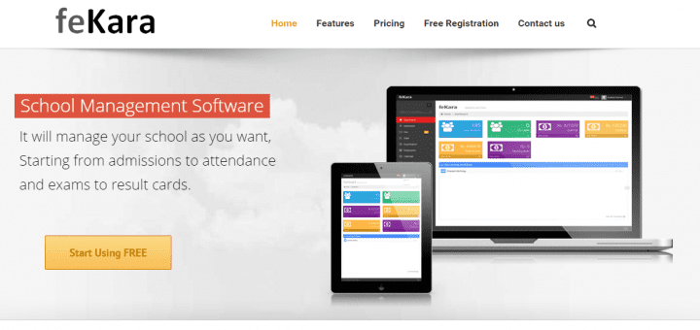

FeKara is an all–around school admin powerhouse, so long as you are running an operation with 50 students or less.

**Pros:** FeKara is a clean and modern school administration and management software option that covers everything from exams and assignments to budgeting and internal messaging for all staff. FeKara even includes a mobile app that can work on all tablets and smartphones for convenient on-the-go use.

**Cons:** FeKara is limited by the number of students, bandwidth, and storage that can be managed on the free version of its software. FeKara is free for schools as long as they remain under fifty students and five teachers in their system, which limits the free use of this software to much smaller schools. If you upgrade one step up, FeKara charges $0.20 per student with unlimited teachers, and finally, their highest paid tier offers unlimited students and teachers for a one-time charge of $350.

**Features:**

|  |  |
| --- | --- |
| * Dashboard * Examination management * Admissions | * Faculty messaging * Attendance tracking * Time table for classes |

Fekara is similar to my system in that it allows automatic generation of report cards and allows teachers to add student attendance information.

FeKara is different from my system in that it is limited by the number of students, bandwidth, and storage that can be managed on the free version of its software. FeKara is also expensive and has Examination management, Admissions, Faculty messaging and Time table for classes. Fekara doesn`t generate merit lists.

**Fedena**

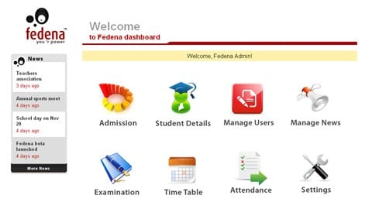

Fedena is an open-source school administration software that largely focuses on handling records.

**Pros:** Fedena offers unlimited administration and student logins to use their system, along with unlimited courses and batches. The system was developed using Ruby on Rails, so schools can easily customize the code to their school’s needs. The system includes human resources, a calendar, financial management, examination management, and student/parent logins.

**Cons**: Fedena is the free version of another school administration software of the same name. When comparing the free version to the paid version, it becomes clear that the open-source version is lacking in a number of features, including inventory, custom reports, registration, and discipline.

**Features:**

|  |  |
| --- | --- |
| * Course management * Admissions * Faculty messaging * School calendar management * Examination management | * Attendance tracking * Dashboards * Student information * Employee/teacher management * Human resources |

Fedena is similar to my system in that it has teacher management, course or subject management and allows addition of student attendance information.

Fedena is different from my system in that it is expensive. Fedena has Examination management, Admissions and Faculty messaging. Fedena doesn`t generate merit lists.

**Gibbon**

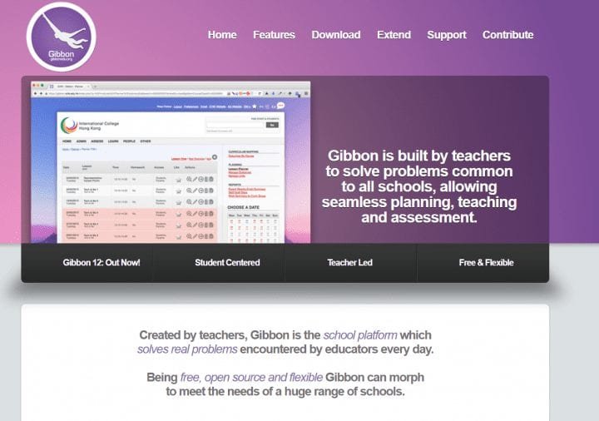

Gibbon gives new meaning to “all-in-one” software. Gibbon is an open-source “school platform” that not only deals with school administration, but also provides features and services for teachers.

**Pros:** Gibbon offers a vast array of features including administration tools dealing with finance, staff management, payroll, invoicing and schedules. Gibbon also provides teaching tools including grade books, rubrics, assessments, planner tools, and library catalogues, and provides assessment access for parents.

The clean user interface also helps in regards to the learning curve inherent in adopting a new software system.

**Cons:** Software maintenance for Gibbon is quite technical, requiring coding knowledge, which is standard for open-source software. Support is limited to online guides for administrators, teachers, and parents —however, written support will never replace helpful live support. The lack of any transcript features also deducts from its otherwise large features base.

**Features:**

|  |  |
| --- | --- |
| * Attendance tracking * Class management * Time table for classes * Department management * Library management * Gradebooks | * Student management * Rubrics * Examination management * Faculty messaging * Employee/teacher management |

Gibbon is similar to my system in that it has Class Management, Employee/teacher management, and Student management.

Gibbon is different from my system because it has Time table for classes, Library management, Examination management, Faculty messaging and doesn`t generate merit lists.

**School Time**



School Time is a school management software that has both free and paid versions. If you are a smaller school, such as a private elementary or preschool with 50 students or less, the free version of School Time may be just what you are looking for.

**Pros:** No financial obligations or credit cards are required for the free version of the program and it never expires. Features include board management, grading systems, library databases, exam management, transportation, attendance, and even dormitory management.

**Cons:** The most obvious con is the limit on the number of students that can be accounted for in the free version. Of course, this issue can be solved by upgrading to the not-so-free versions of School Time, but doing so would negate the “free and open source” solution. School Time is suitable for schools that have 50 or less students.

**Features:**

|  |  |
| --- | --- |
| * Examination management * Time table for classes * Class management * Curriculum management * Faculty messaging | * Dashboard * Directories * Attendance tracking * Finance reports * Payment gateways |

School Time is similar to my system in that it has Class management, subject management and allows addition of student attendance information.

School Time is different from my system because it is limited on the number of students that can be accounted for or supported in the free version. The full version of the system is expensive. School time has features such as Examination management, Time table for classes, Faculty messaging, Finance reports and Payment gateways which are absent in my system.

**SchoolTool**

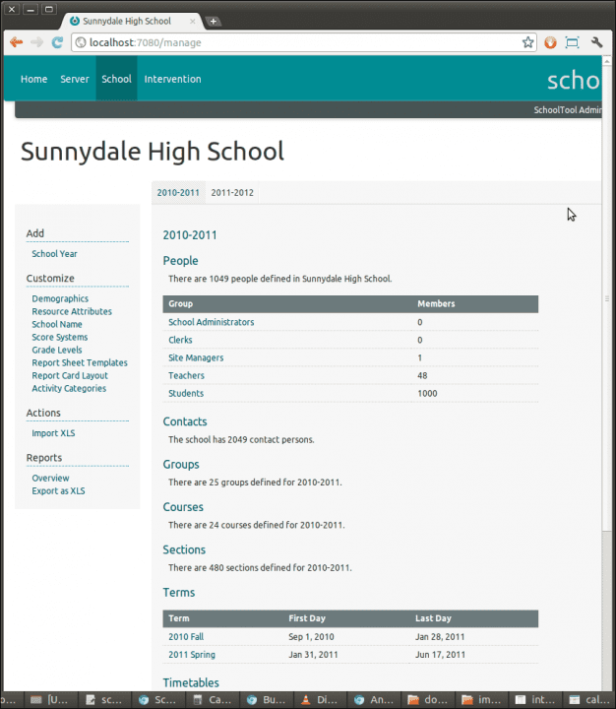

SchoolTool is a web-based open source student information system designed to support a single school.

**Pros:** SchoolTool has a ton of features that largely appeal to teachers. It provides educators with what they need to run their classrooms (gradebooks, skill assessment documents, class attendance sheets, and daily participation journals), strong organization features (including a calendar that plugs in with popular calendar applications like Google Calendar), and a great report card generator. SchoolTool was made with Python, is largely secure, and is run on Linux Ubuntu.

**Cons:** SchoolTool is a great starting software for smaller schools, but it isn’t an all-inclusive piece of software.

SchoolTool is far more a tool for teachers than it is for administrators. SchoolTool announced that as of October 17, 2016, their primary developers had moved onto other projects, so while outside developers have access to the source code to make improvements, the main team will not be contributing to future updates. It remains to be seen whether or not this will affect the software’s performance in the long run, but the uncertainty doesn’t help in terms of confidence in performance.

**Features:**

|  |  |
| --- | --- |
| * Gradebooks * Attendance tracking * Student management * Assessments | * Participation Journals * Contact management * School calendar management * Discipline tracking |

School Tool is similar to my system in that it produces automatic reports cards, and has Student management.

School Tool is different from my system in that it is limited in the number of students it can support. It has Contact management and Discipline tracking which are absent in my system. School Tool doesn`t generate merit lists.

**TS School**

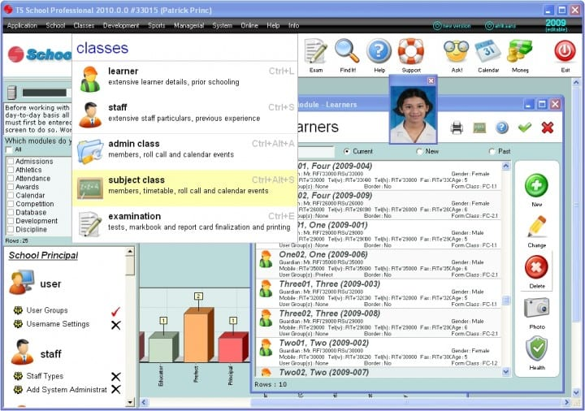

TS School, or Time Software School, is a classic powerful tool that offers the basics for schools of all sizes.

**Pros:** TS School is great for managing the workforce, it has a powerful human resources module to help manage the school staff. TS School also offers a robust student management system, reports, a powerful organizational calendar (with plenty of space to detail sports team timetables or organize classes by subject matter), and an exam module for teachers.

**Cons:** There are some notable features lacking in TS School that can be found in the paid version, including customizable reports, development, inventory, safety, and admissions. TS School may also present a challenge to teachers who have never worked with school administration software before, as some claim it is not immediately intuitive to use.

**Features:**

|  |  |
| --- | --- |
| * Admissions * Attendance tracking * School calendar management * Calendar management * Financial reports * Government reports | * Inventory * Faculty messaging * Staff management * Class management * Time table for classes * User management |

TS School is similar to my system in that it has teacher management, Class management and student management

TS School is different from my system because it is not immediately intuitive to use. Full version of the system is expensive. It has Admissions, Financial reports, Government reports, Inventory, and Faculty messaging which are absent in my system.

**Alma Student Information System**

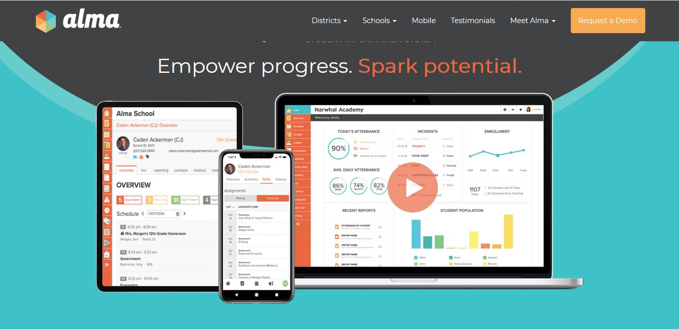

Alma builds a critical Student Information System (SIS) that significantly improves school operations and empowers educators to foster better student outcomes. The features of Alma Student Information System include:

* Attendance Tracking
* Class Summary
* Grade Calculations
* Individualized Assessments
* Lesson Planning
* Parent Portal
* Report Cards
* Teacher Dashboard
* Weighted Assignments
* Virtual Classroom
* Classroom Management

Alma is similar to my system in that it has teacher management, class management, and allows automatic production of report cards.

Alma is different from my system in that it has Lesson Planning, Parent Portal, virtual classroom. It doesn`t generate merit lists.

What makes my system different?

My system is different because:

* It is specifically for primary and secondary schools
* It allows automatic generation of merit lists
* It is relatively cheap, the only cost to this system is the hosting fee.
* The system can support a large number of teachers and students without incurring extra costs.
* It does not include unnecessary features like parent portal, library databases, transportation, or even dormitory management.

**4 Methodology**

**4.1 Introduction**

A methodology is a system of methods used in a particular area of study. It is a body of practices, procedures and rules used by those who work in a discipline or engage in an enquiry. It is in other words, a set of working methods.

Methodology involves a process whereby the existing or current system is studied to identify the requirements. It is used to refer to a specific series of steps or procedures which governs the analysis and design of a particular project. It also includes the techniques and methods which are used to collect and analyze information. The types of methodologies include: Prototyping, Object Oriented Analysis and Design Methodology (OOADM), Expert Systems and Structured System Analysis and Design Methodology (SSADM).

**Prototyping:** A prototype typically implements only a small subset of the features of the eventual project.

**Object-Oriented Analysis and Design Methodology (OOADM):** OOADM is adapted from Michael Gora’s application of OOADM in Database Management System (DBMS) application. It can be used to analyze problem requirements, design a solution to the problem, and implement a solution in a programming language or database.

**Expert Systems:** An Expert System is a knowledge-based Information System that uses its knowledge about a specific, complex application area to act as an expert consultant to end users.

**Structured Systems Analysis and Design Methods (SSADM):** Structured Systems Analysis and Design Methodology (SSADM) is an integrated set of standards which guides the analysis and design of computer systems.

For the interest of this work, SSADM was employed. The steps involved in the analysis of the student result processing system with regards to SSADM are explained below.

## **Problem Identification**

There is the need to present a clear picture of the problems which brought about the design of a new system; these are invariably the problems of the old system. The manual system of result processing was tedious and tasking. The system was discovered to be slow and as such, resulting to delays in the academic processes. Also, it was observed that results computation was characterized by errors. These problems brought about the need for a more efficient way of result processing through a method of automation.

**Study Population**

The study population was Noah`s Ark School students, teachers and the headmaster. This population was assumed to have adequate knowledge of the subject to be investigated and the research variables for investigation.

**Method of Data Collection**

A thorough investigation of the current manual system was made in order to obtain detailed facts about the application area to be designed. In the investigation paper, several methods of data collection were employed which included interviewing of teachers and students, evaluation or inspection of report cards and direct observation. These methods were adopted to ensure the validity of data collected and relevance of the results after processing the data.

**Interviewing**

In in order carry out the research investigation, teachers, the headteacher as well as students were interviewed. This method yields the most profitable result as it is obtained by physical contacts; hence a first-hand knowledge of the various processes involved is obtained by speaking to the potentials users of the system. The essential element of the interview is obtained directly and in a short time than when other methods are employed since the interviewer is with the interviewee. This immediate feedback gives the opportunity to ask ambiguous questions and hence, obtain detailed responses.

**Observation**

This method of data collection enables the researchers to witness a first-hand operation of the old system. Direct observation is the surest method of learning as a scientist and this method was richly employed. During the observation, there was a feel of:

1. The volume of work carried out
2. The manual result processing

**Evaluation and Inspection of Documents**

Close examination of report cards was carried out and it proved to be an important method during the course of the investigation. Through the inspection, some deductions and inference, which were of immense benefit to this research, were drawn.

**4.2 Participatory Incremental Process Model**The aim of this project was the development of a Student Result Processing System tailored to analyze students’ results and produce report cards and merit lists in various schools around the country, using Noah`s Ark School in Lusaka as a case study. Participatory incremental process model (PIP Model) shown in Figure 4.2, was also used in developing the system.

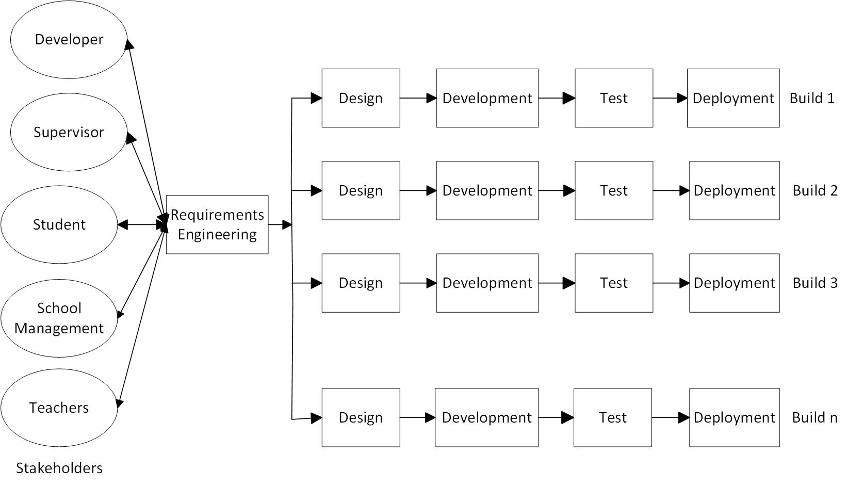

Figure 4.2: Participatory incremental process model (PIP Model)

The system stakeholders included, the software developer, supervisor, students, school management and teachers. The PIP model began with requirement engineering which embodied all activities carried out by the developer in understanding, analyzing, validating and properly replicating the user’s mental model of the system. The activities in requirement engineering stage included analysis of existing system, requirement elicitation, requirement analysis, requirement validation and verification, as well as requirement specification, which gave rise to requirement documentation and requirement management. Interviews, questionnaire, stakeholders’ group discussion, social analysis, evaluation and inspection of documents were used to elicit the user and system requirements. The requirements were analyzed to ensure that the requirement specification was free of inconsistencies, omissions, redundancy, ambiguity etc. Stakeholder’s feedback and comments were sought for at each stage of the requirement engineering process to facilitate a complete requirement specification that met stakeholders’ needs. Every conflict in the requirement specification was reconciled through the process of negotiation. Measures were also put in place to identify, control and track requirements and requirement changes at any time in the system lifecycle.

**4.3 Problems of the Existing System**

Due to the manual means being used by Noah`s Ark School in processing students results, a lot of problems were encountered which included:

* duplication of results.
* loss of results while files were being carried around.
* wrong calculations during computation.
* omission of results which were encountered frequently.
* Delay in publishing of results
* It took time to analyse the entered results manually and determine which student got the highest score and which student got the lowest score.
* It took a lot of time to retrieve a particular student’s results.

**4.4 Analysis of the Existing System**

Results have to be entered manually on the report card using a pen for each student and the results also have to be manually analysed to determine the position of a particular student in class. This manual process makes the system so tedious and time consuming. In this manual system, the report card for each student is stored in a separate file in a file cabinet in the head teacher’s office. Hence, Students have to visit the school to get their results. They have to go to the headmaster`s office to collect their results. This process takes some time because the headteacher has to search for a particular report card for each student and sometimes the students have to wait in a queue just to get their results.

**4.5 Analysis of the Proposed System**

According to the investigations carried out that identify various operational and logical problems, the research therefore concludes that it is necessary to set up a new system.

The proposed system must be able to meet the following expectations.

**Functionality:** System must successfully support the user’s requirements. Specified hardware, software and business routine must enable the system to automatically undertake teacher`s processing tasks.

**Accuracy:** The problem of inaccuracy and data entry error should be easily checked and remedied.

**Efficiency:** It must be able to meet functional requirement within a specified time.

**Elimination of duplication error:** The new system should provide room to eliminate the duplication problem, which the current system is known for.

**Economical:** It should be highly economical, demand minimum storage and minimize redundant data stored by the system in order to reduce the problems associated with data redundancy.

**User friendliness:** The system should provide comfortable environment for work.

**High quality and comprehensive output:** The new system should be able to eliminate the voluminous paper work of the existing system and produce timely management report. It should have a clearly defined content of the past records of every student.

**4.6 System Requirements**

System requirements is a statement that identifies the functionality that is needed by a system in order to satisfy the customer’s requirements. From the data collections methods used under the system methodology, lists of system requirements of the Student Result Processing System were compiled. The system requirements composed of functional requirements, non‐functional  
requirements, and hardware and software requirements. System requirements are the most effective way of meeting the user needs and reducing the cost of implementation.

**4.6.1. Functional Requirements**

Functional requirements in an SRS (software requirements specification) document, indicate what a software system must do and how it must function. Functional requirements are product features that focus on user needs. They define the basic system behaviour. The following are the functional requirements of the student result processing system which are grouped into categories.

**Head teacher**

The head teacher:

* Should be able to login
* Should be able to configure grading pattern
* Should be able to view merit list for end of term results
* Should be able to add, edit or delete teacher’s information.
* Should be able to add, edit or delete classes information.
* Should be able to add, edit or delete subject’s information.
* Should be able to view merit list for mid-term results.
* Should be able to add or delete class and subject combination information.
* Should be able to add, edit or delete student`s information.
* Should be able to view student`s results, but not edit or delete them.
* Should be able update his/ her own password.

**Teacher**

The teacher:

* Should be able to login
* Should be able to add, edit or delete student attendance information
* Should be able to view merit list for end of term results
* Should be able to view or update mid-term as well as end of term results for students who belong to his/her class.
* Should be able to also view results of all other students who belong to another class and their performance but can`t edit or delete them.
* Should be able to view merit list for end of term results
* Should be able update his/ her own password

**Student**

The student:

* Should be able to login
* Should be able to view his/her results.
* Should be able to print his/her report card.
* Should be able update his/ her own password

**System**

The system:

* Should be able to automatically generate merit list for end of term results
* Should be able to automatically compute Total Marks, Percentage of Total Marks, Class Average, and Position in Class for each student.
* Should be able to automatically analyze student performance in a specific subject by generating comments.
* Should be able to automatically generate merit list for mid-term results
* Should be able to automatically generate report card

**4.6.2. Non-Functional Requirements**

Non-Functional Requirements (NFR) specify the quality attribute of a software system. They judge the software system based on Responsiveness, Usability, Security, Portability and other non-functional standards that are critical to the success of the software system. They do not affect the basic functionality of the system. Even if the non-functional requirements are not met, the system will still perform its basic purpose.

The following are the non-functional requirements of the student result processing system:

**Reliability**

The system must have high system robustness against data-loss or system failure.

The system must be available to the user for 24 hours a day.

**Efficiency**

The web page of the system must be able to reload completely in less than 180 seconds.

The system must use minimal hardware resources.

**Integrity**

The system must provide high level of data security using secure MySQL database. The headteacher and students should not be allowed to update results.

The Teacher should not be able to update results of student who belong to another class.

**Usability**

The system must be user friendly, and must have intuitive design and self-explanatory functionalities.

The system must enable easy accessibility of information.

**Maintainability**

Errors in the system must be able to be identified and eliminated with minimal effort.

The system must have well commented code.

**Flexibility**

The system must be able to provide for adding new and updating existing features.

The system must be able to be adapt easily to a changing environment.

**Testability**

The system should be able to be tested and run.

The main components of the system should be in good working directories before the system starts.

The system must be able to perform its intended functions.

**Portability**

The system must be web based.

The system should be able to work on both desktop and mobile platforms.

**Scalability**

The system should be able to handle an increase in the number of users which include teachers and students.

**4.6.3** **Hardware and Operating System Requirement**

This is for the implementation of the web application software. For effective and efficient functioning of the system, the following hardware and software specifications are recommended.

**Software Specifications**

Minimum of the following:

1. Microsoft Windows XP or any newer version of windows operating system
2. Mozilla, Internet Explorer, or any other internet browser.
3. MySQL server 5.0 or any newer version
4. Apache Tomcat server 5.0 or any newer version

**Hardware Requirements**

The following are the hardware requirements for the system.

**Requirements for Processor**

The software requires a minimum of 600 MHZ Pentium processor. It is however recommended that for optimum performance faster processors like 1.5GHZ Pentium grade processor be used.

**RAM Size**

The minimum RAM requirement is 1GB but 4GB is recommended for flawless execution. This is because all connection to the server will use memory on the RAM for processing of request.

**Disk Space**

The host computer must have a minimum of 20GB of Hard disk space available. The user may be able to make more space available by removing temporary files on the computer, including temporary files created when you decompress some of the software for installation

In order to run or operate this application software, the user must be sure to pay careful attention to the software requirements relative to the prerequisite programs listed earlier that must be installed prior to running the application.

# 4.7 System Design

**4.7.1 Purpose of System Design**

The purpose of the system design is to effectively divide the overall problems into small and more manageable problems that can be easily handled by separate program modules. The separate program modules will later be integrated forming the entire system. This design methodology is called “Top-Down-Design”. The program modules that control the main logic of the system must rely on lower level modules to perform subordinate tasks reliably.

A detailed design of the new system will guide work on implementation of the system. The new system will be based on the development of Student Result Processing System for primary and secondary schools.

The proposed system will be based on the requirements specified under system requirements. Entity relationship diagram (ERD) will be used to show the relationships between the tables. Flowcharts will also be used to show the procedural flow of the system. The database tables will be identified, table structures will also be specified and queries for creating the database will be designed.

**4.7.2 Program Design**

The program design does the work of identification of all modules of its software and the relationship that exists between them and also solution statement and coding. The Top-Down-Design method of modular programming was adopted in program design.

The Top-Down-Design is a design process whereby a software designer begins from a top most module to break the system into subsystems by taking each system in turn and breaking them into program modules. The major idea in top-down-design is that the design must progress from the general purpose, with each program module being progressively designed. Modular programming is simply the art of writing programs in independent modules, the central idea in modular programming is to sub-divide the system into smaller units that are independently testable and which can be integrated to accomplish the overall program objectives.

**4.7.3 Functional Decomposition of Student Result Processing System**The functional decomposition of the student Result Processing system is presented in Figure 4.7 and the modules are further decomposed into their respective sub-modules.

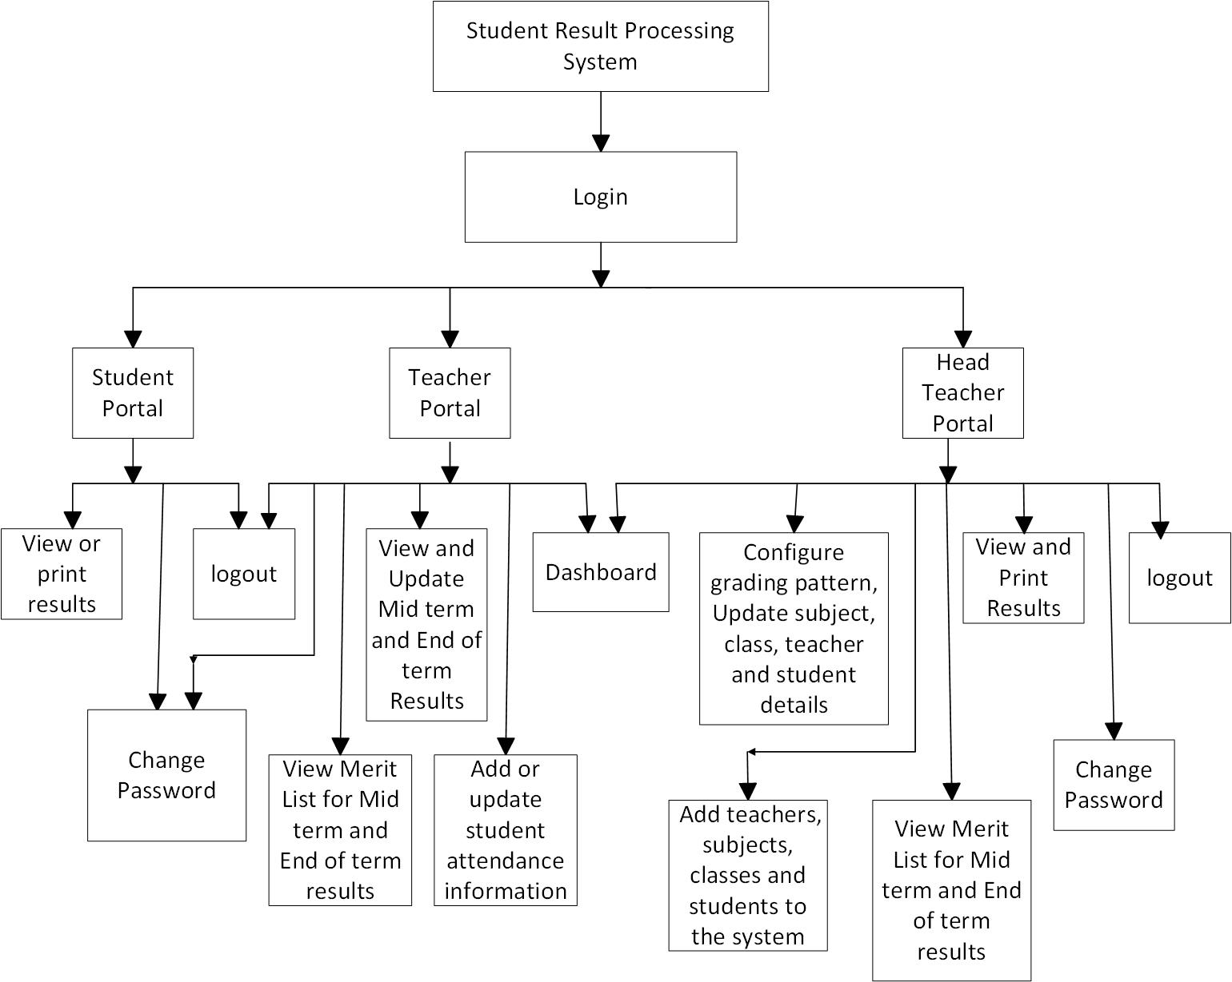

Figure 4.7 Functional Decomposition of the system

The system can be accessed by the Head teacher, students and regular teachers. The head teacher is registered in the system by default and can login using his default password and username and may decide to change his/her password at any time. The regular or ordinary teacher must be registered on System by the Head teacher and then login with his/her username and password. The head teacher has the highest access privileges. Teachers have the lower privileges than the head teacher. Students have the least privileges. The students must also be registered on the Student Result Processing System by the head teacher and then login using their student number as username and a default password which they can later change. In the system, the student will have student privileges which will enable the student to view or print his/her own results. The following are the main modules of the system.

**Login Module**The system policy requires that every user should be registered on the system and then login each time the user wants to access system functionalities. Registered users can login using their username and password. In this Student Result Processing System, all registered users on the system can login from the same login page. The redirected page depends on the login details of the user. Figure 4.7.1 shows the login process for students, teachers and head teacher. For security reasons, students can login using their student number as username and a default password which they can later change.

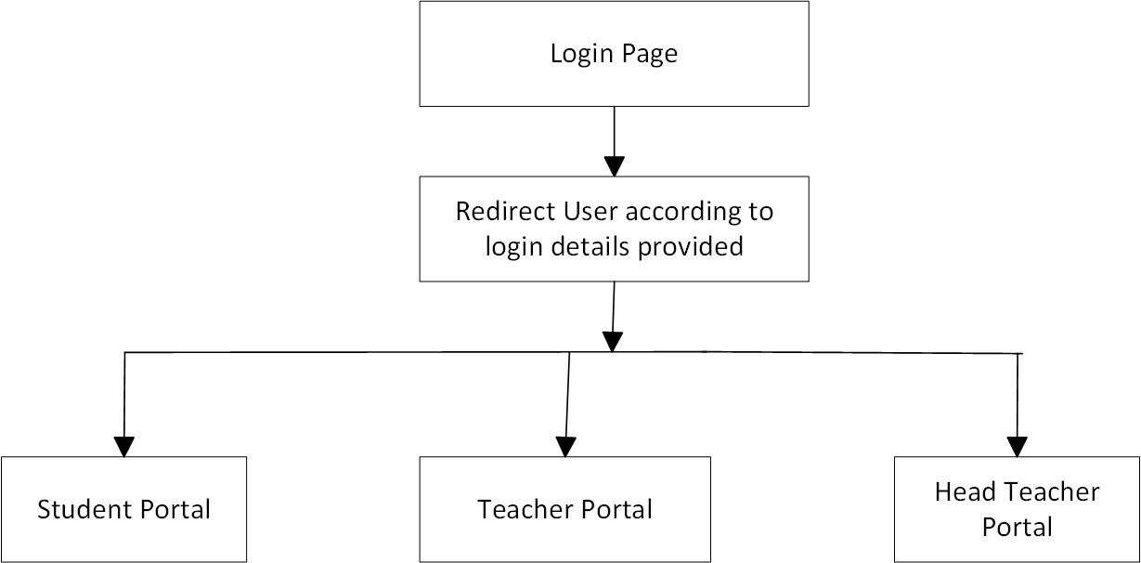

Figure 4.7.1 Login Process for Teachers, Students and Head Teacher.

**Head Teacher Module**The Head teacher module (Figure 4.7.2), is the module meant for the head teacher that manages the control panel of the software. The Head teacher module manages the grading system as well as merit lists for both mid-term and end of term results. It also manages student`s details, teacher details, subjects, classes, head teacher`s password and also keeps track of the total number of published end of term results as well as mid-term results.

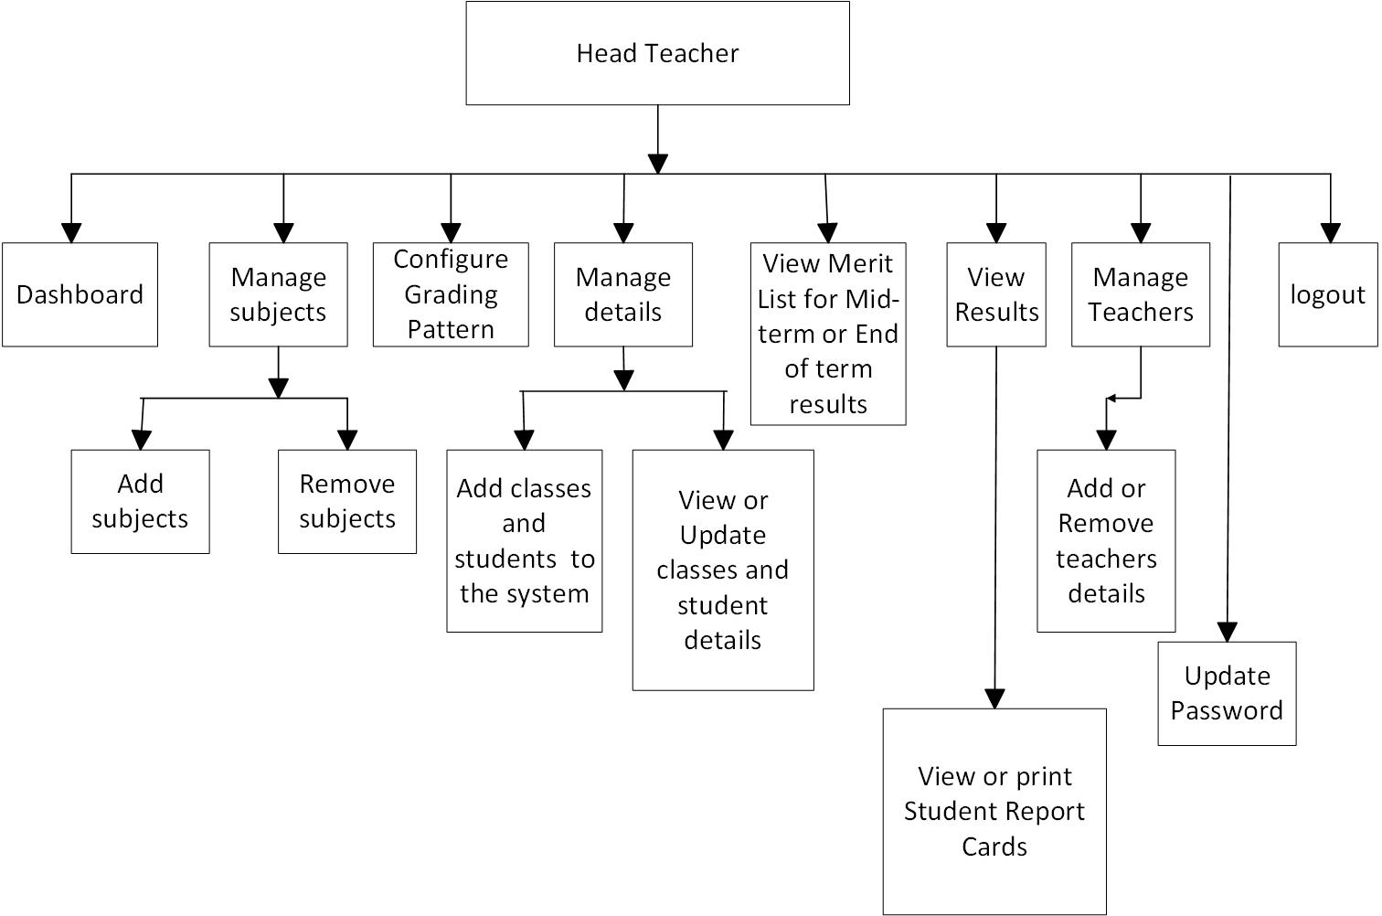

Figure 4.7.2 The Head Teacher Module

**Teacher Module**

The teacher module (Figure 4.7.3), is the module meant for the teacher. The teacher module allows the teacher to view or update mid-term results as well as end of term results for students who belong to his/her class. In addition, the teacher module allows the teacher to view the merit list for mid-term results as well as end of term results. The teacher module also allows the teacher to view results of all students who belong to another class and their performance but not to edit their results. The teacher module also enables the teacher to add or update student attendance information and also enables the teacher to change his/her password.

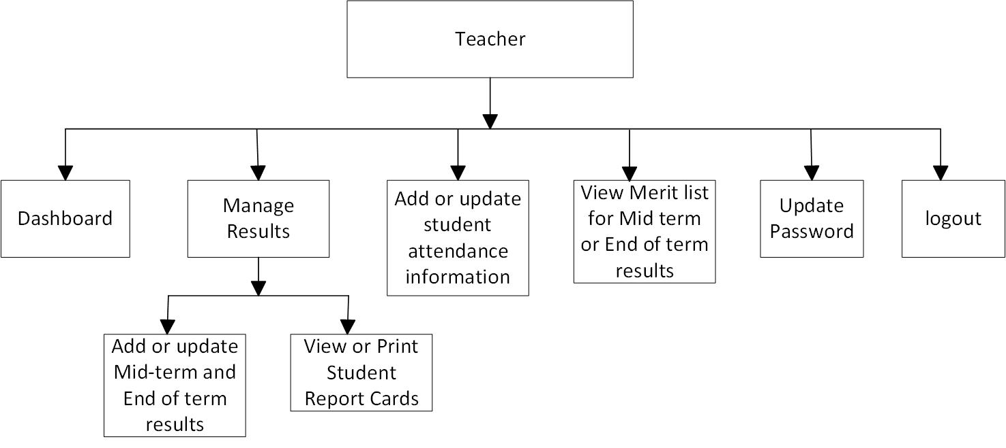

Figure 4.7.3 The Teacher Module

**Student Module**The student module (Figure 4.7.4), is the module meant for the student. The student module allows students to view and print their results. The student module also allows students to change their passwords and to logout of the system.

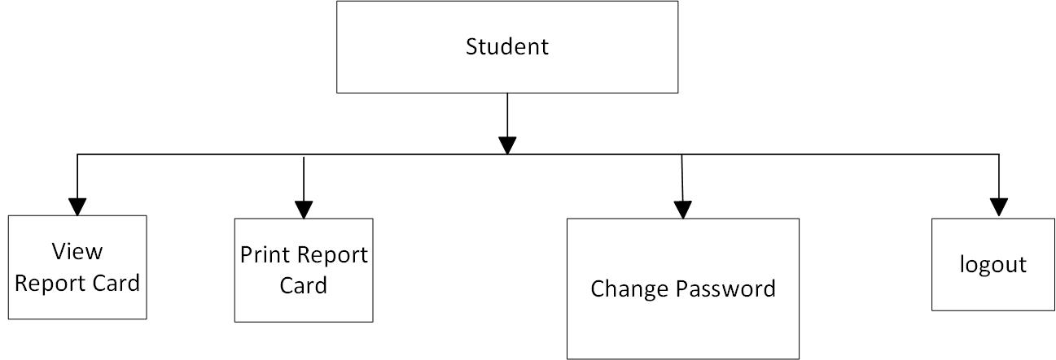

Figure 4.7.4 The Student Module

**4.7.4 Program Specification Flowchart**

Program specification flowchart can be defined as a diagrammatic representation that illustrates the sequence of operations to be performed to get the solution of a problem. The flowchart is a means of visually presenting the flow of data through information processing, the operations performed within the system and the sequence in which they are performed.

A program flowchart plays a vital role in programming of a problem and quite helpful in understanding the logic for complicated and lengthy problems. Once the flowchart is drawn, it becomes easy to write the program in any high-level language.

The advantages of using a program specification flowchart are:

1. **Communication:** Flowcharts are better way of communicating the logic of a system to all concerned.
2. **Effective Analysis:** With the help of flowchart, the problem can be analysed in more effective way.
3. **Proper Documentation:** Program flowcharts serve as a good program documentation, which is needed for various purposes.
4. **Efficient Coding:** The flowcharts act as a guide or blueprint during the system analysis and program phase.
5. **Proper Debugging:** The flowchart helps in debugging process.
6. **Efficient Program Maintenance:** The maintenance of operating program becomes easy with the help of flowchart. It helps the programmer to easily be able to maintain the program.

Figure 4.7.5 shows the General Flowchart of the Student Result Processing System.

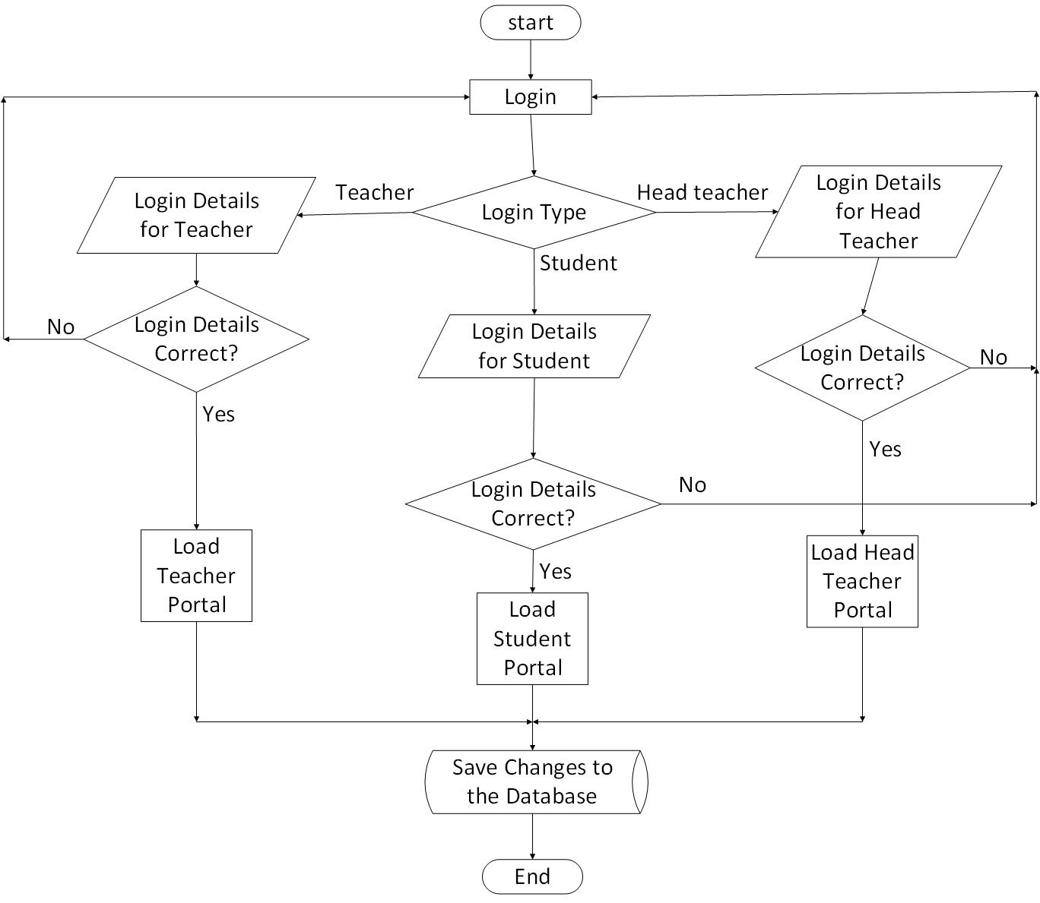

Figure 4.7.5 General Flowchart of the Student Result Processing System

**Program Module Flowcharts**

Figure 4.7.6 shows the flowchart for the Login Module.

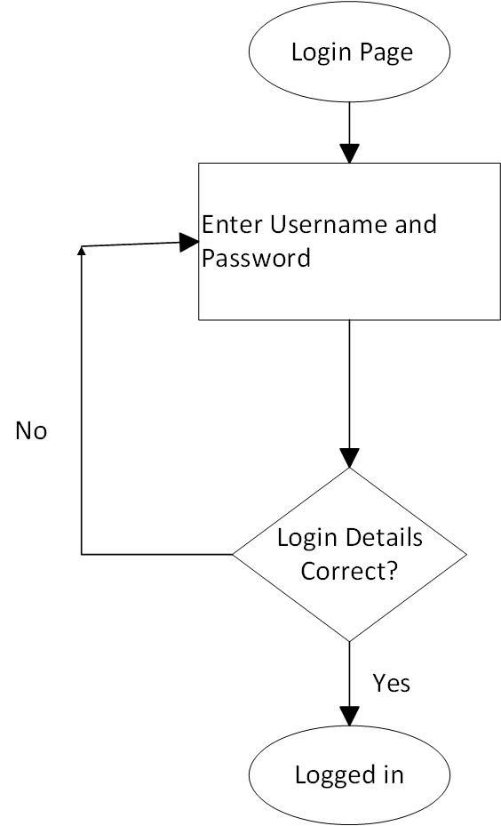

Figure 4.7.6 Login Module Flowchart

The flowchart for the Head Teacher Module is presented in figure 4.7.7.

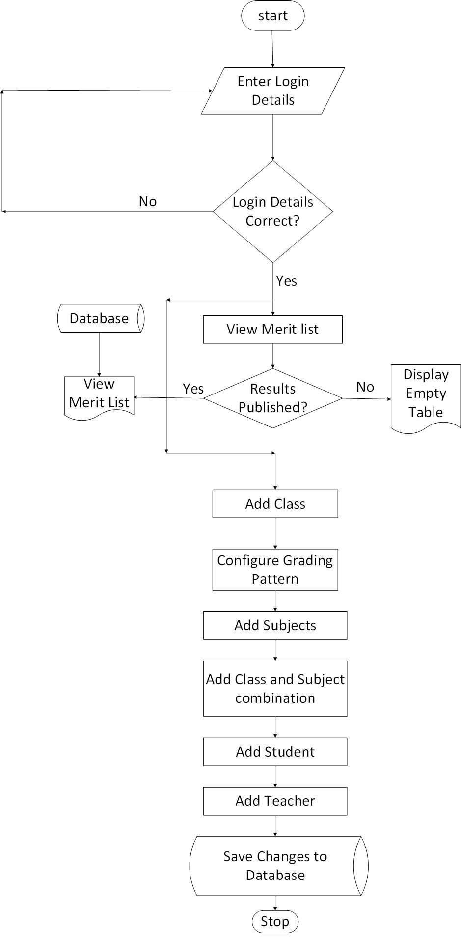

Figure 4.7.7 Head Teacher Flowchart

Figure 4.7.7 shows the Head Teacher Flowchart for viewing results. 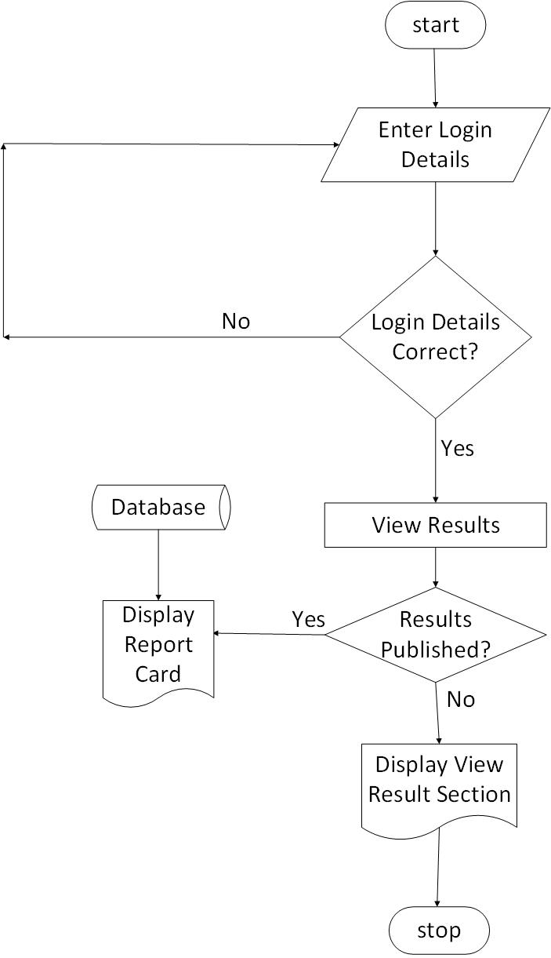

Figure 4.7.7 Head Teacher Flowchart for viewing results.

Figure 4.7.8 shows the Teacher Flowchart for publishing both mid-term and end of term results

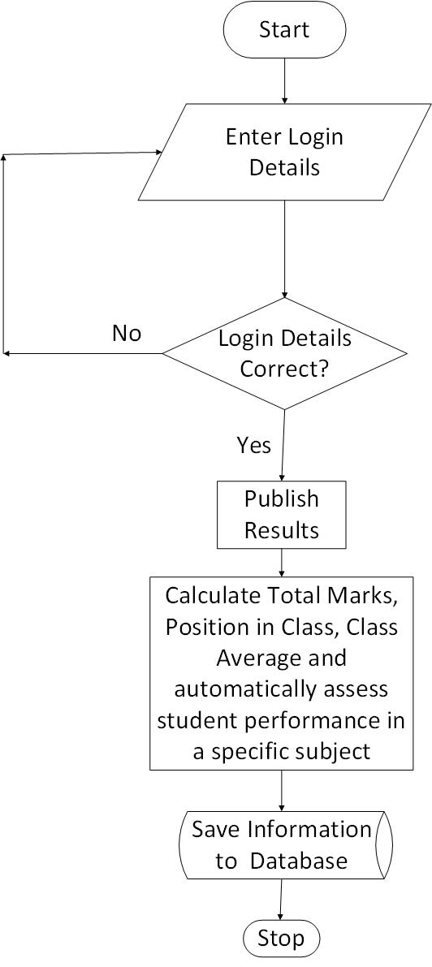

Figure 4.7.8 Teacher Flowchart for Publishing Results

The Teacher Flowchart for viewing results is presented in Figure 4.7.9

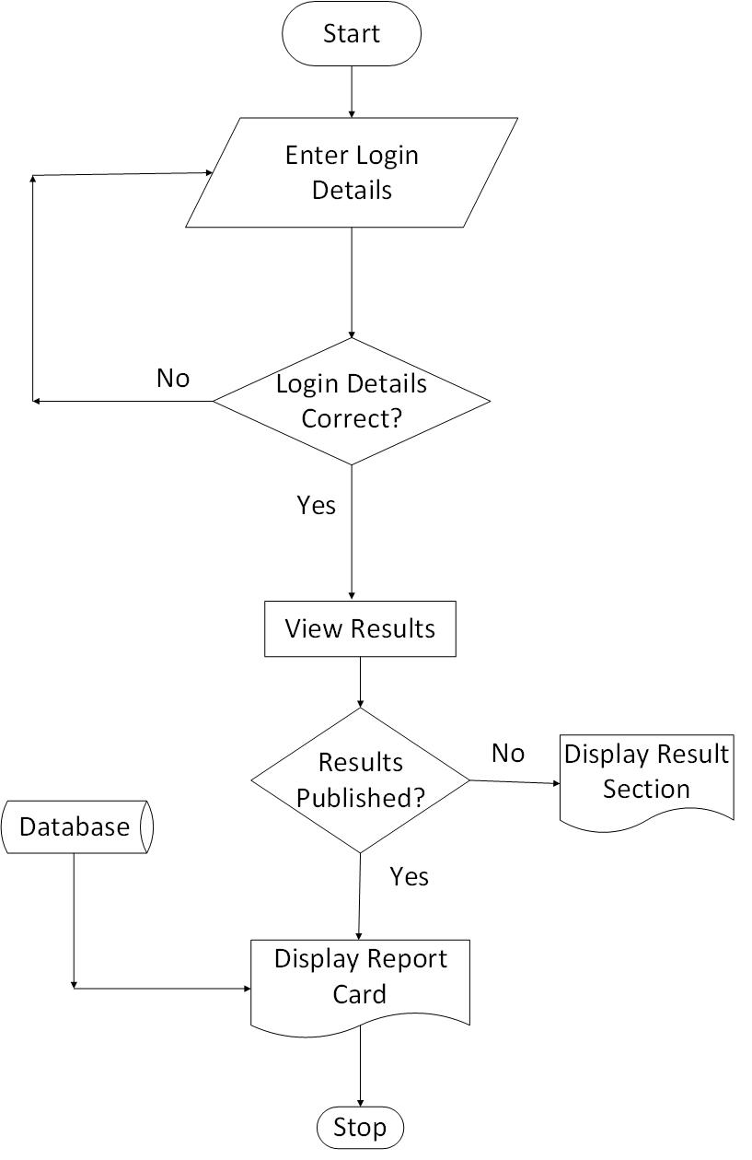

Figure 4.7.9 Teacher Flowchart for Viewing Results

Figure 4.8.1 shows the Teacher Flowchart for viewing merit list for both mid-term and end of term results.

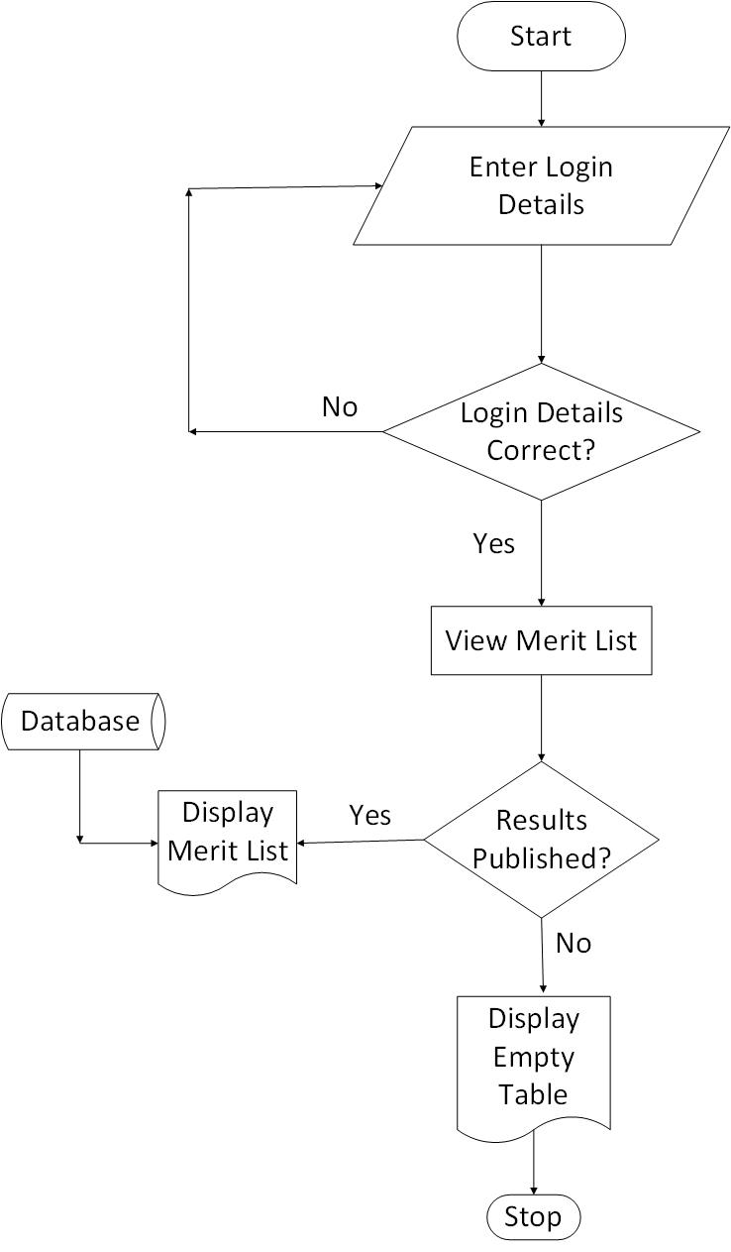

Figure 4.8.1 Teacher Flowchart for Viewing Merit List

The Teacher flowchart for adding student attendance information is presented in figure 4.8.2

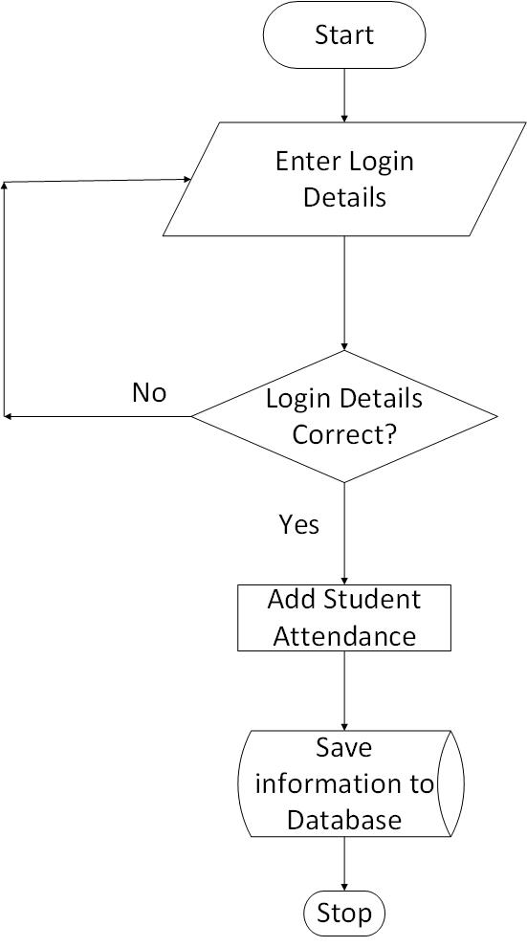

Figure 4.8.2 Teacher Flowchart for Adding Student Attendance Information

Figure 4.8.3 shows the Flowchart for the student.

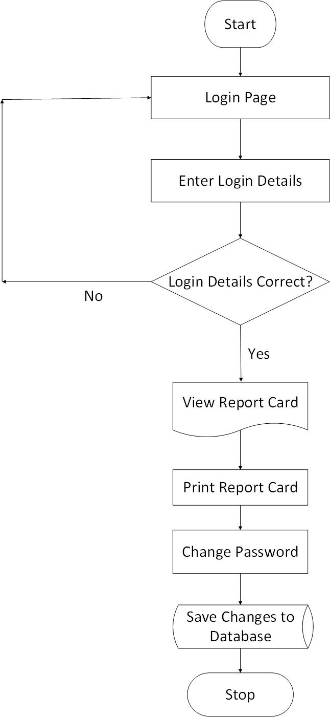

Figure 4.8.3 Student Flowchart

**4.7.5 Use Cases**The use cases of the system are identified to be “Login”, “Configure Grading Pattern”, “View Merit List for Mid-Term or End of Term Results”, “Delete or Add Class Details”, “View or Print Report Card”, “Add or Remove Subjects”, “Update Password”, “View Students”, “Update Mid Term or End of Term Results”, “Add or Update Student Attendance”, “Remove or Add Student Details”, “Add or Delete Teacher Details”.

The use case diagram of the system is depicted in Figure 4.8.4.

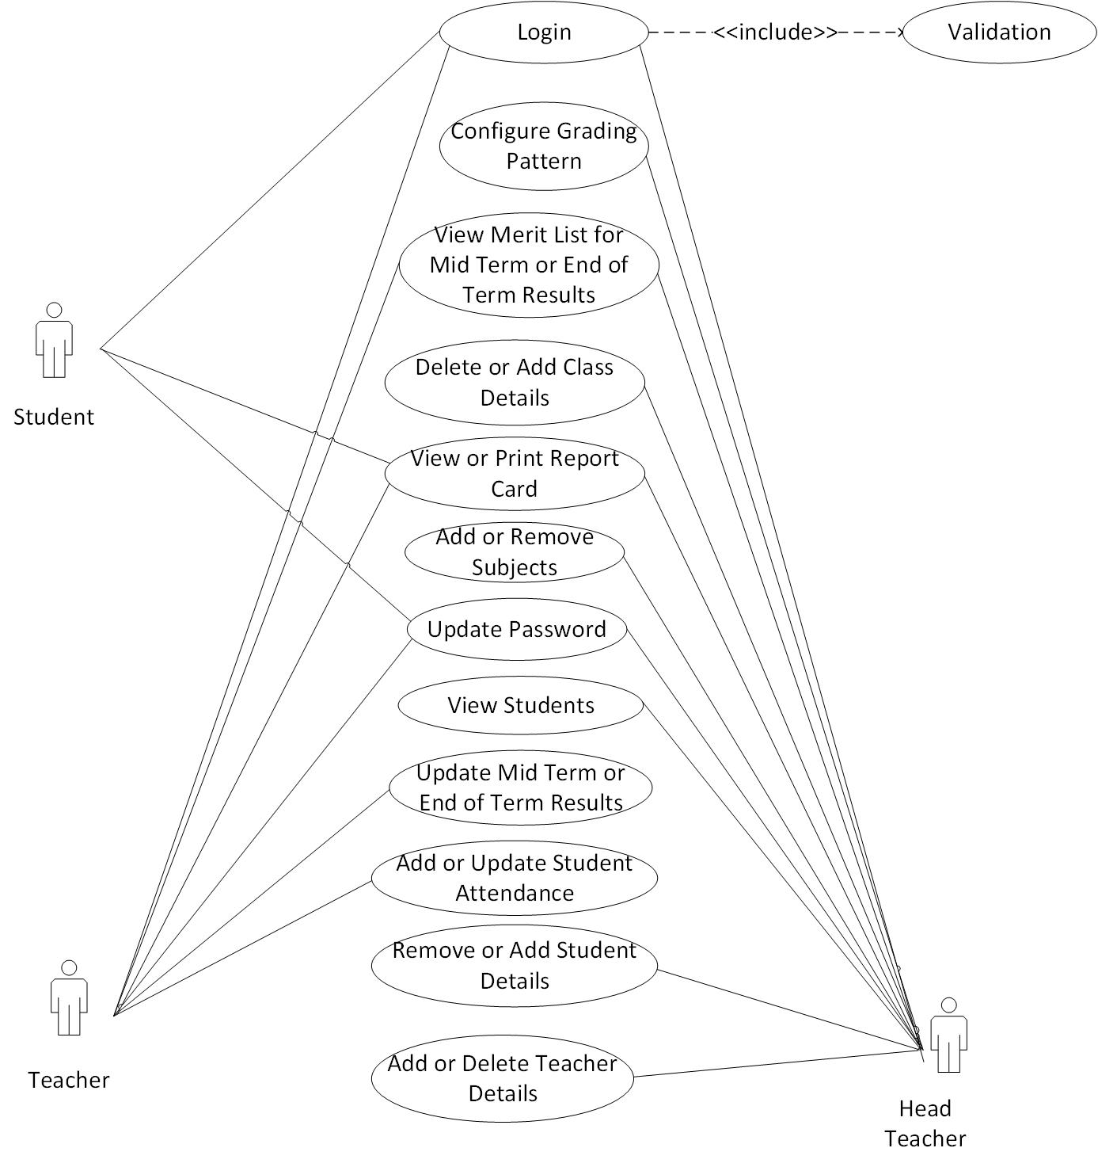

Figure 4.8.4 Use Case Diagram

**4.7.6 Database Specification**

The database was designed with MySQL Database Management System (DBMS). The database contains information of tables of the student result processing system. It organizes and manages the information to obtain the report card and merit lists that are vital to the existence of the student result processing system. The entity relationship diagram (ERD) below is used to show how common fields relates to different tables of data, it shows the relationships between different tables of the database.

Figure 4.8.5 shows the entity relationship diagram.

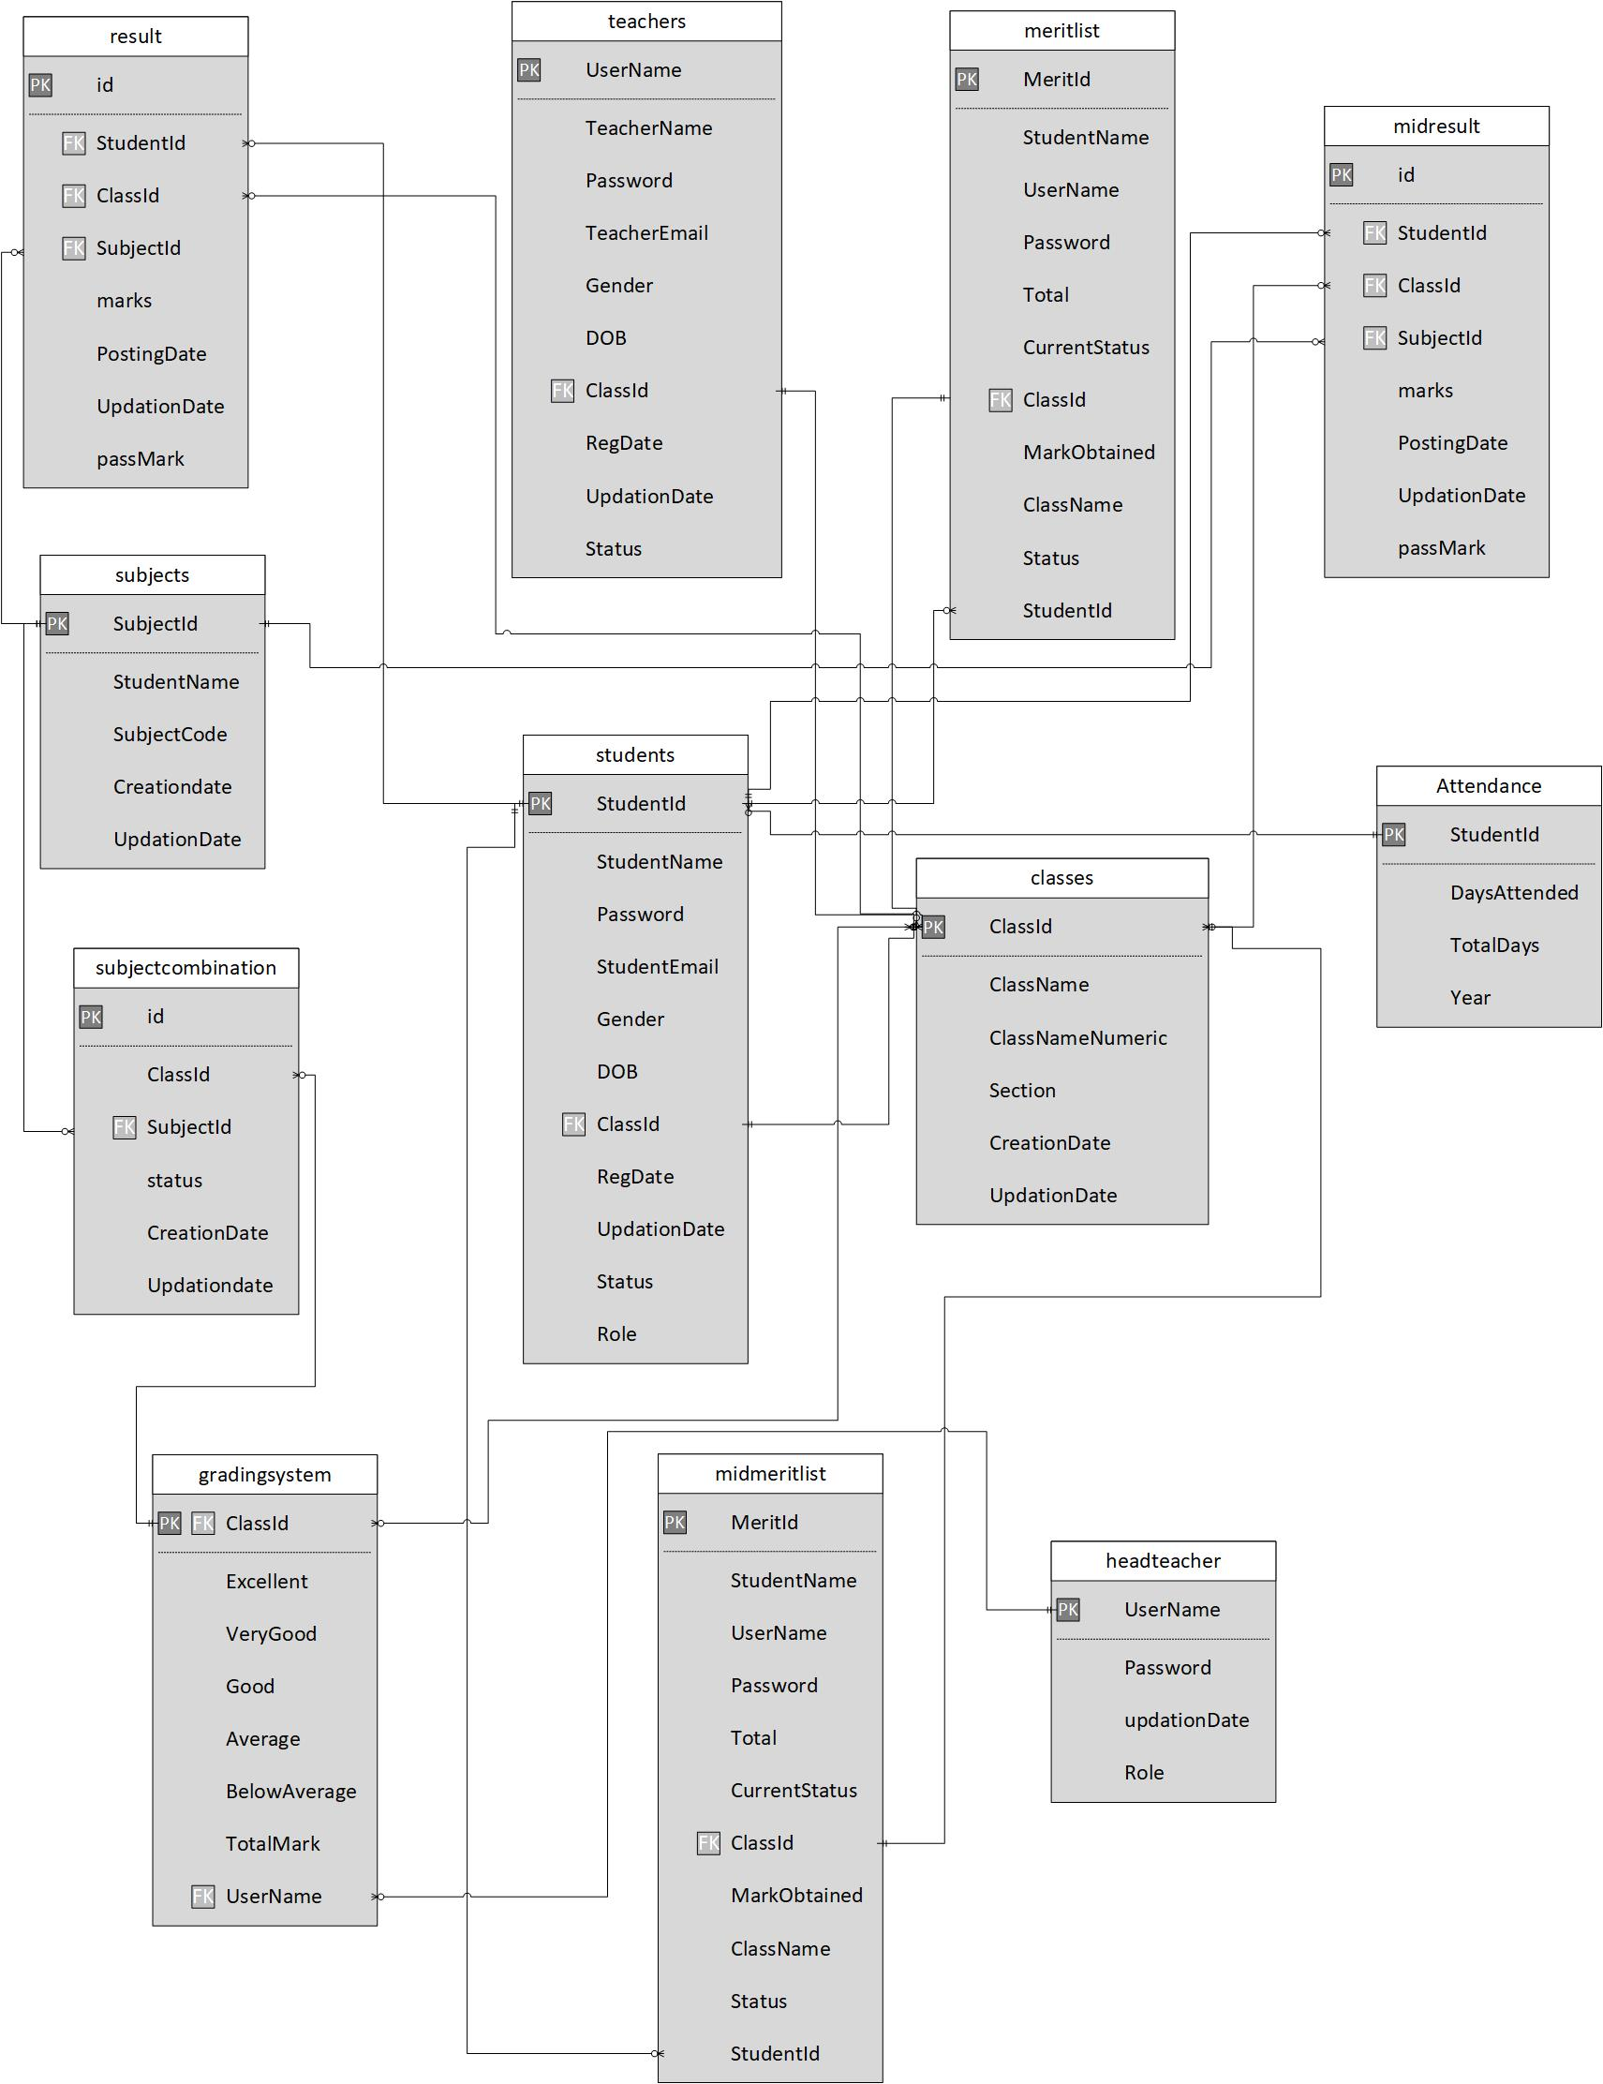

Figure 4.8.5 Entity Relationship Diagram

**Data Dictionary**

In the database specification, the following database tables below were used.

The following tables illustrate the structures of the database of the Student Result Processing System.

Table 1.0: Grading system table

|  |  |  |  |  |  |
| --- | --- | --- | --- | --- | --- |
| **gradingsystem** | | | | | |
| **Column** | **Type** | **Null** | **Default** | **Extra** | **Comments** |
| ClassId | int(11) | No |  |  | Primary key for class table |
| Excellent | decimal(50,0) | No |  |  | Stores the minimum value to get “excellent” |
| VeryGood | decimal(50,0) | No |  |  | Stores the maximum value for the comment “Very Good” |
| Good | decimal(50,0) | No |  |  | Stores the maximum value for the comment “Good” |
| Average | decimal(50,0) | No |  |  | Stores the maximum value for the comment “Average” |
| BelowAverage | decimal(50,0) | No |  |  | Stores the value that is used to rate a grade as “Below Average” |
| TotalMark | decimal(50,0) | No |  |  | Stores the total marks for each subject |

Table 2.0: Classes table

|  |  |  |  |  |  |
| --- | --- | --- | --- | --- | --- |
| **classes** | | | | | |
| **Column** | **Type** | **Null** | **Default** | **Extra** | **Comments** | |
| id | int(11) | No |  | auto_increment | Primary key of the table | |
| ClassName | varchar(80) | Yes | NULL |  | Name of Class | |
| ClassNameNumeric | int(4) | Yes | NULL |  | Name of Class in numeric form | |
| Section | varchar(5) | Yes | NULL |  | Name of Division or section | |
| CreationDate | timestamp | Yes | current_timestamp() |  | Date of Creation | |
| UpdationDate | timestamp | Yes | NULL |  | Date of Updation | |

Table 3.0: Headteacher`s table

|  |  |  |  |  |  |
| --- | --- | --- | --- | --- | --- |
| **headteacher** | | | | | |
| **Column** | **Type** | **Null** | **Default** | **Extra** | **Comments** |
| id | int(11) | No |  | auto_increment | Id of headteacher(Primary Key) |
| UserName | varchar(100) | Yes | NULL |  | Username of headteacher |
| Password | varchar(100) | Yes | NULL |  | Password of headteacher |
| updationDate | timestamp | Yes | NULL |  | Date of Updation |
| Role | varchar(11) | No | headteacher |  | Role |

Table 4.0: Merit list table for end of term results

|  |  |  |  |  |  |
| --- | --- | --- | --- | --- | --- |
| **meritlist** | | | | | |
| **Column** | **Type** | **Null** | **Default** | **Extra** | **Comments** |
| MeritId | int(11) | No |  | auto_increment | Id of Merit List(Primary Key) |
| StudentName | varchar(100  ) | No |  |  | Name of student |
| UserName | varchar(100  ) | No |  |  | Student username |
| Password | varchar(100  ) | Yes | 1A1DC91C9  07325C692  71DDF0C94  4BC72 |  | Password |
| Total | varchar(10) | No |  |  | Total marks for the subjects |
| CurrentStatus | varchar(100  ) | No |  |  | Current Status of the student |
| ClassId | int(11) | No |  |  | Class id |
| MarkObtained | decimal(10, 0) | No |  |  | Total marks the student gets |
| ClassName | varchar(50) | No |  |  | Name of the class |
| Status | int(1) | No |  |  | status |
| StudentId | varchar(100  ) | No |  |  | Student id |

Table 5.0: Student results table for end of term tests

|  |  |  |  |  |  |
| --- | --- | --- | --- | --- | --- |
| **result** | | | | | |
| **Column** | **Type** | **Null** | **Default** | **Extra** | **Comments** |
| id | int(11) | No |  | auto_increment | Result id(Primary key) |
| StudentId | int(11) | Yes | NULL |  | Student id |
| ClassId | int(11) | Yes | NULL |  | Class id |
| SubjectId | int(11) | Yes | NULL |  | Subject id |
| marks | int(11) | Yes | NULL |  | Marks for each subject |
| PostingDate | timestamp | Yes | current_tim estamp() |  | Date of Result publication |
| UpdationDate | timestamp | Yes | NULL |  | Updation Date |
| passMark | int(11) | Yes | NULL |  | Passmark |

Table 6.0: Students table

|  |  |  |  |  |  |
| --- | --- | --- | --- | --- | --- |
| **students** | | | | | |
| **Column** | **Type** | **Null** | **Default** | **Extra** | **Comments** |
| StudentId | int(11) | No |  | auto_increment | Id of Student(Primary Key) |
| StudentName | varchar(100  ) | Yes | NULL |  | Name of Student |
| RollId | varchar(100  ) | Yes | NULL |  | Student rollid |
| StudentEmail | varchar(100  ) | Yes | NULL |  | Student email |
| Gender | varchar(10) | Yes | NULL |  | Student Gender |
| DOB | varchar(100  ) | Yes | NULL |  | Date of Birth |
| ClassId | int(11) | Yes | NULL |  | Class id |
| RegDate | timestamp | Yes | current_tim estamp() |  | Registration Date |
| UpdationDate | timestamp | Yes | NULL |  | Updation Date |
| Status | int(1) | Yes | NULL |  | Status |
| Role | varchar(11) | No | student |  | Role |
| Password | varchar(100  ) | No | 1A1DC91C9  07325C692  71DDF0C94  4BC72 |  | Password |

Table 7.0: Combine class and subject table

|  |  |  |  |  |  |
| --- | --- | --- | --- | --- | --- |
| **subjectcombination** | | | | | |
| **Column** | **Type** | **Null** | **Default** | **Extra** | **Comments** |
| id | int(11) | No |  | auto_increment | Id for class and subject combination(Primary key) |
| ClassId | int(11) | Yes | NULL |  | Class id |
| SubjectId | int(11) | Yes | NULL |  | Subject id |
| status | int(1) | Yes | NULL |  | status |
| CreationDate | timestamp | Yes | current_tim estamp() |  | Date of Creation |
| Updationdate | timestamp | Yes | NULL | on update curre nt_timestamp() | Date of Updation |

Table 8.0: Subjects table

|  |  |  |  |  |  |
| --- | --- | --- | --- | --- | --- |
| **subjects** | | | | | |
| **Column** | **Type** | **Null** | **Default** | **Extra** | **Comments** |
| id | int(11) | No |  | auto_increment | Subject id(Primary key) |
| SubjectName | varchar(100  ) | No |  |  | Name of Subject |
| SubjectCode | varchar(100  ) | Yes | NULL |  | Subject code |
| Creationdate | timestamp | Yes | current_tim estamp() |  | Date of Creation |
| UpdationDate | timestamp | Yes | NULL |  | Date of Updation |

Table 9.0: Teachers table

|  |  |  |  |  |  |
| --- | --- | --- | --- | --- | --- |
| **teachers** | | | | | |
| **Column** | **Type** | **Null** | **Default** | **Extra** | **Comments** |
| TeacherId | int(11) | No |  | auto_increment | Teacher id(Primary key) |
| TeacherName | varchar(100  ) | No |  |  | Name of Teacher |
| UserName | varchar(100  ) | No |  |  | username |
| Password | varchar(100  ) | Yes | 1A1DC91C9  07325C692  71DDF0C94  4BC72 |  | password |
| TeacherEmail | varchar(100  ) | No |  |  | Teacher Email address |
| Gender | varchar(10) | No |  |  | Gender of Teacher |
| DOB | varchar(100  ) | No |  |  | Date of Birth |
| ClassId | int(11) | No |  |  | Class id |
| RegDate | timestamp | No | current_tim estamp() |  | Registration Date |
| UpdationDate | timestamp | Yes | NULL | on update curre nt_timestamp() | Date of Updation |
| Status | int(1) | No |  |  | Status |

Table 10.0: Student results table for mid-term tests

|  |  |  |  |  |  |
| --- | --- | --- | --- | --- | --- |
| **midresult** | | | | | |
| **Column** | **Type** | **Null** | **Default** | **Extra** | **Comments** |
| id | int(11) | No |  | auto_increment | Result id(Primary key) |
| StudentId | int(11) | Yes | NULL |  | Student id |
| ClassId | int(11) | Yes | NULL |  | Class id |
| SubjectId | int(11) | Yes | NULL |  | Subject id |
| marks | int(11) | Yes | NULL |  | Marks for each subject |
| PostingDate | timestamp | Yes | current_tim estamp() |  | Date of Result publication |
| UpdationDate | timestamp | Yes | NULL |  | Updation Date |
| passMark | int(11) | Yes | NULL |  | Passmark |

Table 11.0: Merit list table for mid-term results

|  |  |  |  |  |  |
| --- | --- | --- | --- | --- | --- |
| **midmeritlist** | | | | | |
| **Column** | **Type** | **Null** | **Default** | **Extra** | **Comments** |
| MeritId | int(11) | No |  | auto_increment | Id of Merit List(Primary Key) |
| StudentName | varchar(100  ) | No |  |  | Name of student |
| UserName | varchar(100  ) | No |  |  | Student username |
| Password | varchar(100  ) | Yes | 1A1DC91C9  07325C692  71DDF0C94  4BC72 |  | Password |
| Total | varchar(10) | No |  |  | Total marks for the subjects |
| CurrentStatus | varchar(100  ) | No |  |  | Current Status of the student |
| ClassId | int(11) | No |  |  | Class id |
| MarkObtained | decimal(10, 0) | No |  |  | Total marks the student gets |
| ClassName | varchar(50) | No |  |  | Name of the class |
| Status | int(1) | No |  |  | status |
| StudentId | varchar(100  ) | No |  |  | Student id |

Table 12.0: Student attendance table

|  |  |  |  |  |  |
| --- | --- | --- | --- | --- | --- |
| **attendance** | | | | | |
| **Column** | **Type** | **Null** | **Default** | **Extra** | **Comments** |
| StudentId | int(50) | No |  |  | Primary and foreign key of the table |
| DaysAttended | int(4) | Yes | NULL |  | Number of Days Attended |
| TotalDays | int(4) | Yes | NULL |  | Total Number of Days Supposed to Attend |
| Year | int(4) | Yes | NULL |  | Year of Attendance |

**5 Project Feasibility**

After the analysis and study of all required functionalities of the Student Result Processing System, the next step was to do the feasibility study of the project. All projects are feasible given unlimited resources and infinite time.

The feasibility study included consideration of all the possible ways to provide a solution to a given problem. The proposed solution should satisfy all user requirements and should be flexible enough so that future changes can be made based on future upcoming requirements.  
**Economical Feasibility**

This was a very important aspect that was considered while developing the project. The technology to be used was decided based on minimum cost factor. All hardware and software costs were borne by the developer.

It was economically feasible to build the software as a personal computer and mobile phone were used to develop the system and free programming languages and development software tools like PHP, MySQL, JavaScript, html and CSS were also used.

**Technical Feasibility**

This included the study of function, performance and constraints that affect the ability to produce an acceptable system. For this feasibility study, complete functionality to be provided in the system was studied and checked if developing the functionality was feasible.

This project was technically feasible as it was possible to implement the requirements using existing frontend and backend platforms or development frameworks and was developed by a single developer due to its relatively small size.

**Operational Feasibility**

This project was operationally feasible as the system required little or no training to use because all inputs to the system were self-explanatory.

**6 Results and Discussion**

A functional Student Result Processing System was developed using PHP and MYSQL as the side-server and HTML and CSS as the client-side. The database used in the Student Result Processing System was designed with MYSQL Database Management System (DBMS). All the information pertaining to the Student Result Processing System are stored in the system database. The sample output results are shown in the various screen shots presented in this section. Figure 6.1 shows the login page for Student Result Processing System. All users are expected to login from this login page. At this login page, the user is required to provide their username and password in order to be logged in. Invalid login details are flagged by an appropriate error message.

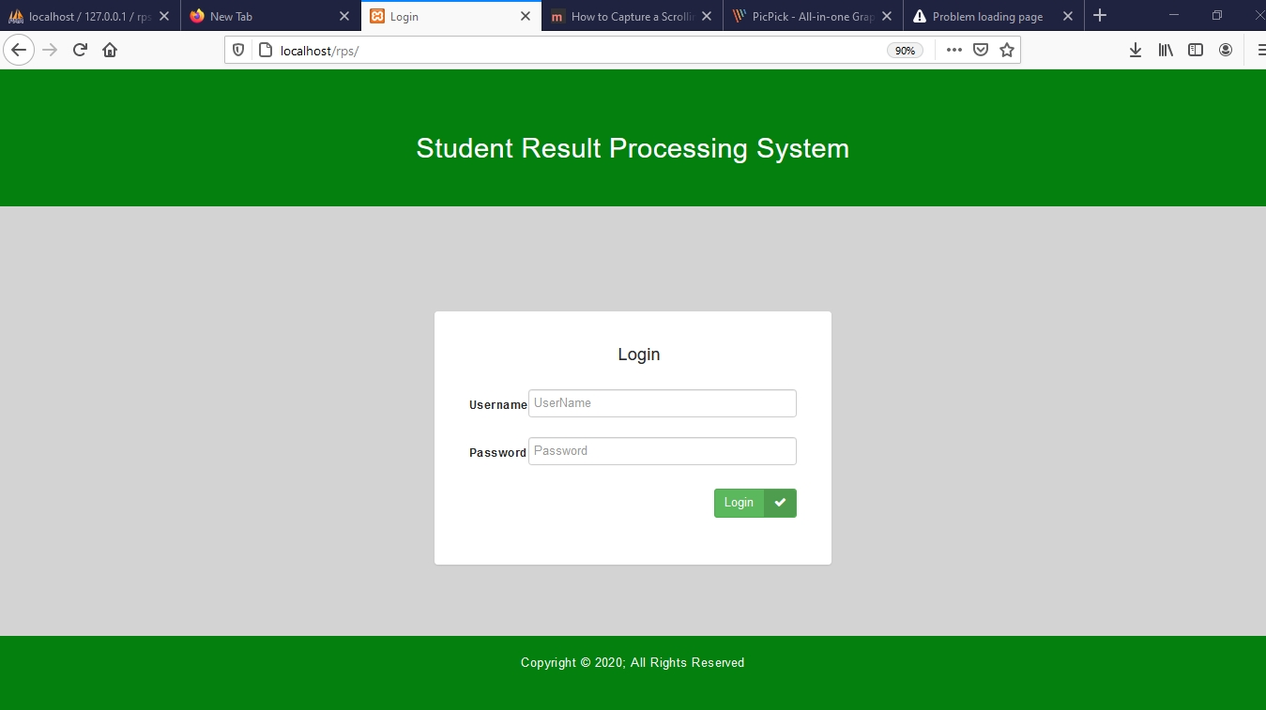

Figure 6.1 Login Page

Figure 6.1.1 shows the message that is generated when incorrect login details are provided.

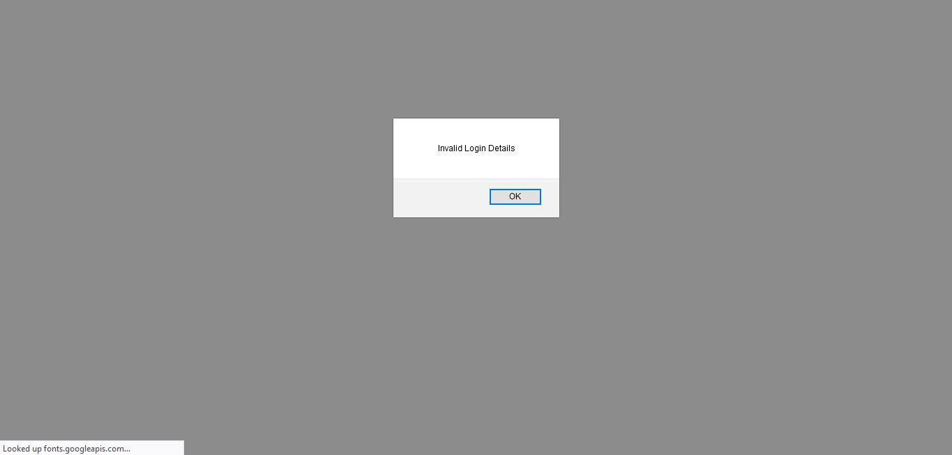

Figure 6.1.1 Invalid Login

The head teacher dashboard is presented in figure 6.1.2 which has a left navigation bar, top bar, and dashboard stats. The dashboard stats display the total number of teachers, students, subjects, classes, and also the total number of published mid-term results as well as the total number of published End of term results. On these dashboard stats the user can click on view to see detailed information about the teachers, students, subjects etc. Initially the dashboard stats will display zero because no information has been added to the system yet.

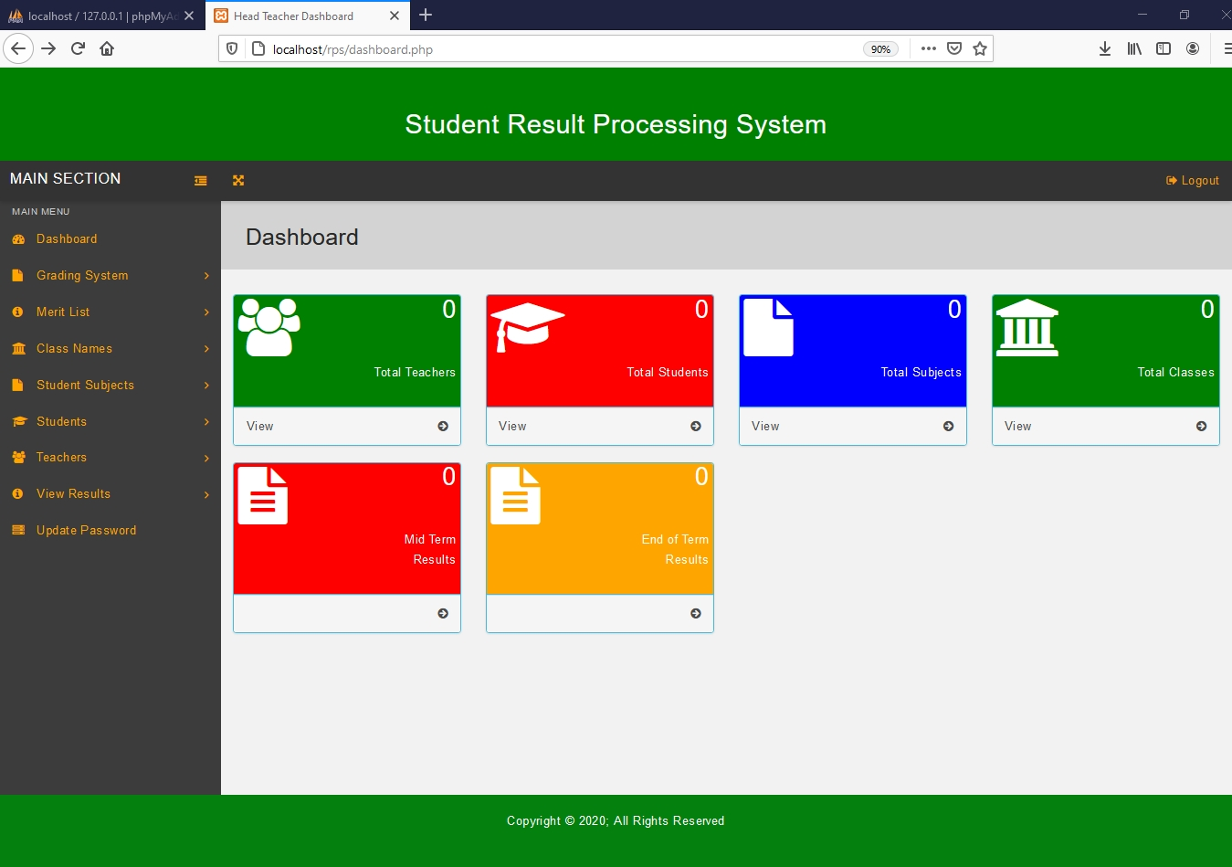

Figure 6.1.2, Head Teacher dashboard

Figure 6.1.3 shows the Add or Edit Classes page. This page has a add class button which can be clicked in order to add a new class to the system

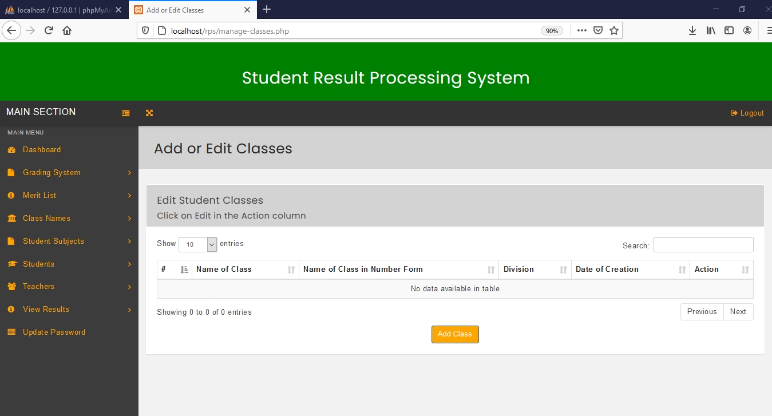

Figure 6.1.3 Add or Edit Classes Page.

Figure 6.1.4 shows the Add Student Class Page. The head teacher must fill in this form in order to add a class to the system

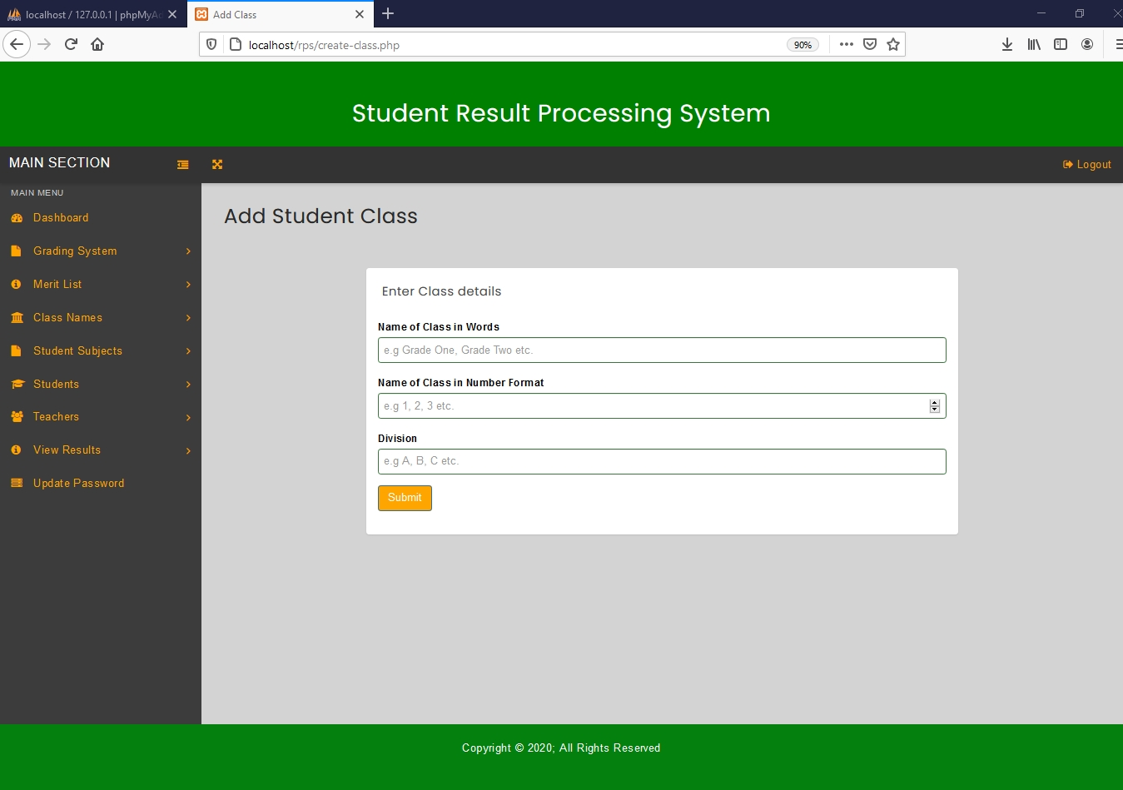

Figure 6.1.4 Add Student Class Page

Figure 6.1.5 Shows the Add or Edit Class Page after Classes have been added to the system. The head teacher can edit or delete classes on this page.

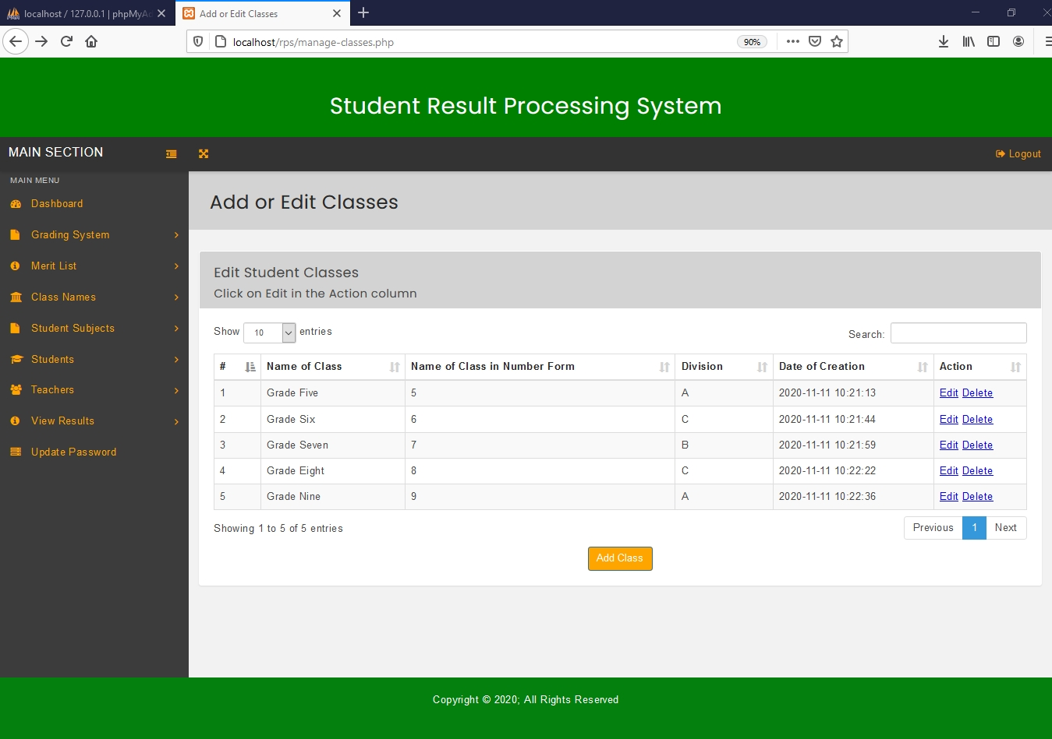

Figure 6.1.5 A filled Add or Edit Class Page

The Edit Class Page is presented in Figure 6.1.6. The edit class page allows the head teacher to edit class details by changing values of the input fields and then clicking update.

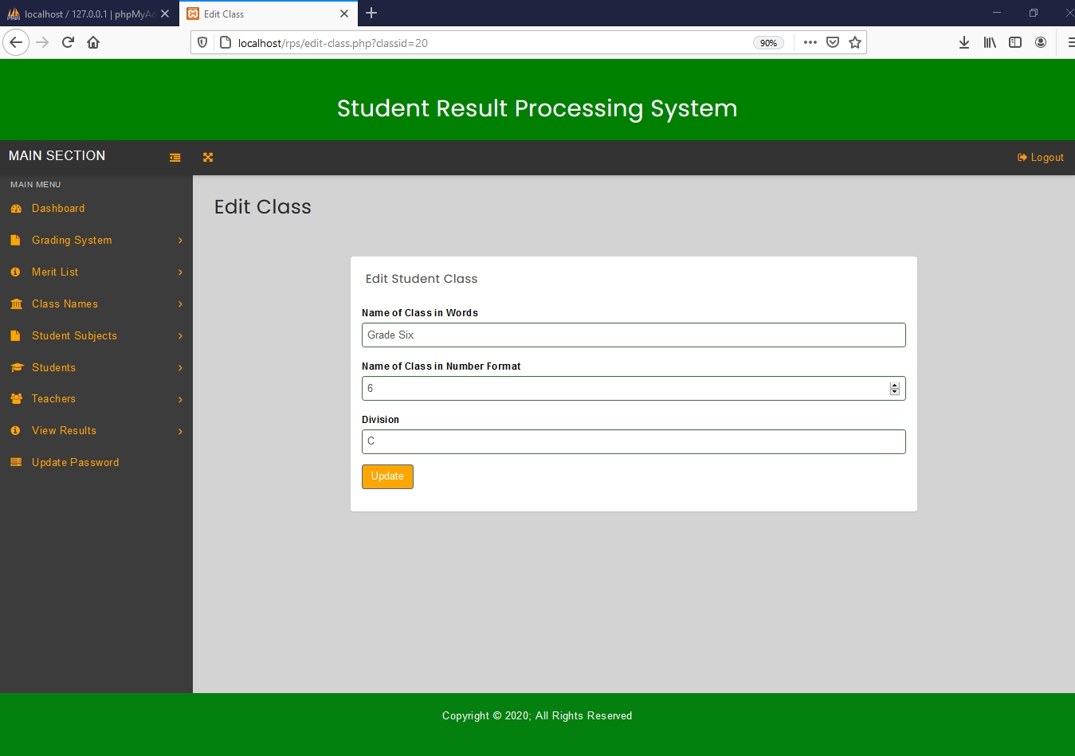

Figure 6.1.6 Edit Class Page

Figure 6.1.7, Shows the Configure Grading System page. This page allows the head teacher to add a grading pattern to a specific class.

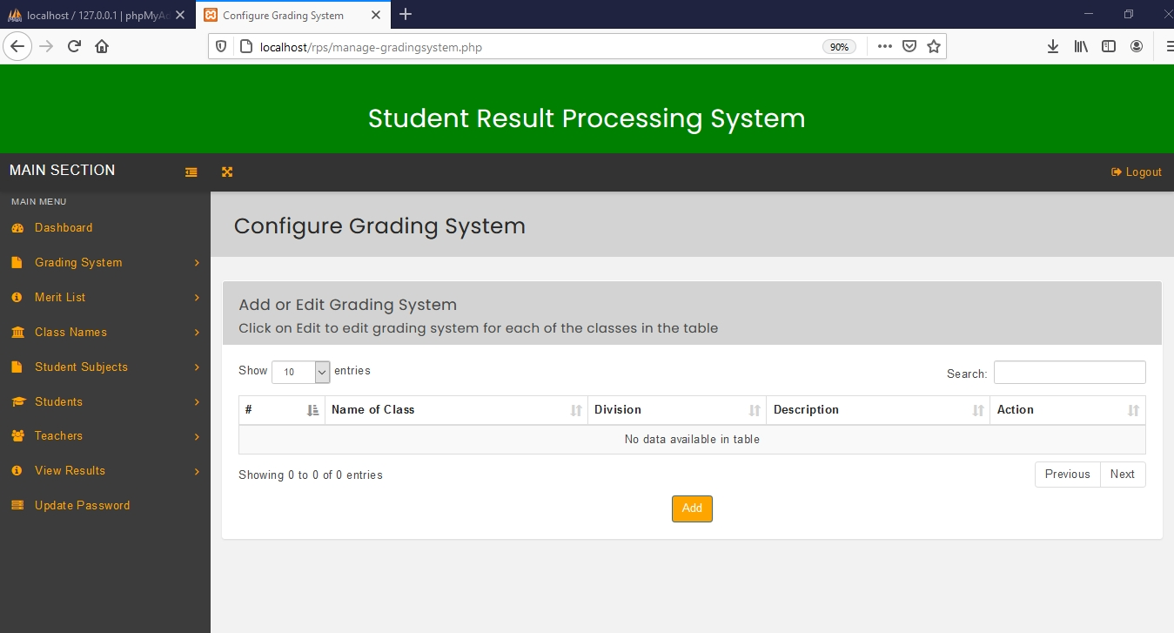

Figure 6.1.7, Configure Grading System page

The Create Grading System page is presented in Figure 6.1.8. This page is used for selecting the class you want to add a grading pattern.

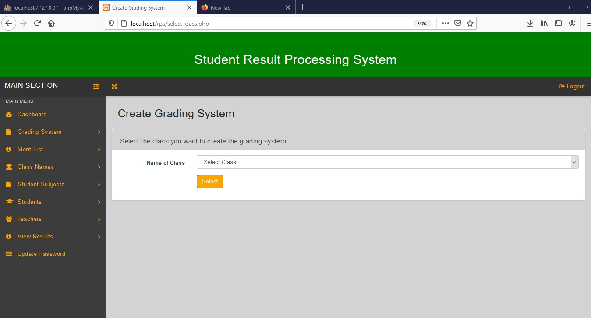

Figure 6.1.8, Create Grading System page for selecting the class

Figure 6.1.9, shows the Create Grading System page for setting the grading pattern. This page can be used to add a grading pattern to the system.

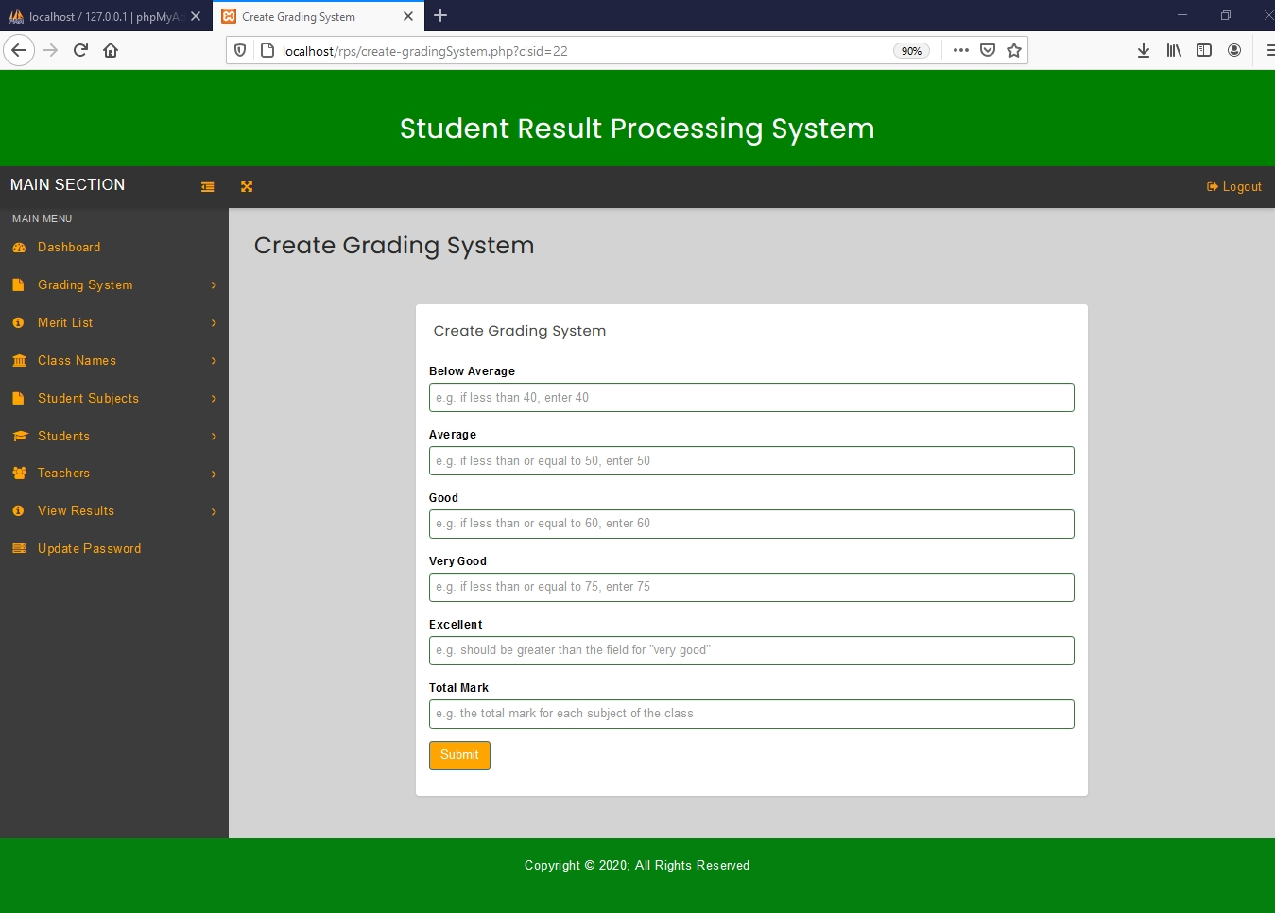

Figure 6.1.9, Create Grading System page

Figure 6.1.10, Shows the Configure Grading System page, after grading patterns have been added to the classes. The head teacher can edit or delete the grading pattern for a specific class by clicking on either edit or delete on this page.

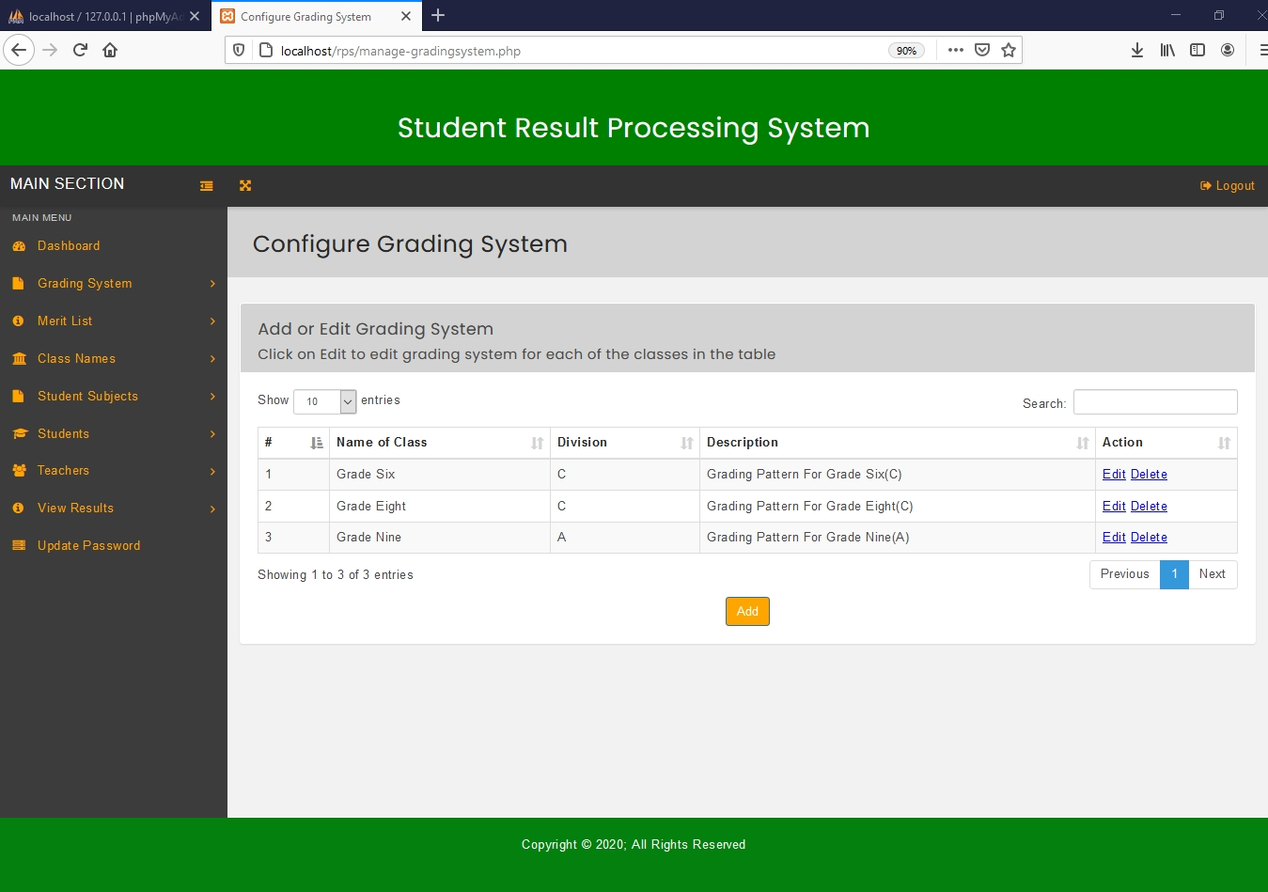

Figure 6.1.10, A Filled Configure Grading System page

Figure 6.1.11 shows the Edit Grading System page. This page allows the head teacher to edit or change information of a grading system.

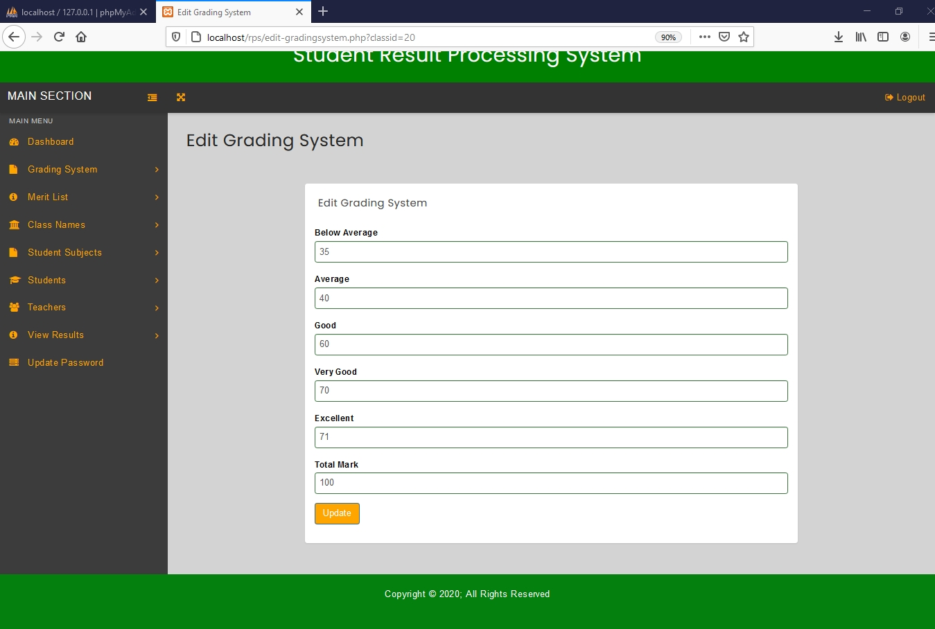

Figure 6.1.11, Edit Grading System page

Figure 6.1.12, shows the Add or Edit Subject page. This page allows the head teacher to add a subject to the system by clicking on the ‘add subject’ button.

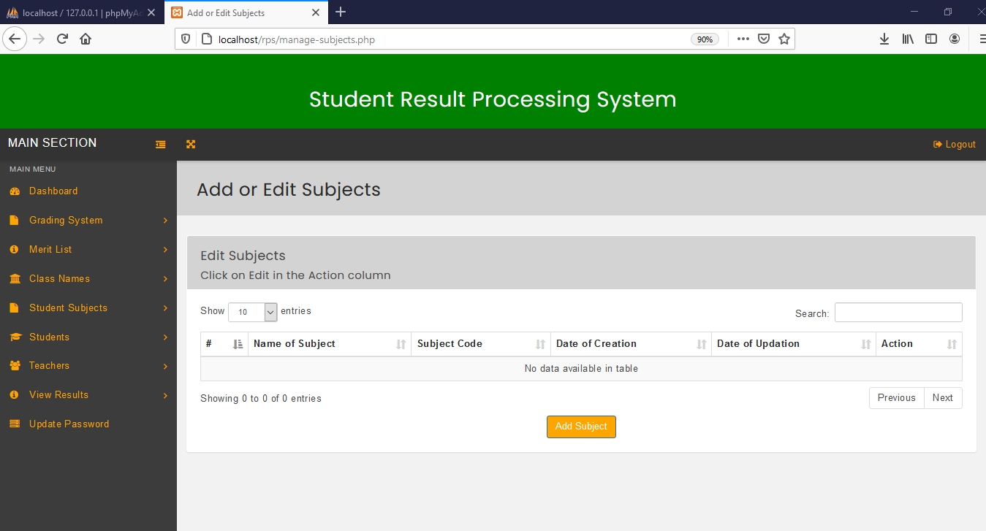

Figure 6.1.12, Add or Edit Subject page

Add Subject page is presented in Figure 6.1.13. The head teacher can add subject details on this page.

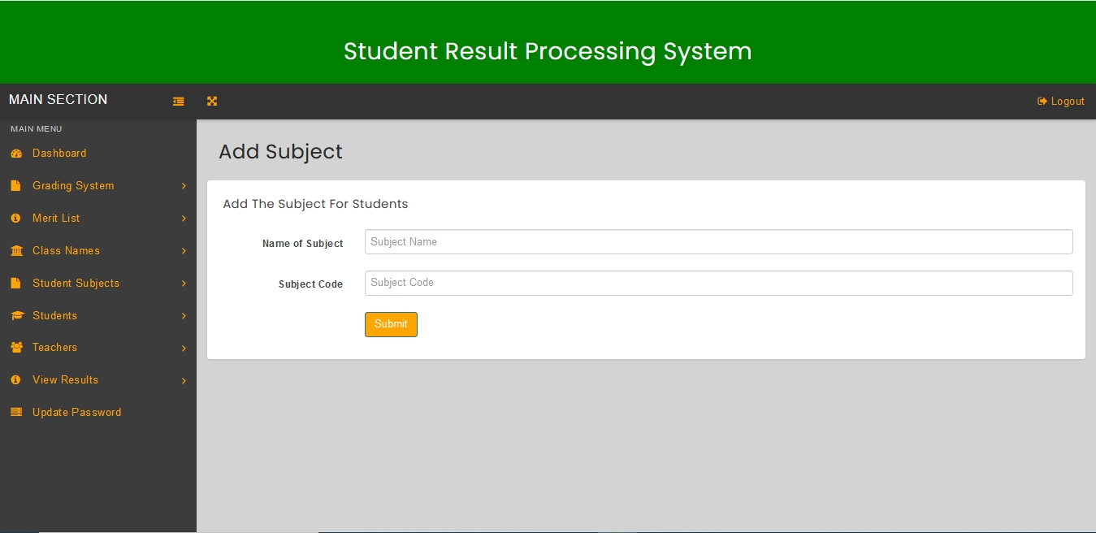

Figure 6.1.13, Add Subject page.

Figure 6.1.14, shows the Add or Edit Subjects page after adding subjects to the system. This page allows the head teacher to edit or delete subjects by clicking on the edit or delete link.

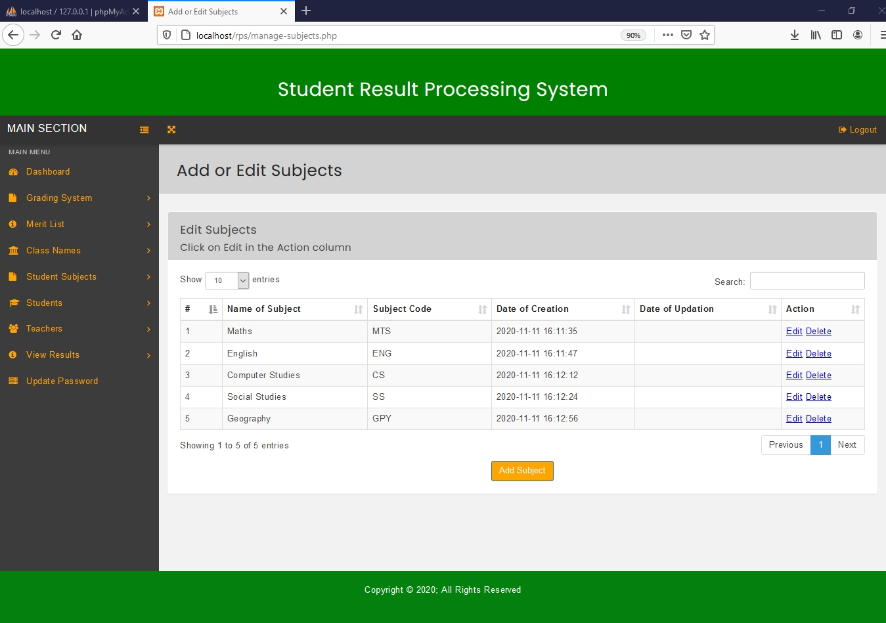

Figure 6.1.14, A filled Add or Edit Subjects page

Figure 6.1.15, shows the Edit Subject page. The head teacher can change subject details using this page.

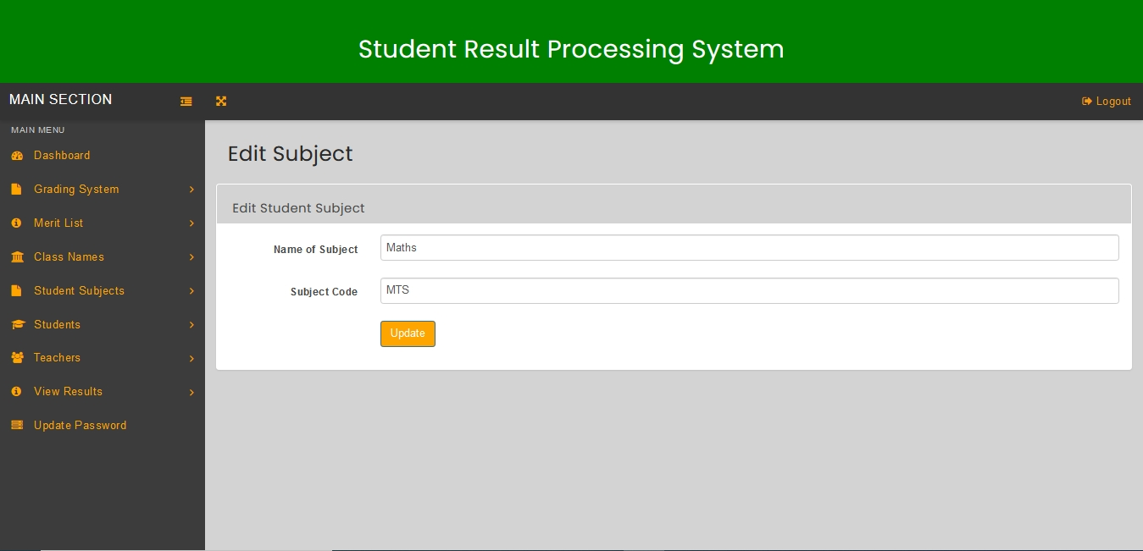

Figure 6.1.15, Edit Subject page.

Figure 6.1.16, shows the View Class and Subject Combination page. This page allows the head teacher to combine classes with specific subjects by clicking on the ‘add combination’ button.

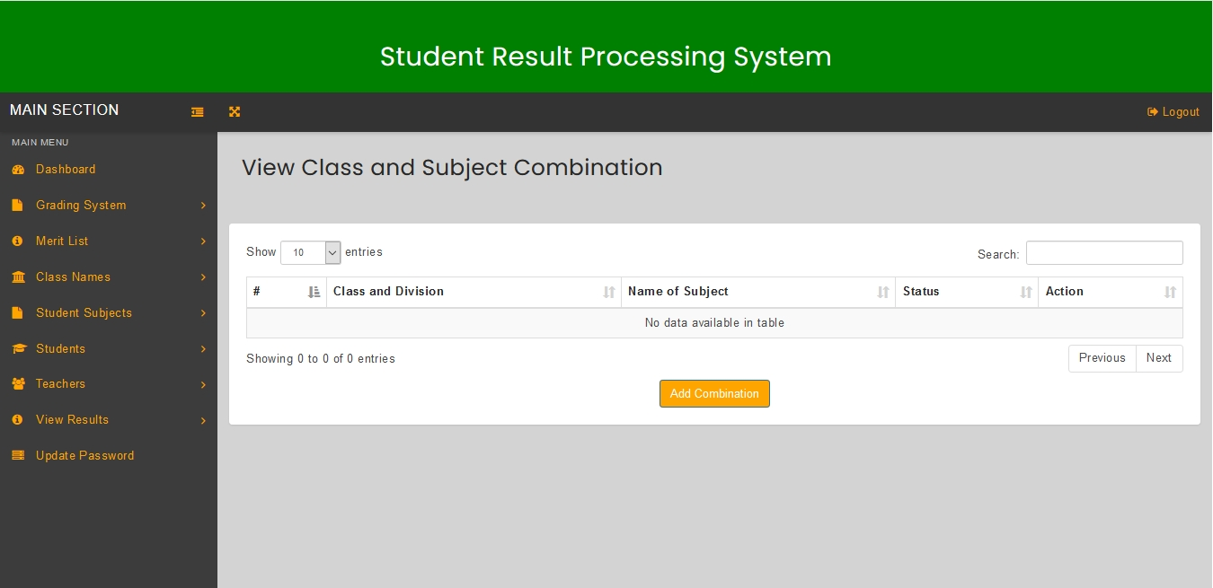

Figure 6.1.16, View Class and Subject Combination page.

Combine Class and Subject page is presented in Figure 6.1.17. On this page the head teacher can combine a class with a specific subject.

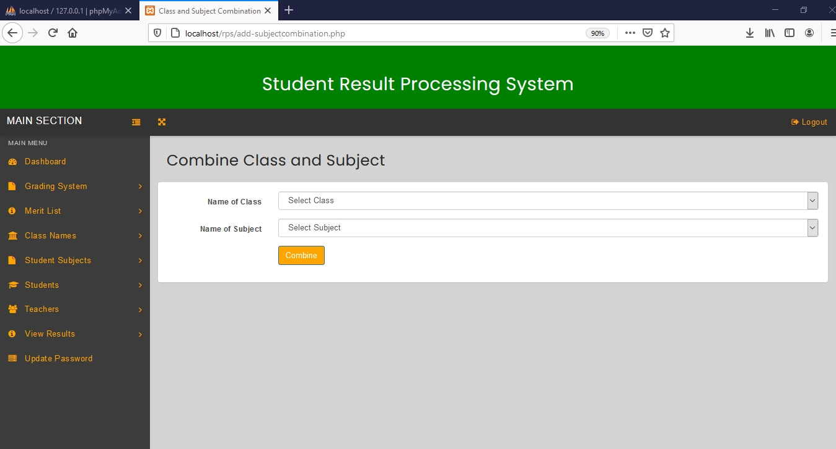

Figure 6.1.17, Combine Class and Subject page

Figure 6.1.18, shows the View Class and Subject Combination page after class and subject combinations have been added to the system. This page allows the head teacher to delete a specific class and subject combination.

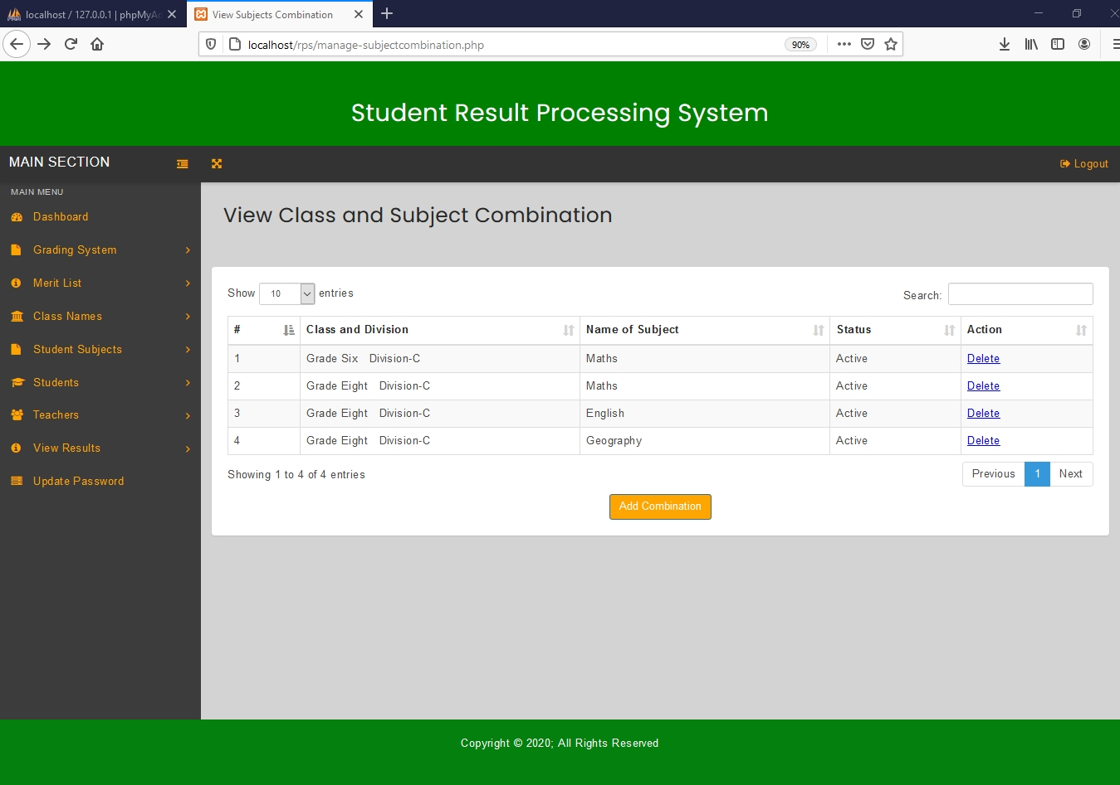

Figure 6.1.18, A filled View Class and Subject Combination page

Figure 6.1.19 shows the Add or Edit Students page. The head teacher can add a student to the system using this page by clicking on the ‘add student’ button.

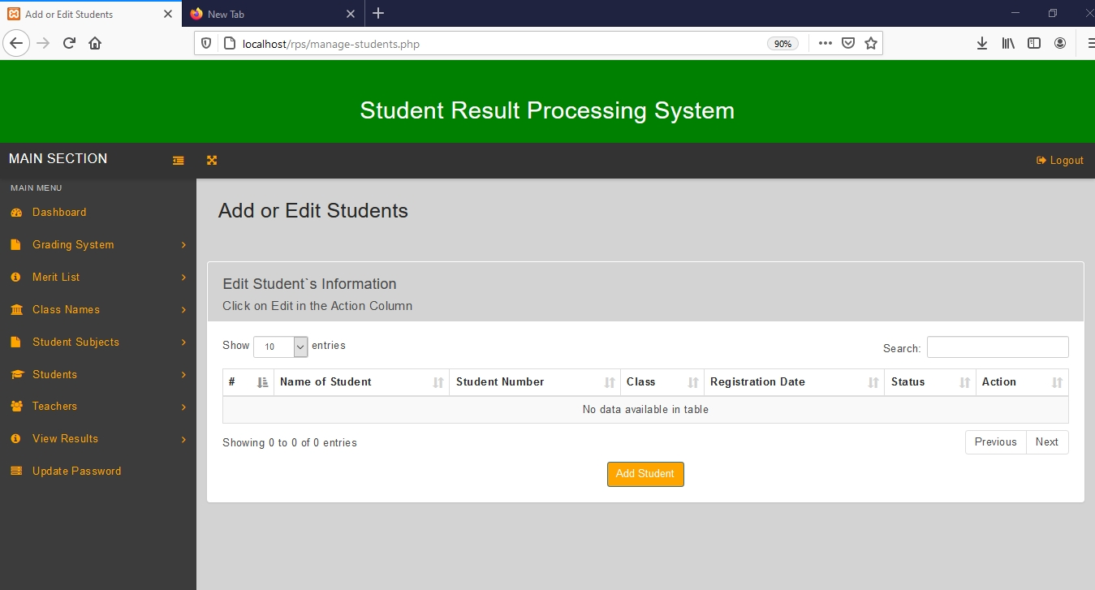

Figure 6.1.19, Add or Edit Students page.

Figure 6.1.20, shows the Add Student page. This page allows the head teacher to enter student details into the system.

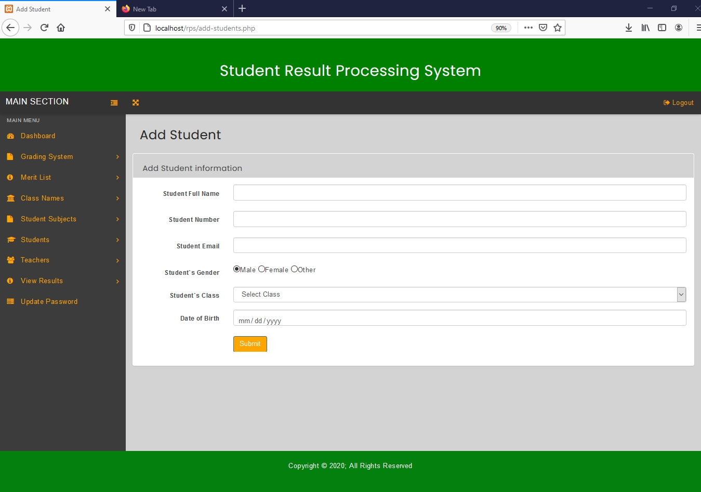

Figure 6.1.20, Add Student page

Figure 6.1.21, shows the Add or Edit Students page after adding students to the system. The head teacher can edit or delete students by clicking on the edit or delete links on this page.

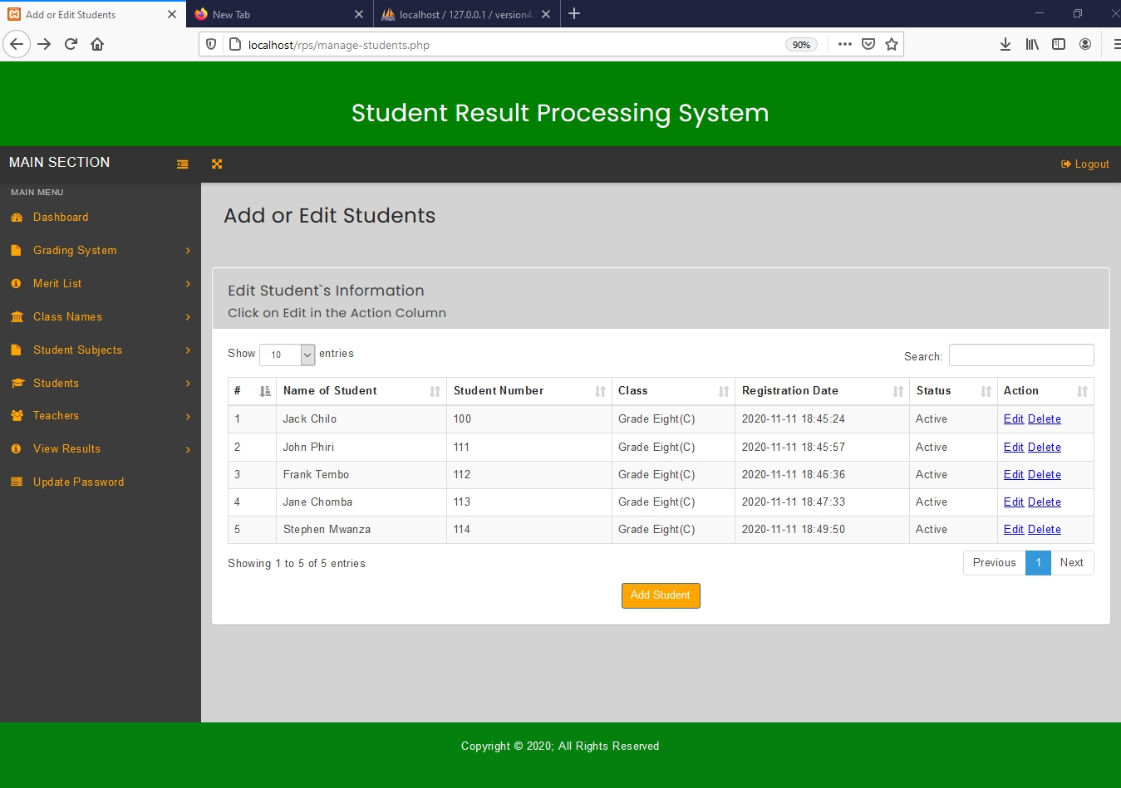

Figure 6.1.21, A filled Add or Edit Students page

Edit Student Page is presented in Figure 6.1.22. This page is generated after clicking on the edit link on the Add or Edit Students page and allows the head teacher to change student details.

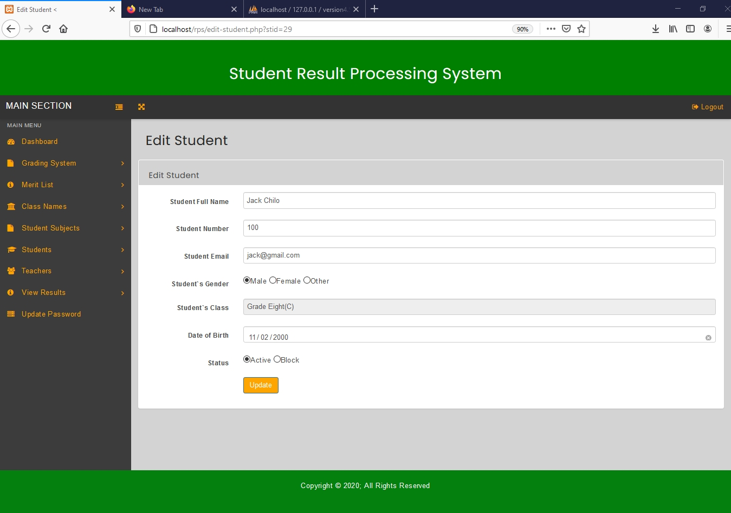

Figure 6.1.22, Edit Student page

Figure 6.1.23, shows the Add or Edit Teachers page. The head teacher can add a teacher by clicking the ‘add teacher’ button on this page.

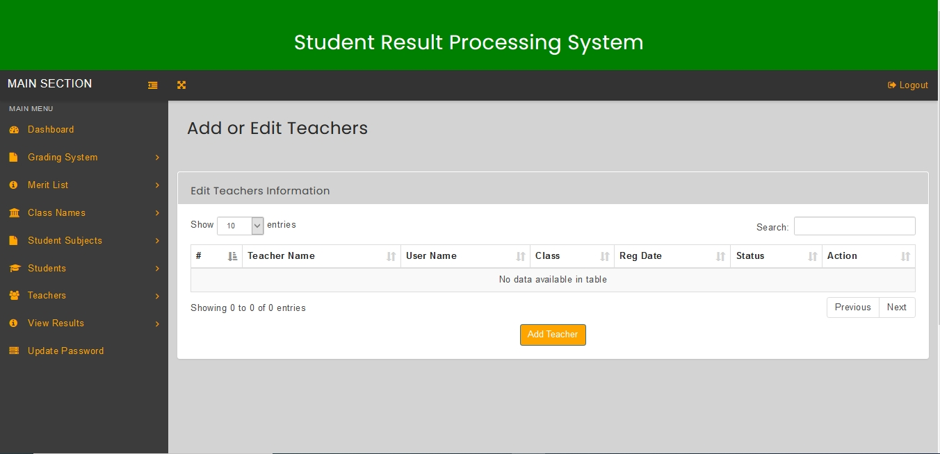

Figure 6.1.23, Add or Edit Teachers page.

Add Teacher page is presented in Figure 6.1.24. This page allows the head teacher to enter teacher details into the system.

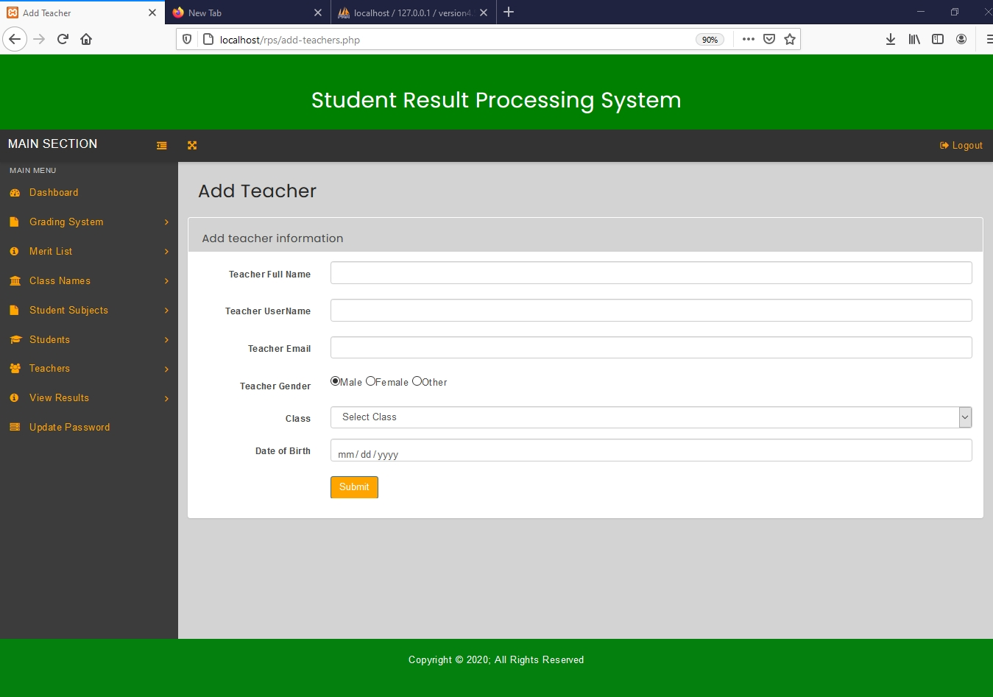

Figure 6.1.24, Add Teacher page.

Figure 6.1.25, shows the Add or Edit Teachers page after adding teachers to the system. The head teacher can edit or delete teachers by clicking on either edit or delete link on this page.

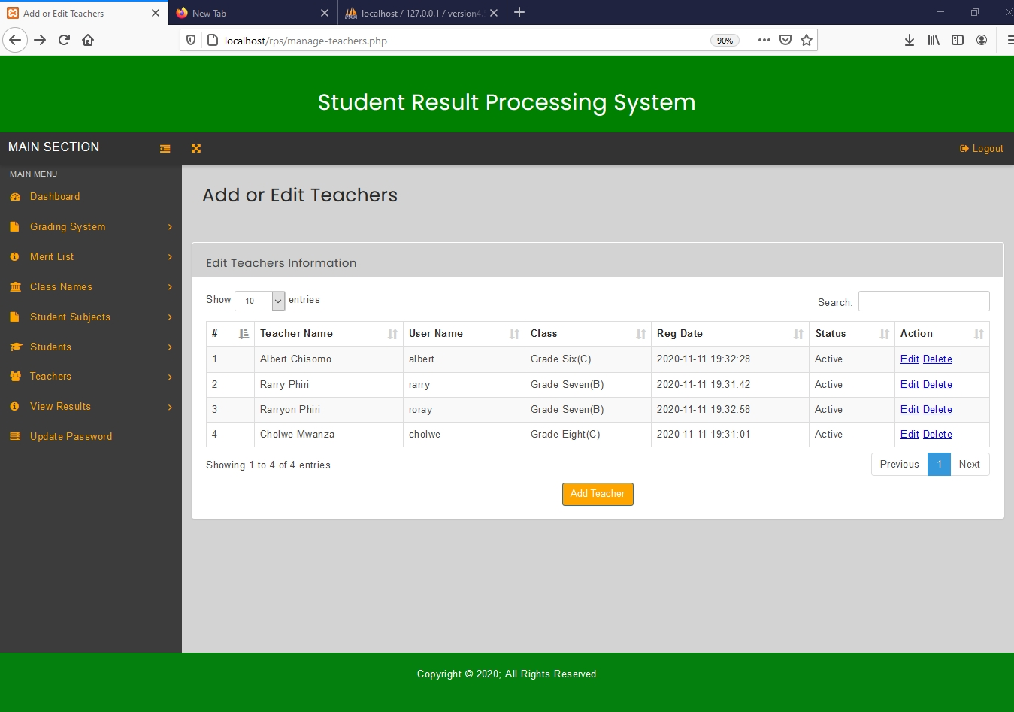

Figure 6.1.25, A filled Add or Edit Teachers page.

Figure 6.1.26, show the Edit Teacher page. This page allows the head teacher to change teacher information.

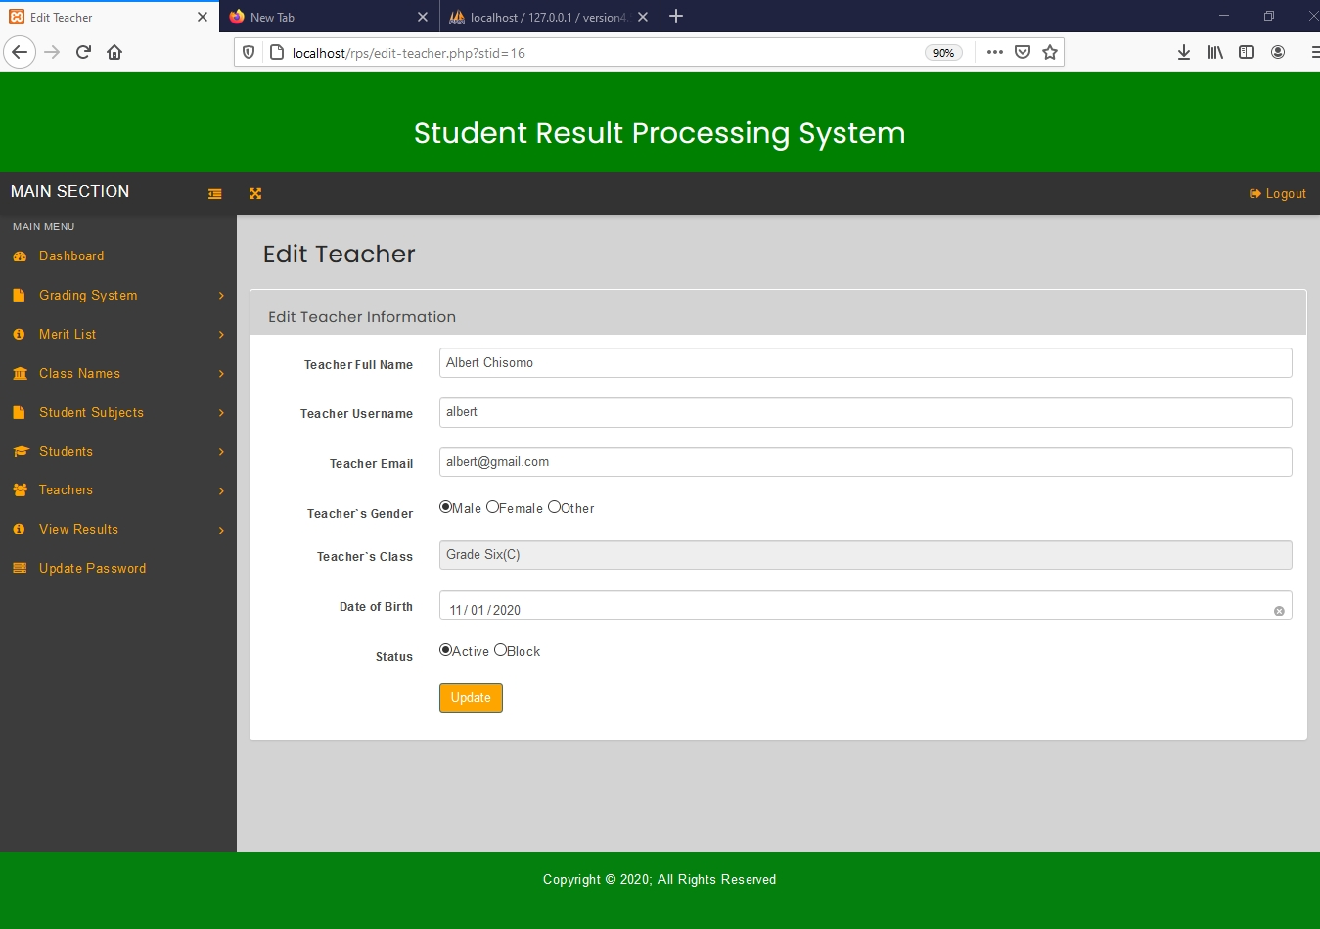

Figure 6.1.26, Edit Teacher page.

View Results page is presented in Figure 6.1.27. The head teacher can view results of a particular student by clicking on view on this page.

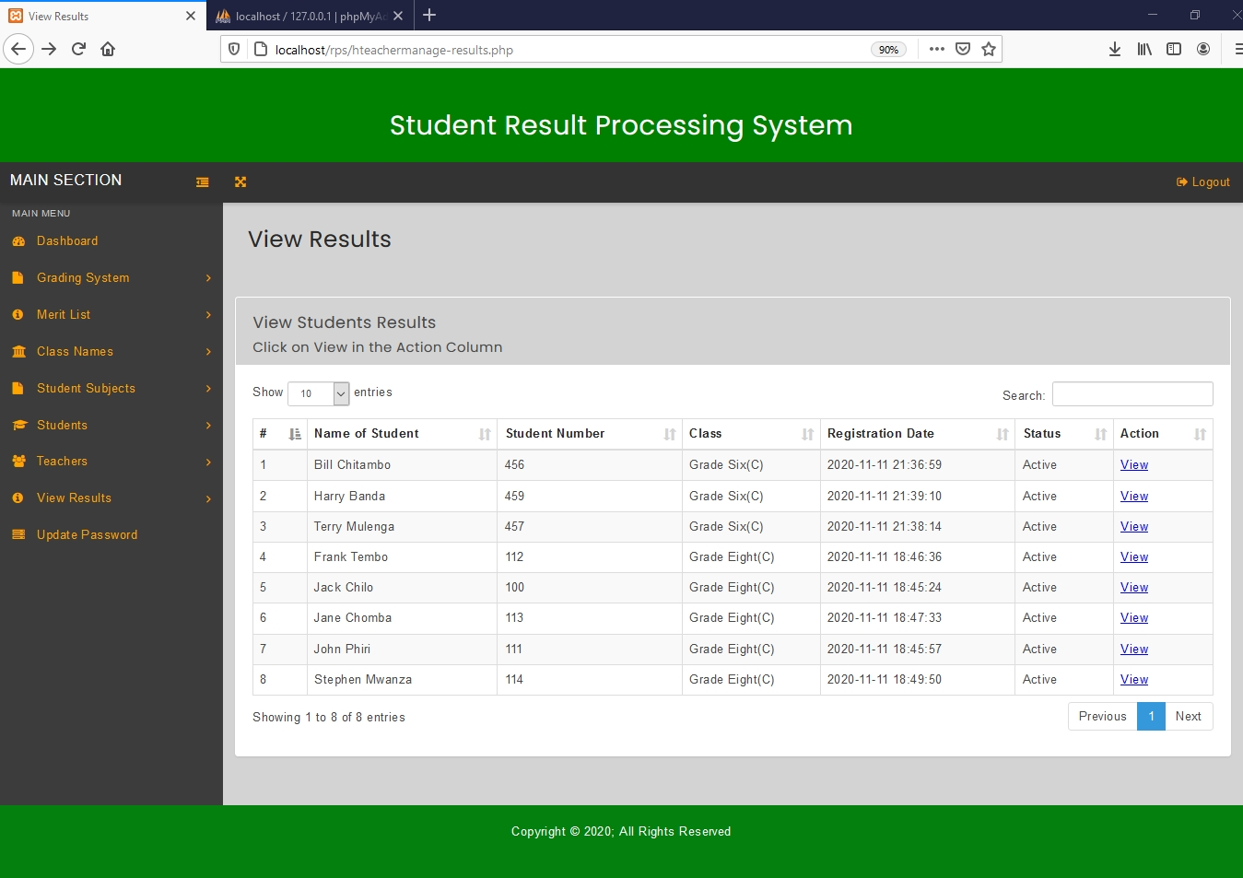

Figure 6.1.27, View Results page

Figure 6.1.28, shows the Student Results page which is produced after clicking on view on the view results page. The Student Results page automatically generates a report card for a particular student on which the view link was clicked. The Student Results page allows the head teacher to print results by clicking on the print icon on the student report card.

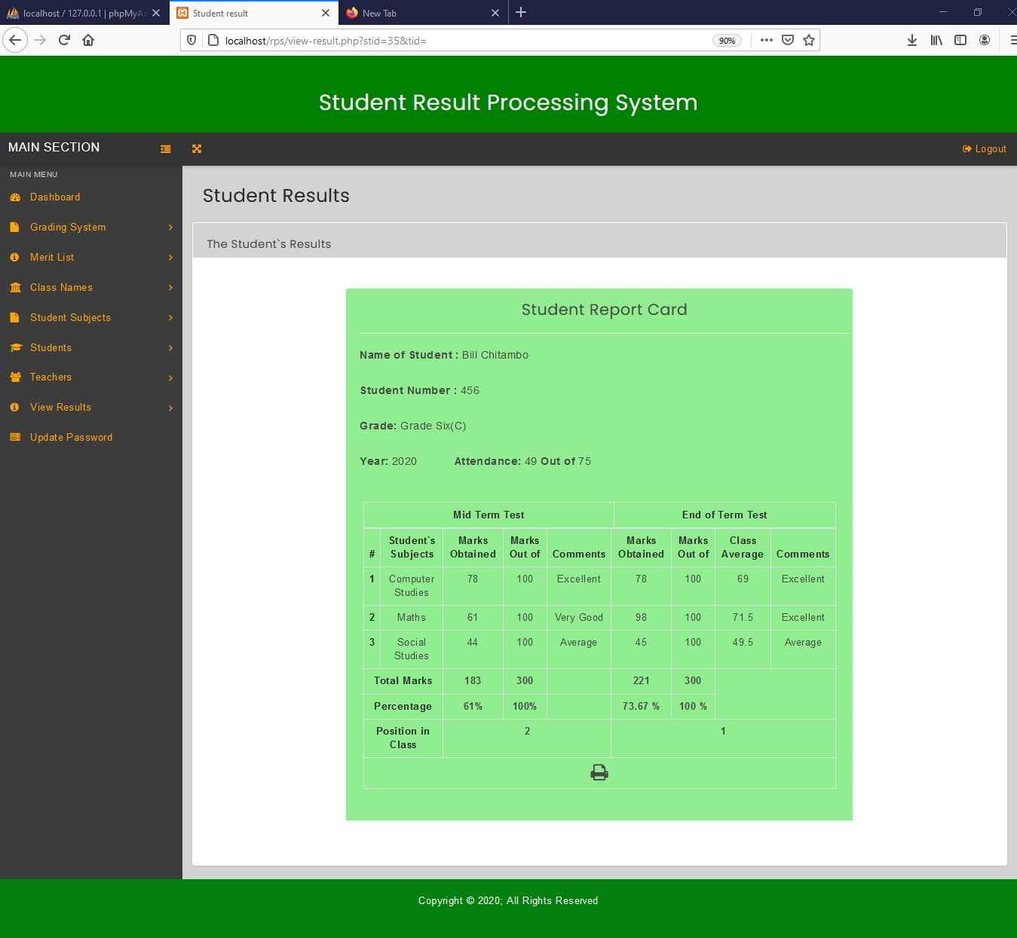

Figure 6.1.28, Student Results page

Figure 6.1.29, shows the Check End of Term Merit List page. This page allows the head teacher to select a class for which he/she wants to view the end of term merit list.

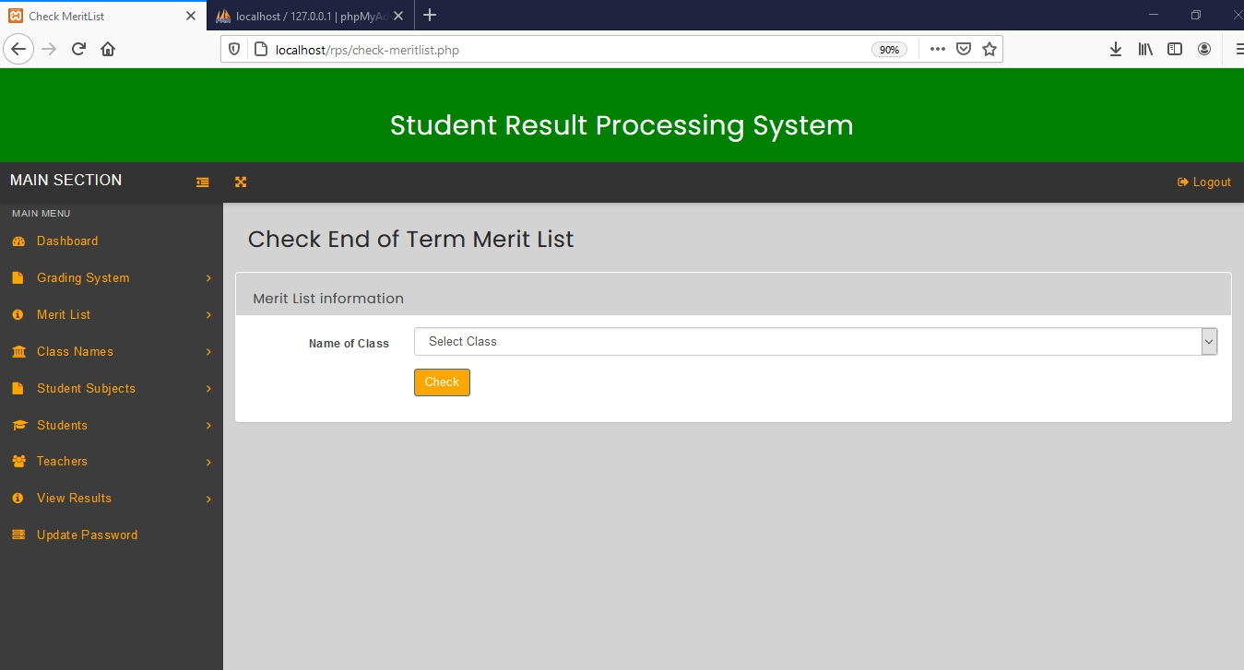

Figure 6.1.29, Check End of Term Merit List page

Figure 6.1.30, shows the End of Term Merit List. This merit list is generated after selecting a particular class for which you want to view a merit list for end of term results.

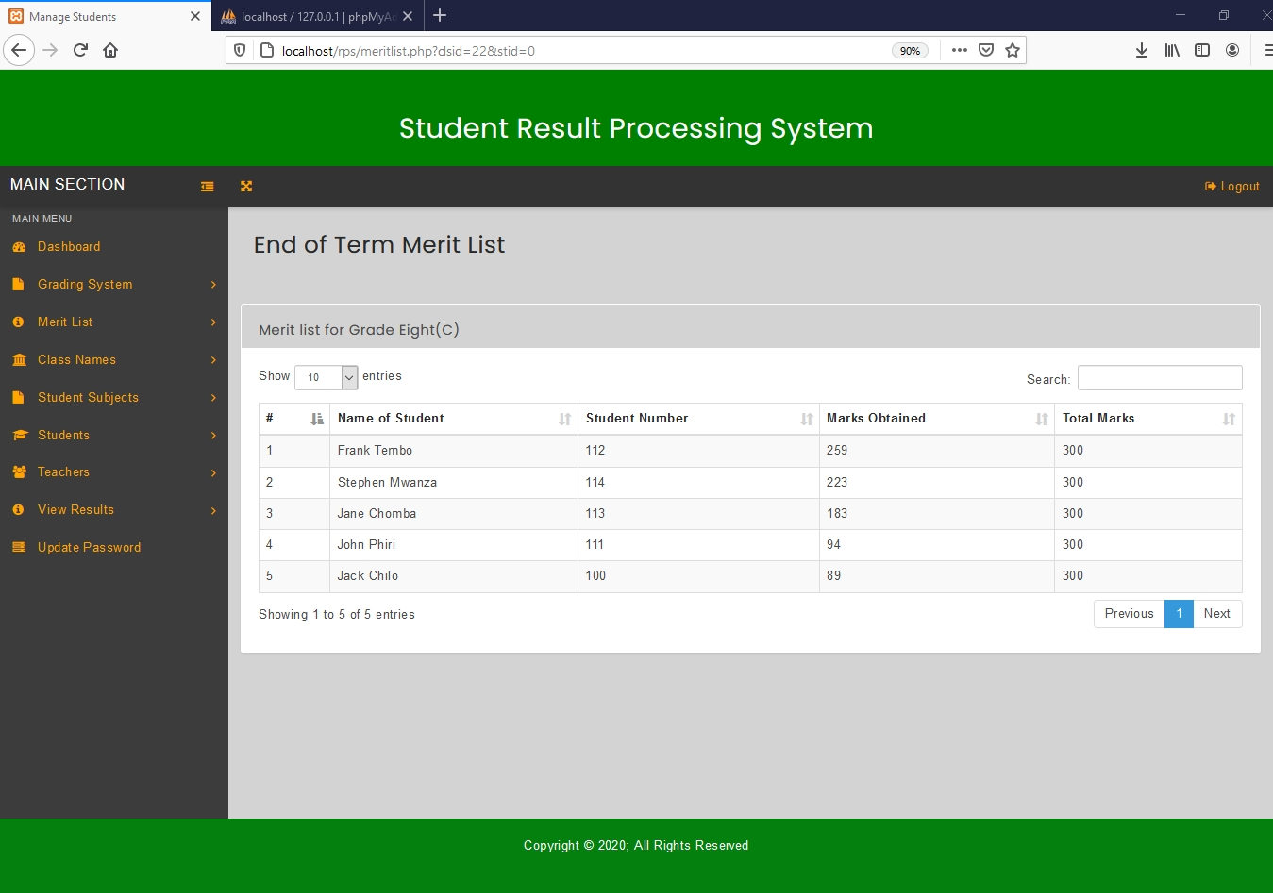

Figure 6.1.30, End of Term Merit List.

Figure 6.1.31, shows the Check Mid Term Merit List page. This page allows the head teacher to select a class for which he/she wants to view the merit list for mid-term results.

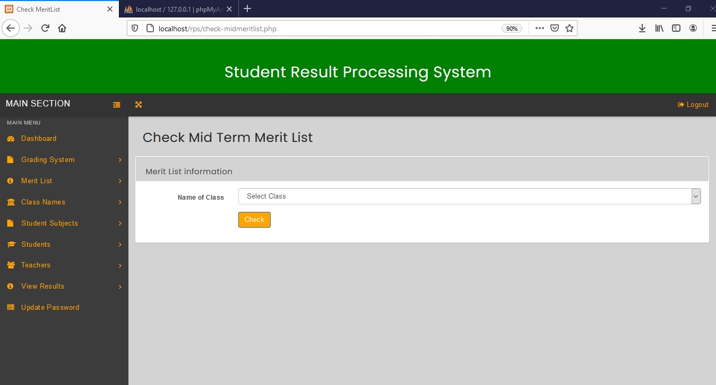

Figure 4.1.31, Check Mid Term Merit List page

Figure 6.1.32, shows the Mid Term Merit List. This merit list is produced after selecting a particular class for which you want to view a merit list for mid-term results.

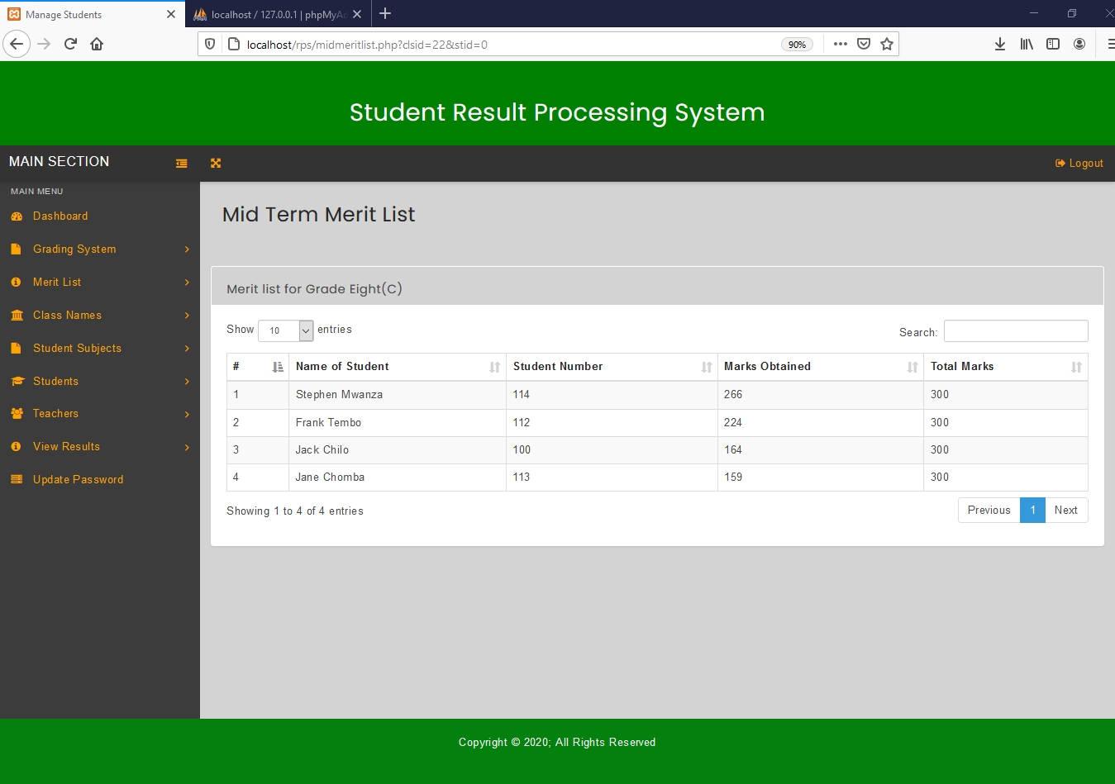

Figure 6.1.32, Mid Term Merit List page.

Figure 6.1.33, shows the update password page for the head teacher. This page allows the head teacher to change his/her password.

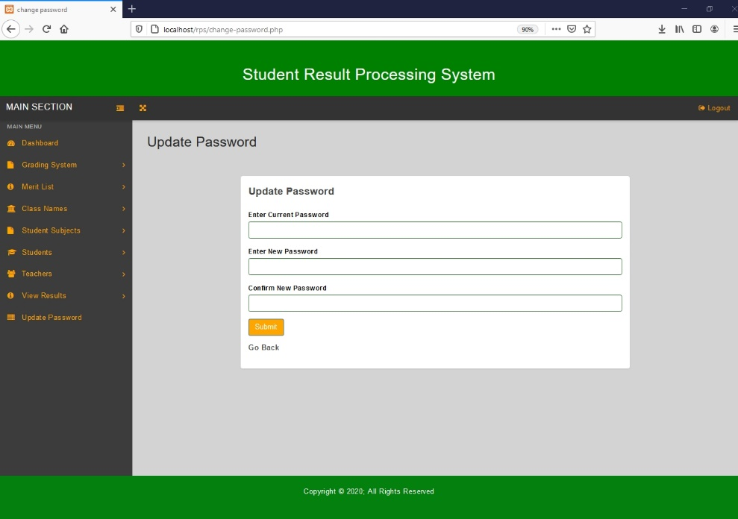

Figure 6.1.33, Update Password Page

Figure 6.1.34, shows the Head Teacher Dashboard after information has been added to the system.

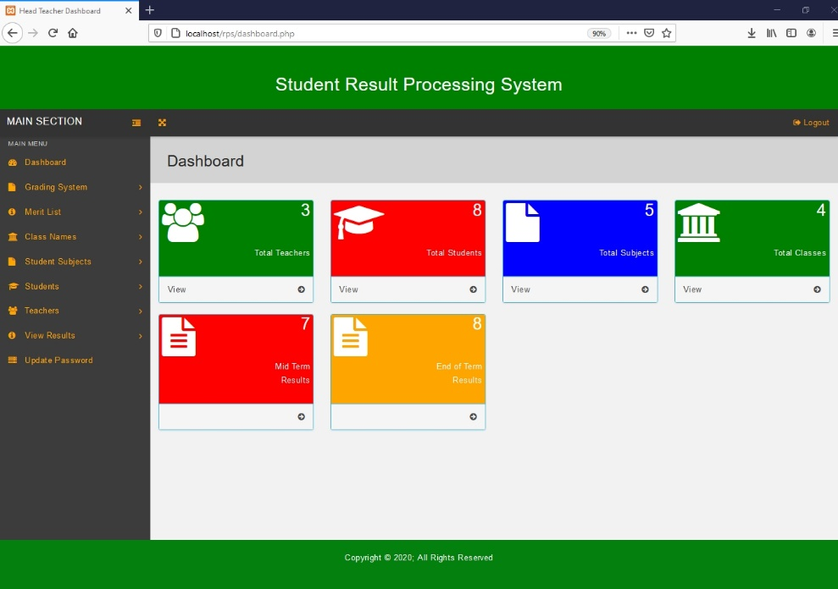

Figure 6.1.34, Head Teacher Dashboard

The Teacher Dashboard is presented in figure 6.2, which has a left navigation bar, top bar, and dashboard stats. The dashboard stats display the total number of subjects the teacher`s class has, the number of classes the class teacher is responsible for, and also the total number of published mid-term results as well as the total number of published End of term results. The teacher can click on view on the dashboard stats in order to see detailed information about the class subjects, teacher`s classes, midterm results and end of term results. Initially the dashboard stats for mid-term and end of term results will display zero because no results have been added to the system yet.

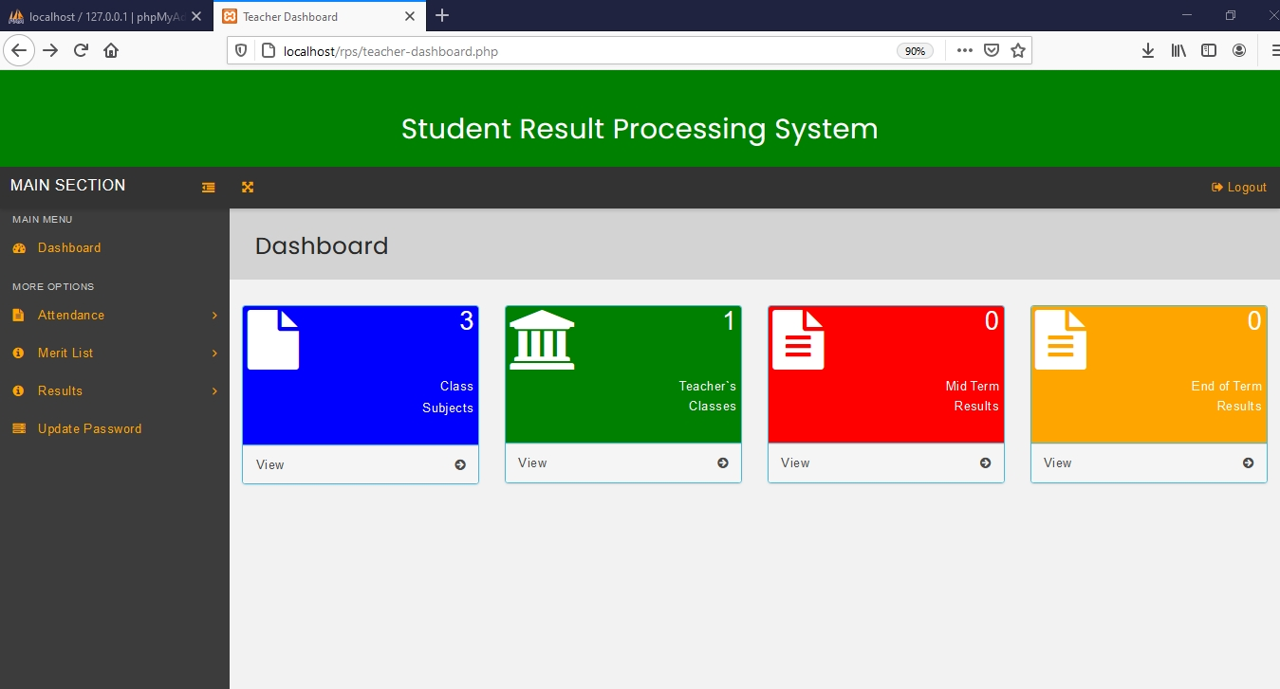

Figure 6.2, Teacher Dashboard.

Add or Edit Attendance page is presented in Figure 6.2.1. This page allows the teacher to add student attendance by clicking on ‘add’ button.

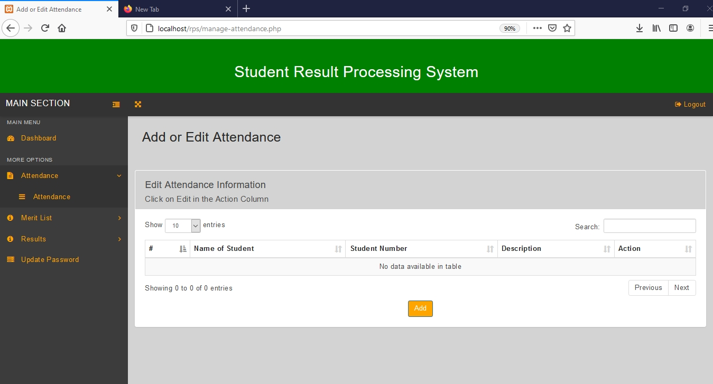

Figure 6.2.1, Add or Edit Attendance page.

Figure 6.2.2, shows the Add Attendance page for selecting student. This page allows the teacher to select a student for which he/she wants to add attendance information.

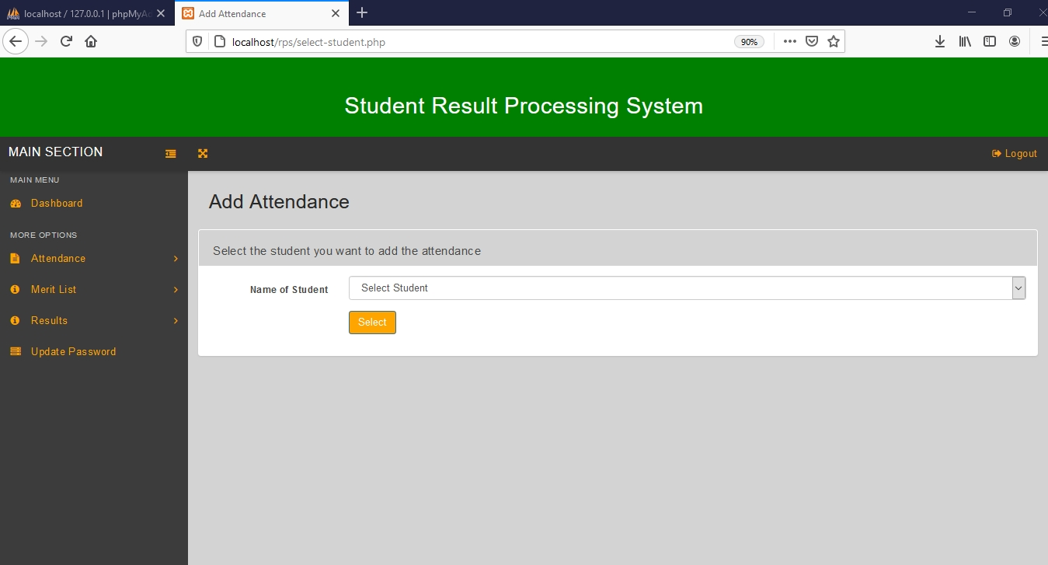

Figure 6.2.2, Add Attendance page for selecting student

Figure 6.2.3, shows the Add Attendance page, for filling attendance information. This page enables the teacher to enter attendance information for a particular student.

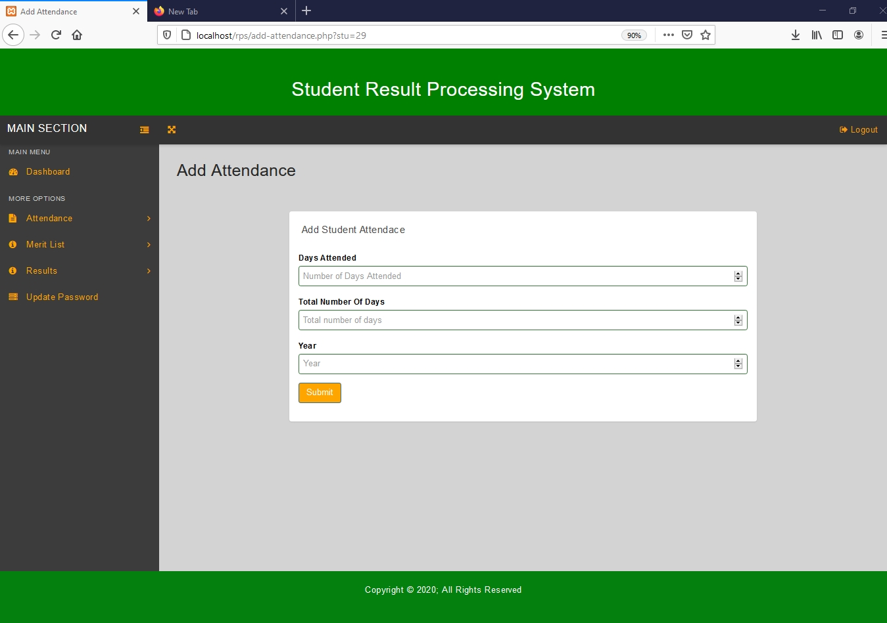

Figure 6.2.3, Add Attendance page.

Figure 6.2.4, shows the Add or Edit Attendance page, after adding student attendance information to the system. The teacher can edit or delete attendance information by clicking on edit or delete links on this page.

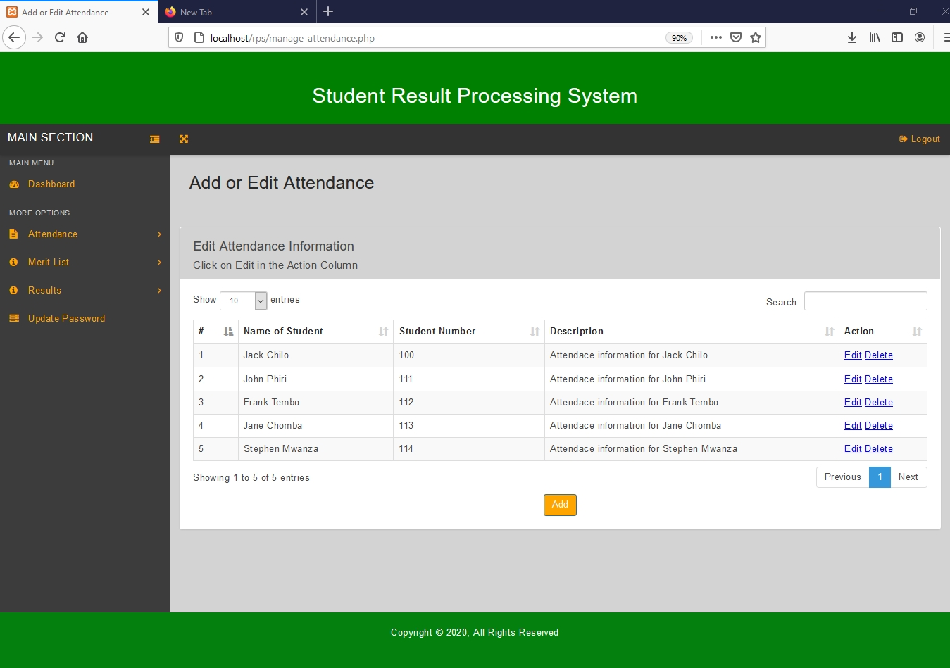

Figure 6.2.4, A filled Add or Edit Attendance page.

Edit Attendance page is presented in Figure 6.2.5. This page allows the teacher to change attendance information for a particular student.

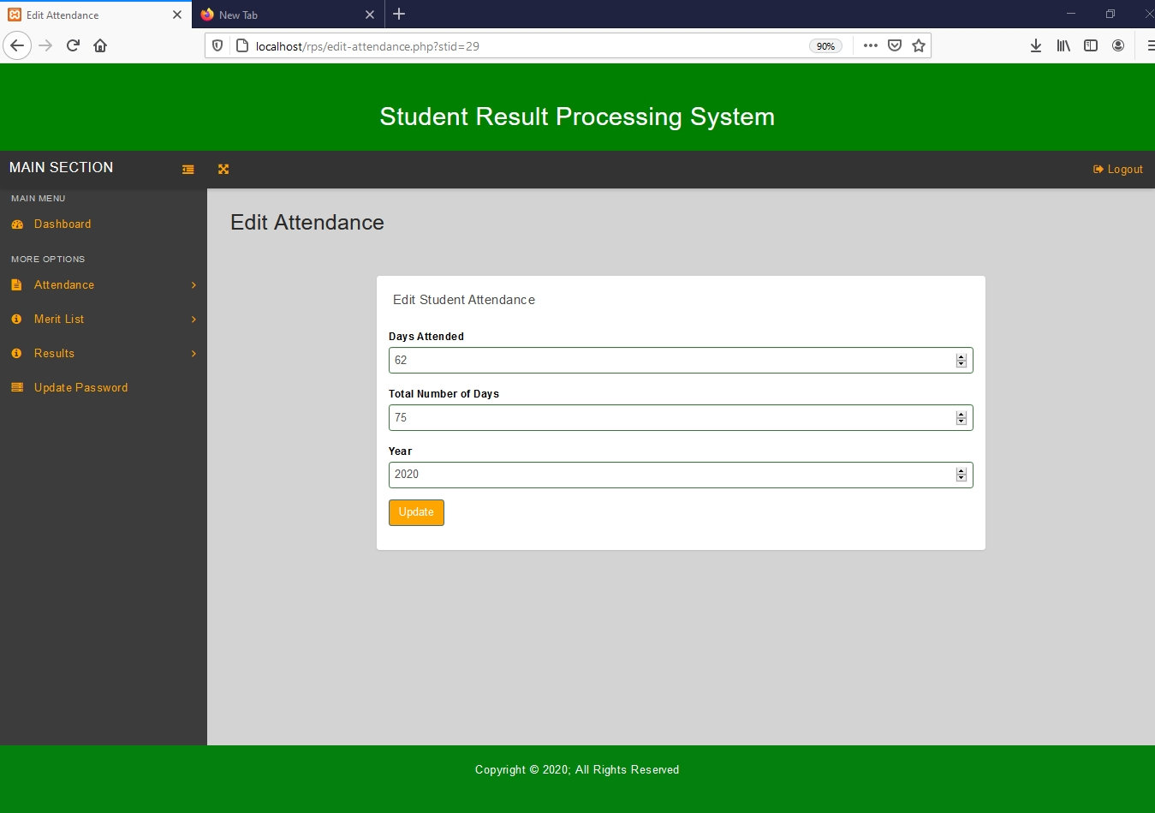

Figure 6.2.5, Edit Attendance page.

Figure 6.2.6, shows End of Term Results page. The teacher can add end of term results by clicking on ‘publish result’ button on this page.

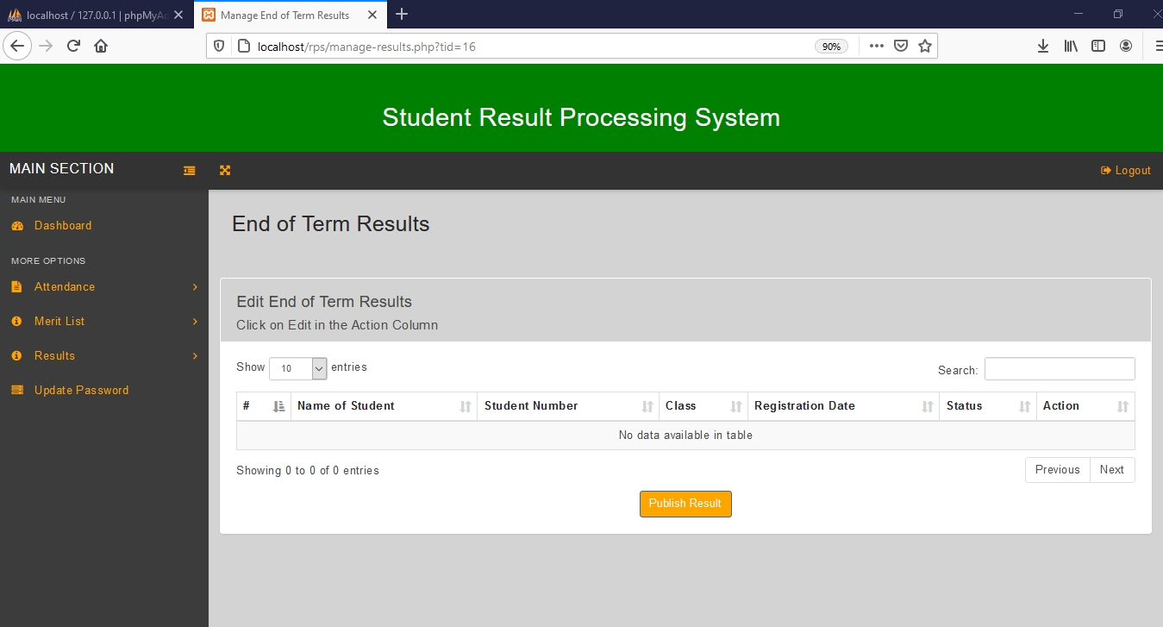

Figure 6.2.6, End of Term Results page.

Figure 6.2.7 shows the Publish End of Term Results page. This page allows the teacher to enter end of term results into the system.

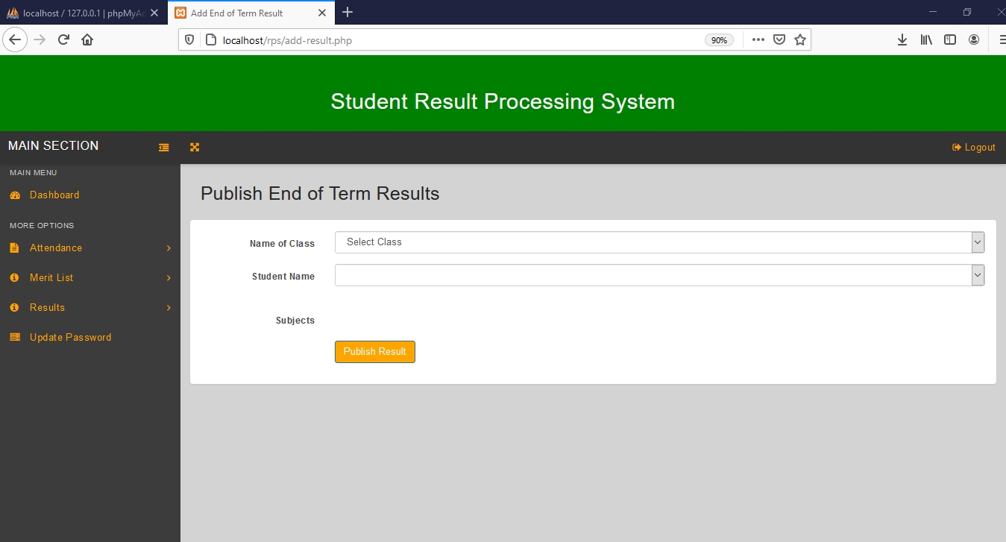

Figure 6.2.7, Publish End of Term Results page.

Figure 6.2.8, shows the Publish End of Term Results page, with input fields for entering marks that are generated based on the class selected.

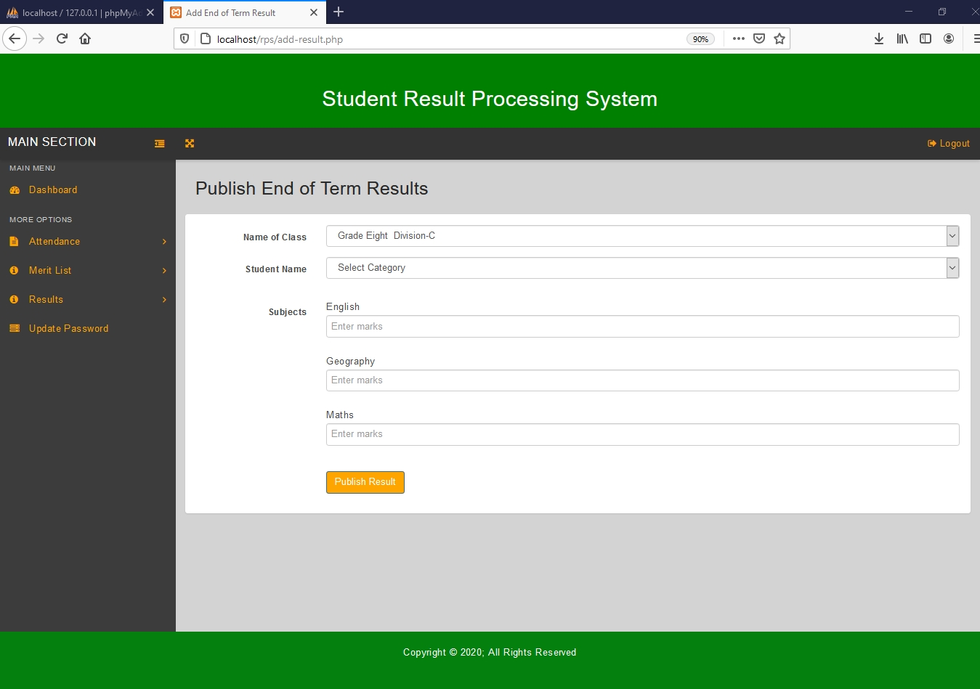

Figure 6.2.8, Publish End of Term Results Page with Subject Input Fields

Figure 6.2.9, shows the End of Term Results page after adding end of results to the system. This page shows results for two different classes. This page allows the teacher to edit or delete end of term results for his/her class only. The teacher can only view results for other classes but can`t edit or delete results belonging to a different class.

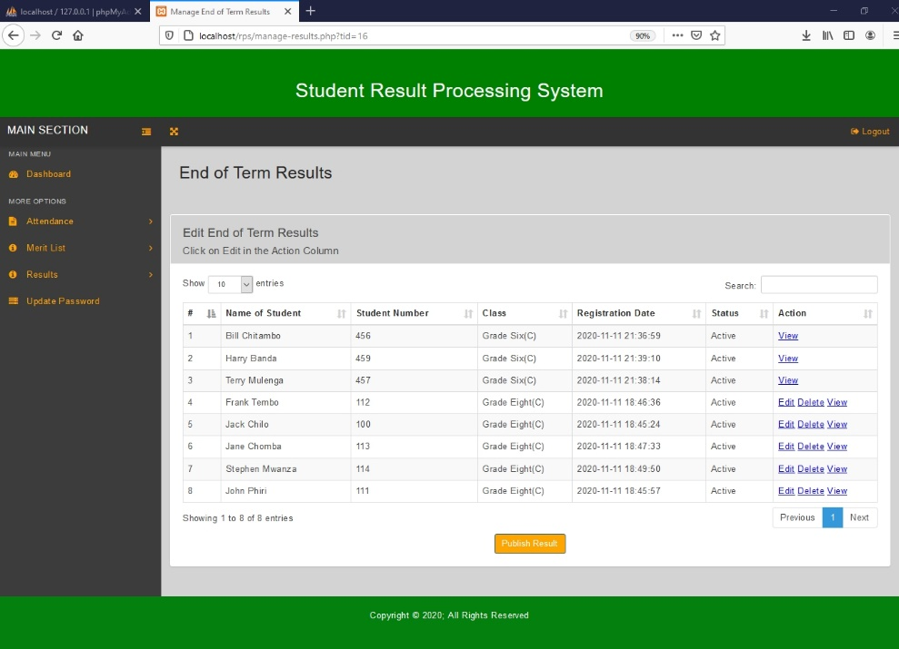

Figure 6.2.9, A filled End of Term Results page.

Figure 6.2.10, shows the Student Report Card. This Report Card shows only end of term results, because they are the only ones that have been added yet. This report card is generated after clicking the view link on the End of Term results page. The teacher can print the report card by clicking the print icon on the report card.

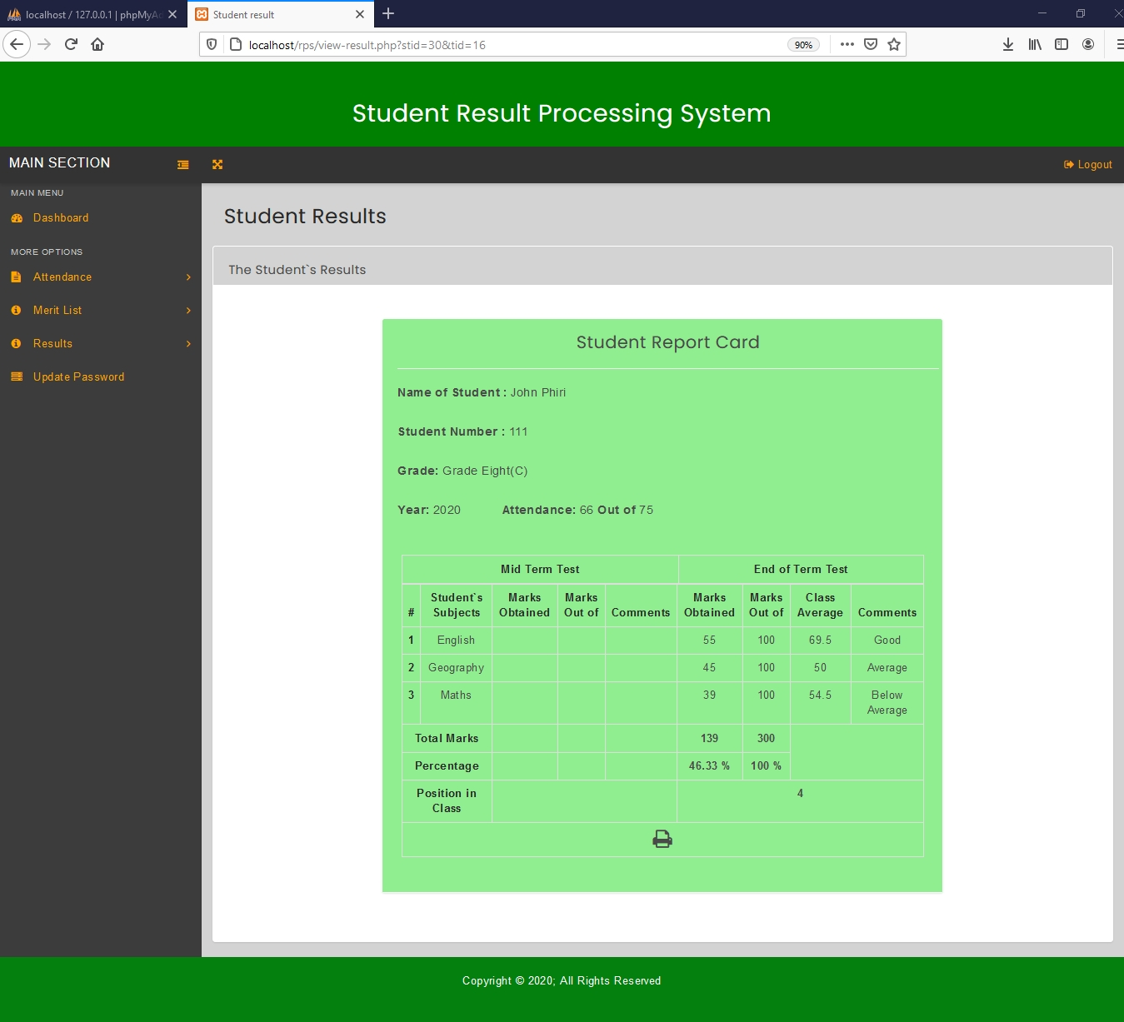

Figure 6.2.10, Student Report Card, showing only end of term results.

Edit Results page for end of term results is presented in Figure 6.2.11. This page enables the teacher to change the end of term results.

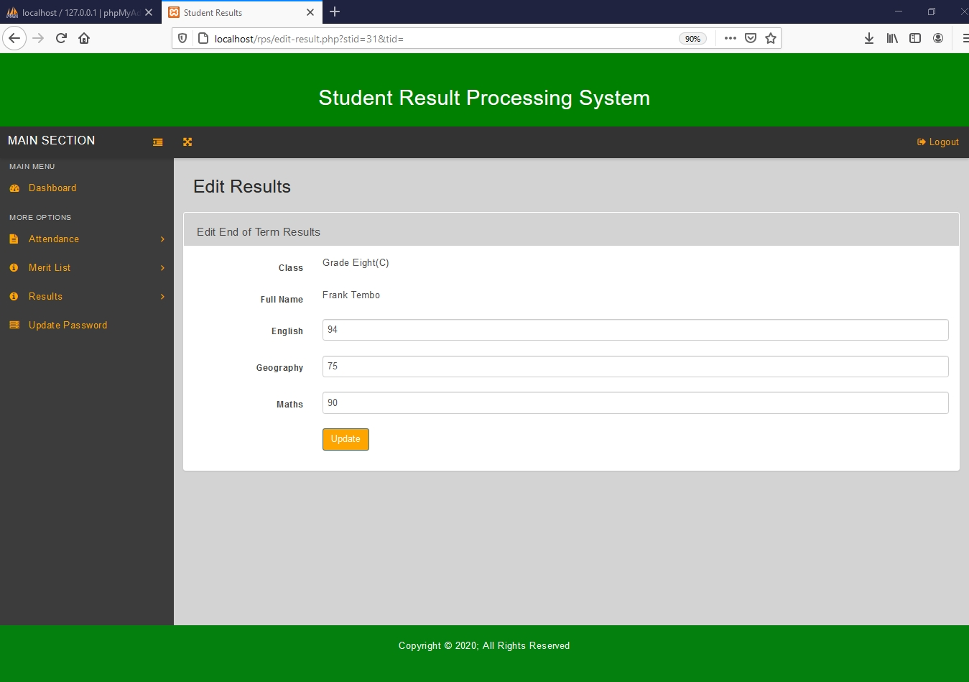

Figure 6.2.11, Edit Results page for end of term results

Figure 6.2.12, shows the Mid Term Results page. This page allows the teacher to add mid-term results by clicking on the ‘publish result’ button.

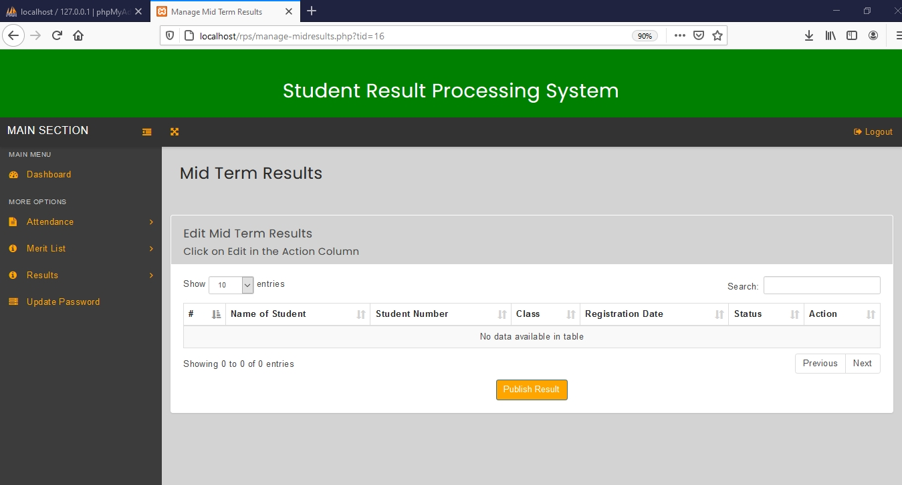

Figure 6.2.12, Mid Term Results page.

Publish Mid Term Results page is presented in Figure 6.2.13. This page allows the teacher to add mid-term results for a student by clicking on the ‘publish result’ button.

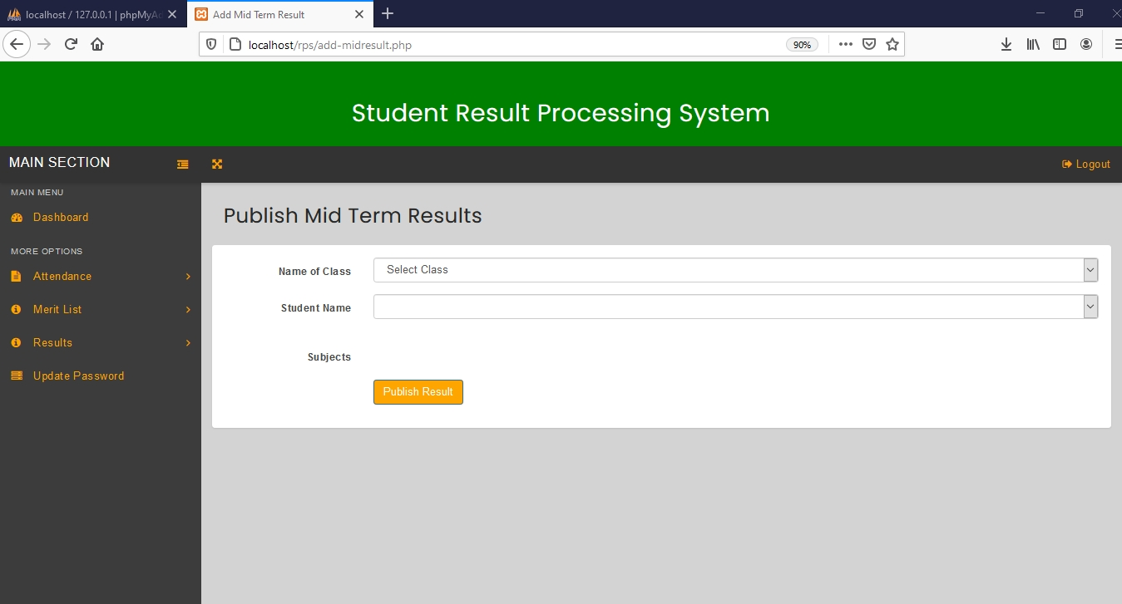

Figure 6.2.13, Publish Mid Term Results page.

Figure 6.2.14, shows the Publish Mid Term Results Page, with input fields for entering marks that are generated based on the class selected.

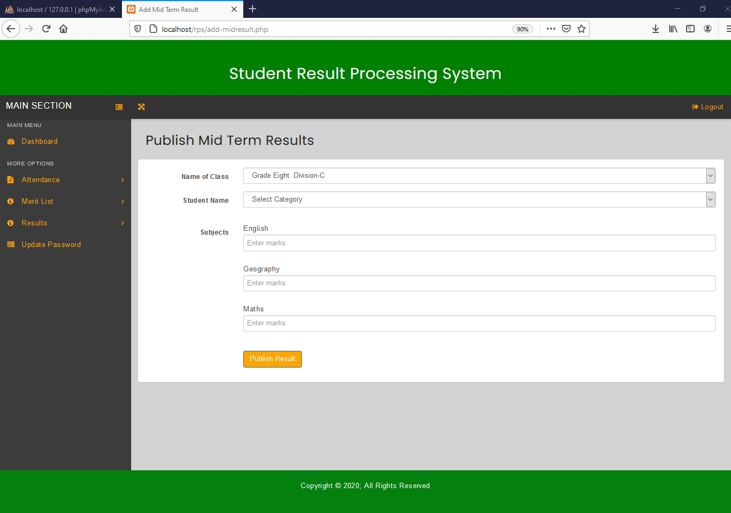

Figure 6.2.14, Publish Mid Term Results Page with Subject Input Fields.

Figure 6.2.15, shows the add Mid Term Results page, after adding mid-term results to the system. This page shows results for two different classes. This page allows the teacher to edit or delete mid-term results for his/her class only. The teacher can only view results for other classes but can`t edit or delete results belonging to a different class.

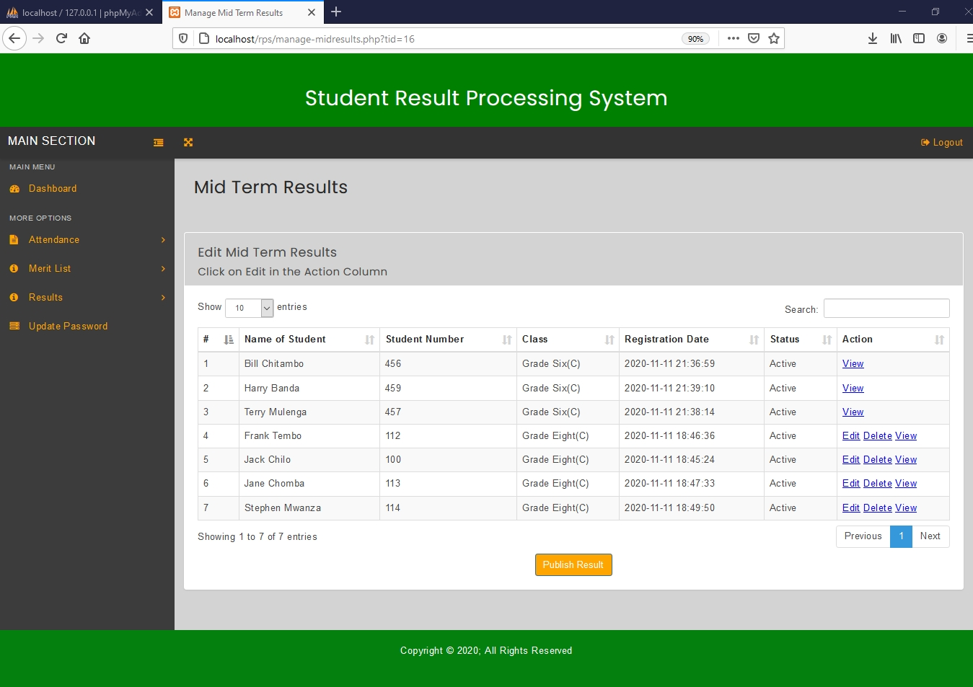

Figure 6.2.15, A filled Mid Term Results page.

Figure 6.2.16, shows the Student Report Card. This Report Card shows both mid-term results and end of term results. This is report card is generated after clicking the view link on the Mid Term Results page. The teacher can print the report card by clicking the print icon on the report card.

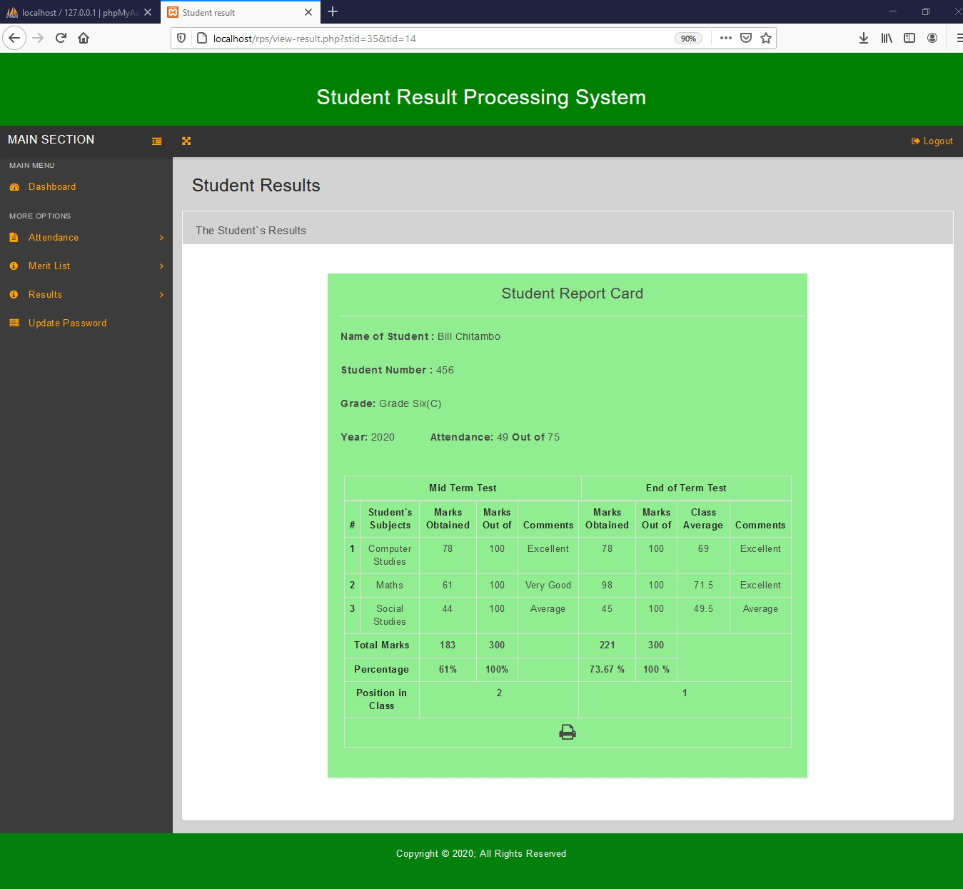

Figure 6.2.16, Student Report Card.

Edit Results page, for mid-term results is presented in Figure 6.2.17. This page enables the teacher to change mid-term results.

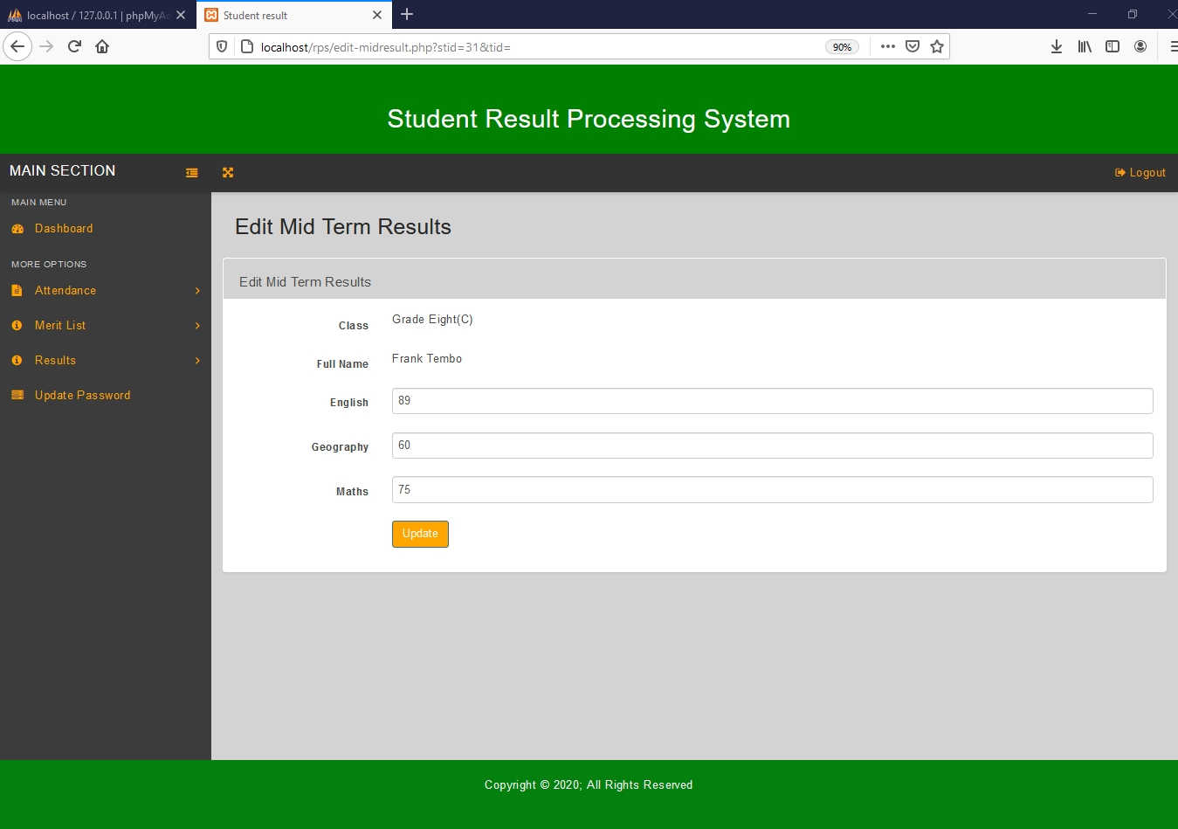

Figure 6.2.17, Edit Mid Term Results page.

Figure 6.2.18, shows the Check End of Term Merit List page. This page allows the teacher to select a class for which he/she wants to view the end of term merit list.

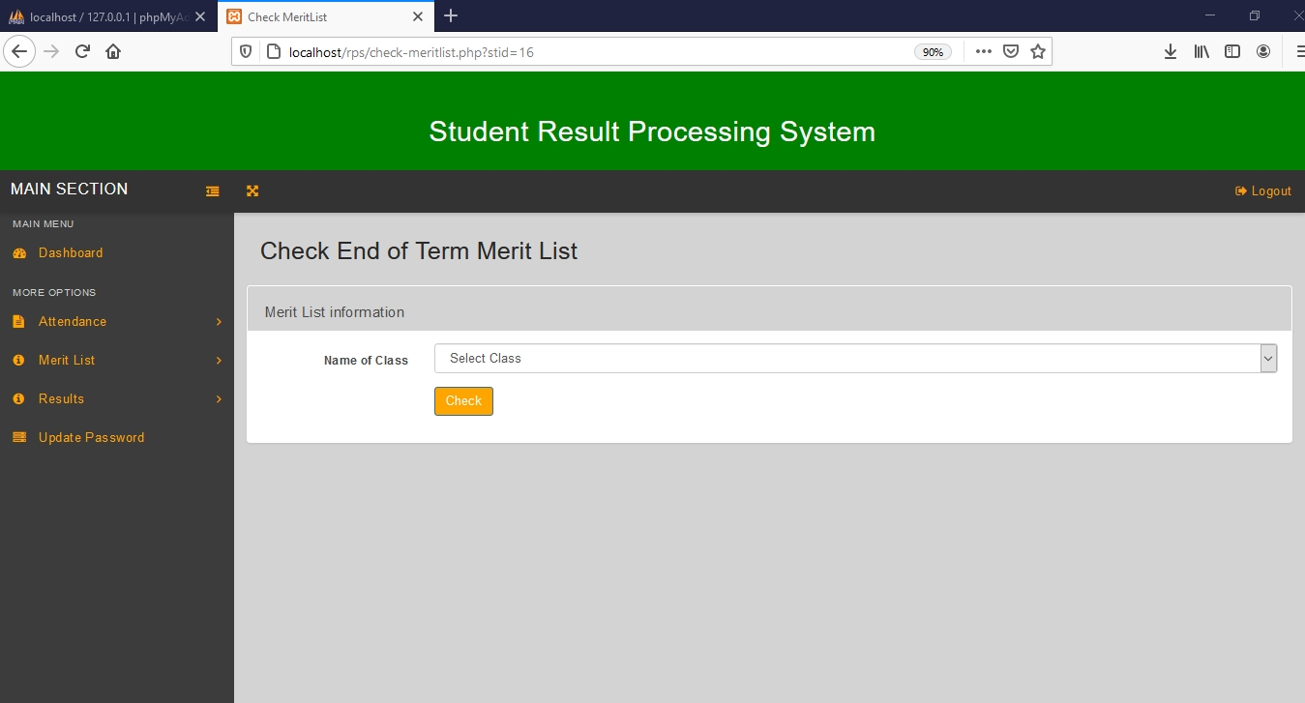

Figure 6.2.18, Check End of Term Merit List page

Figure 6.2.19, shows the End of Term Merit List. This merit list is generated after selecting a particular class for which you want to view a merit list for end of term results.

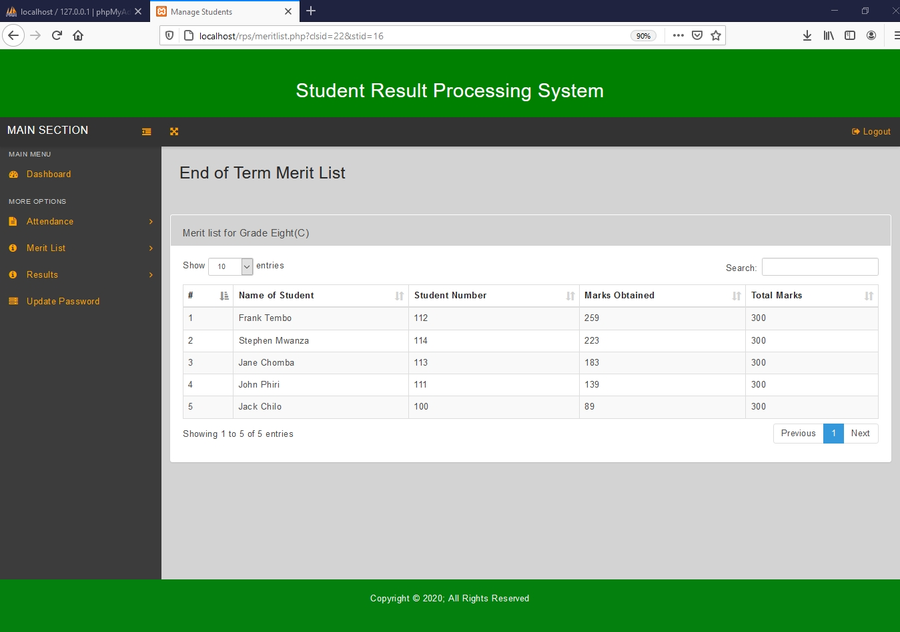

Figure 6.2.19, End of Term Merit List.

Figure 6.2.20, shows the Check Mid Term Merit List page. This page allows the teacher to select a class for which he/she wants to view the merit list for mid-term results.

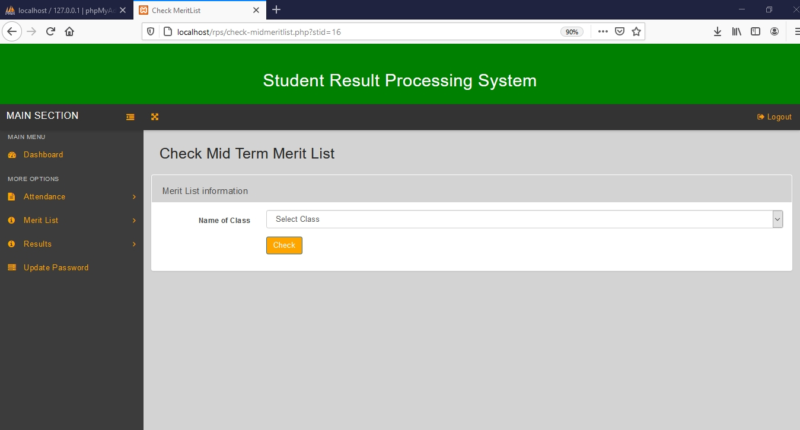

Figure 6.2.20, Check Mid Term Merit List page.

Figure 6.2.21, shows the Mid Term Merit List. This merit list is produced after the teacher selects a particular class for which he/she wants to view a merit list for mid-term results.

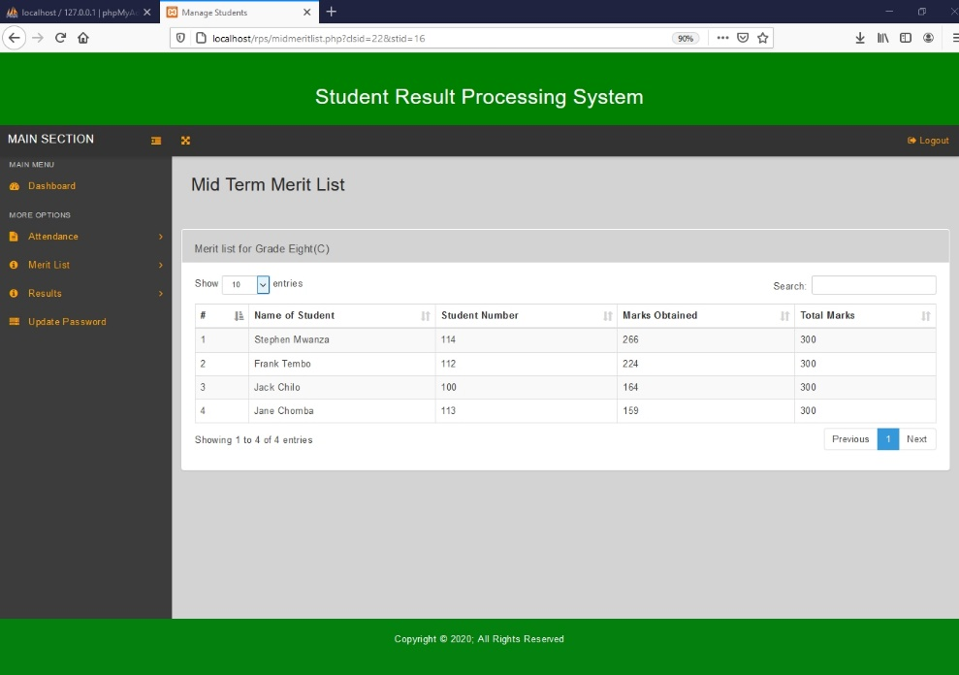

Figure 6.2.21, Mid Term Merit List.

Figure 6.2.22, shows the Update Password Page for teachers. This page allows the teacher to change his/her password.

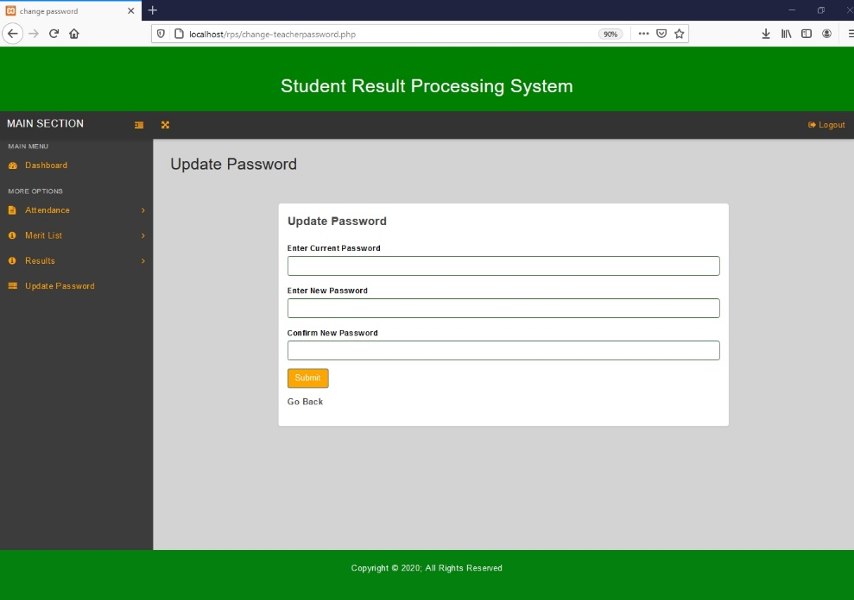

Figure 6.2.22 Update Password Page for Teachers.

Figure 6.2.23, shows the Teacher Dashboard after student results have been added to the system.

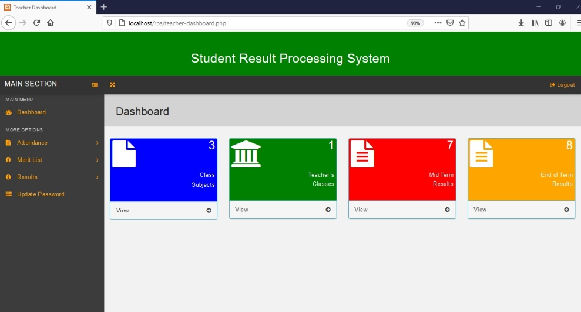

Figure 6.2.23, Teacher Dashboard.

Figure 6.3 shows the report card for the student that is automatically generated by the system in the student portal. This report card displays both end of term and mid-term results because both of these results have been published. In addition to viewing report card, the student can print results by clicking on the print icon on the report card or update password by clicking on the gear icon at the top bar.

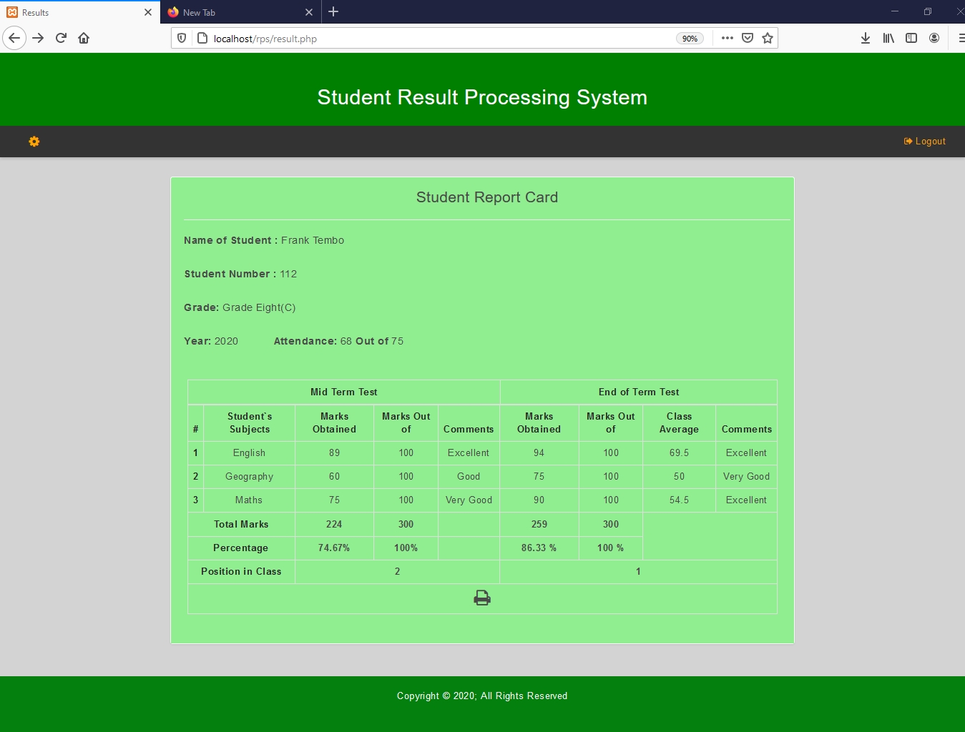

Figure 6.3, Student Report Card Generated by the Student Portal.

Figure 6.3.1, shows the Print Pop Up Window that is generated after the student clicks on the print icon on the report card. The student can click on ‘print’ on this Pop Up Window in order to print the report card.

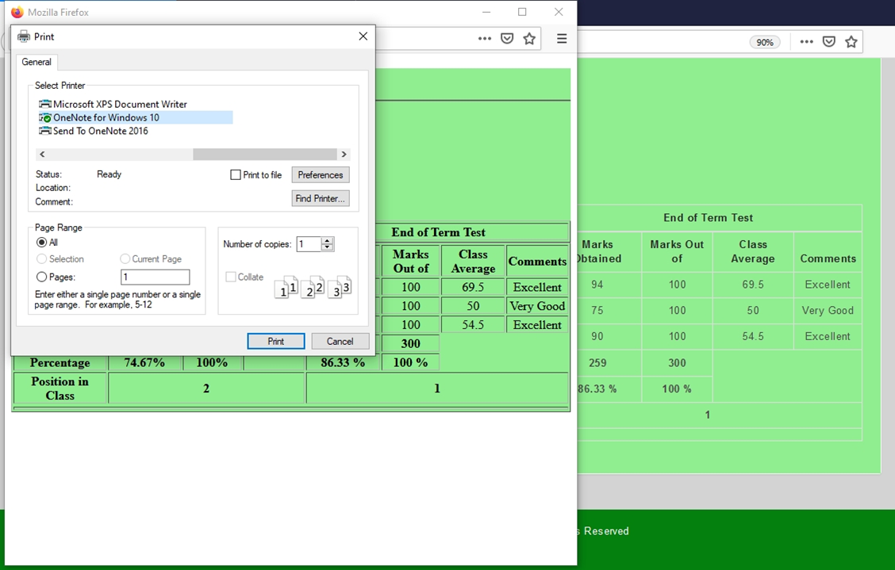

Figure 6.3.1 Print Pop Up Window

Figure 6.3.2, shows the Update Password Page for students. This page allows the student to change his/her password.

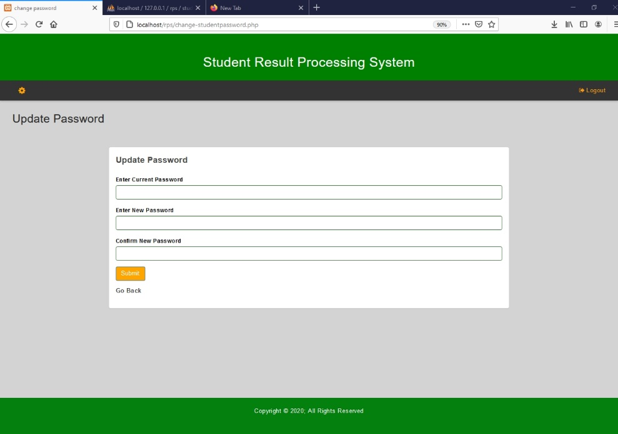

Figure 6.3.2, Update Password Page for Students.

**7 System Testing**

**7.1 Introduction**

System Testing is a level of testing that validates the complete and fully integrated software product. The purpose of a system test is to evaluate the end-to-end system specifications. Usually, the software is only one element of a larger computer-based system. Ultimately, the software is interfaced with other software/hardware systems. System Testing is actually a series of different tests whose sole purpose is to test the full computer-based system.

There are two categories of software testing. These include:

* Black Box Testing
* White Box Testing

White box testing is the testing of the internal workings or code of a software application. It takes into account the internal mechanism of a system or component.

In contrast, black box testing involves the external workings of the software from the user's perspective. It ignores the internal mechanism of a system or component and focuses solely on the outputs generated in response to selected inputs and execution conditions.

System test falls under the black box testing category of software testing.

System testing involves testing the software code for following:

* Testing the fully integrated applications including external peripherals in order to check how components interact with one another and with the system as a whole. This is also called End to End testing scenario.
* Verify thorough testing of every input in the application to check for desired outputs.
* Testing of the user's experience with the application.

This is a very basic description of what is involved in system testing. Detailed test cases and test suites must be built that test each aspect of the application as seen from the outside without looking at the actual source code.

Black box testing was mainly used to test this student result processing system.

**7.2 Test Cases**

A test case is a specification of the inputs, execution conditions, testing procedure, and expected results that define a single test to be executed to achieve a particular software testing objective, such as to exercise a particular program path or to verify compliance with a specific requirement. It is a set of actions executed to verify a particular feature or functionality of the software application.

In Table 13.0, test cases for each of the requirements are given. For each of them, T.C No, Description of Requirement, Expected Outcome, Actual Test Outcome and Result are shown. A T.C No (Test Case Number) is the number that is assigned to each test case. Description of requirement describes the software requirement. Expected outcome is the outcome that is expected. Actual Test Outcome is the actual outcome after carrying out the test for a particular test case. Result shows the if the requirement was met or not, did the test case pass or fail?

**Table 13.0: Test cases.**

|  |  |  |  |  |
| --- | --- | --- | --- | --- |
| **T.C.**  **No** | **Description of Requirement** | **Expected Outcome** | **Actual Test Outcome** | **Result** |
| 1 | All users must be able to login into the system | Users successfully logging into the system | All types of users were able to successfully login into the system | Pass |
| 2 | Head teacher must be able to add, edit and delete grading pattern | Head teacher successfully adding, editing and deleting grading pattern | Head teacher was able to successfully add, edit and delete grading pattern | Pass |
| 3 | Head teacher must be able to view merit list for end of term results | Head teacher successfully viewing merit list for end of term results | Head teacher was able to successfully view merit list for end of term results | Pass |
| 4 | Head teacher must be able to add, edit or delete classes | Head teacher successfully adding, editing and deleting classes | Head teacher was able to successfully add, edit and delete classes | Pass |
| 5 | Head teacher must be able to add, edit and delete students. | Head teacher successfully adding, editing and deleting students. | Head teacher was able to successfully add, edit and delete students. | Pass |
| 6 | Teacher must be able to view and update end of term results for students who belong to his/her class. | Teacher successfully viewing and updating end of term results of students who belong to his/her class. | Teacher was able to successfully view and update end of term results of students who belong to his class. | Pass |
| 7 | Teacher must be able update his/her own password | Teacher successfully updating his/her own password | Teacher was able to successfully update his own password | Pass |
| 8 | Teacher must be able to view and update mid-term results for students who belong to his/her class. | Teacher successfully viewing and updating mid-term results of students who belong to his/her class. | Teacher was able to successfully view and update mid-term results of students who belong to his class. | Pass |
| 9 | Head teacher must be able to view merit list for mid-term results | Head teacher successfully viewing merit list for mid-term results | Head teacher was able to successfully view merit list for mid-term results | Pass |
| 10 | System must be able to automatically compute Total Marks, Percentage of Total Marks, Class Average and Position in Class for each student. | System automatically computing Total Marks, Percentage of Total Marks, Class Average and Position in Class for each student. | The System was able to automatically compute Total Marks, Percentage of Total Marks, Class Average and Position in Class for each student. | Pass |
| 11 | Head teacher must be able to add, edit and delete teachers | Head teacher successfully adding, editing and deleting teachers | Head teacher was able to successfully add, edit and delete teachers | Pass |
| 12 | System must be able to automatically analyze student performance in a specific subject by generating comments. | System automatically analyzing student performance in a specific subject by generating comments. | The system was able to automatically analyze student performance in a specific subject by generating comments. | Pass |
| 13 | Head teacher must be able to view student report cards | Head teacher successfully viewing student report cards | Head teacher was able to successfully view student report cards | Pass |
| 14 | System must be able to automatically generate report card | System automatically generating report card | System was able to automatically generate report card | Pass |
| 15 | Head teacher must be able to print student report cards | Head teacher successfully printing report cards | Head teacher was able to successfully print report cards | Pass |
| 16 | Student must be able to view his/her results. | Student successfully viewing his/her results. | The student was able to successfully view his results. | Pass |
| 17 | System must be able to automatically generate merit list for end of term results | System automatically generating merit list for end of term results | The system was able to automatically generate merit list for end of term results | Pass |
| 18 | Head teacher must be able to add, edit and delete subjects | Head teacher successfully adding, editing and deleting subjects | Head teacher was able to successfully add, edit and delete subjects | Pass |
| 19 | Student must be able to print his/her report card. | Student successfully printing his/her report card | Student was able to successfully print his report card | Pass |
| 20 | Teacher must be able to add, edit and delete student attendance information | Teacher successfully adding, editing and deleting student attendance information | The teacher was able to successfully add, edit and delete student attendance information | Pass |
| 21 | System must be able to automatically generate merit list for mid-term results | System automatically generating merit list for mid-term results | The system was able to automatically generate merit list for mid-term results | Pass |
| 22 | Teacher must be able to print student report card | Teacher successfully printing student report card | Teacher was able to successfully print student report card. | Pass |
| 23 | Teacher must be able to view merit list for end of term results | Teacher successfully viewing merit list for end of term results | Teacher was able to successfully view merit list for end of term results | Pass |
| 24 | Head teacher must be able to add and delete class and subject combination records. | Head teacher successfully adding and deleting class and subject combination records. | Head teacher was able successfully add and delete class and subject combination records. | Pass |
| 25 | Teacher must not be able to edit and delete results of students who belong to another class | Teacher not being able to edit and delete results of students who belong to another class | Teacher was unable to edit and delete results of students who belong to another class | Pass |
| 26 | Head teacher must not be able to edit and delete results | Head teacher not being able to edit and delete results | Head teacher was unable to edit and delete results | Pass |
| 27 | Head teacher must be able update his/ her own password | Head teacher successfully updating his/her own password | The head teacher was able to successfully update his own password | Pass |
| 28 | Student must be able update his/ her own password | Student successfully updating his/her own password | Student was able to successfully update his own password | Pass |
| 29 | Teacher must be able to view merit list for mid-term results | Teacher successfully viewing merit list for mid-term results | The teacher was able to successfully view merit list for mid-term results | Pass |

**8 Conclusion**

In this paper, development of the student result processing system is presented.  
The software is meant to address the challenges that the primary and secondary school teachers often face in analyzing student results and producing student report cards. In order to address these challenges, the Student Result Processing system was developed. The Student Result Processing System was developed using PHP, MySQL, HTML, CSS, JavaScript and was hosted locally using XAMPP. A Participatory Incremental Process Model (PIP Model) was used as the software development methodology. The student result processing system was functionally decomposed into its key modules which were used to explain the major functionalities offered by the system. A use case diagram was also used to show the different categories of the system users and the various functionalities associated with a different system user.

9 Schedule

Table 14.0 shows the schedule of the project

Table 14.0: Project Schedule

|  |  |  |  |
| --- | --- | --- | --- |
| Task Name | Duration | Start | Finish |
| **PROJECT START** | **26 days** | **Fri 7/10/20** | **Fri 8/14/20** |
| Project Registration | 1 day | Fri 7/10/20 | Fri 7/10/20 |
| First Draft Proposal | 2 days | Mon 7/13/20 | Tue 7/14/20 |
| Second Draft Proposal | 3 days | Wed 7/15/20 | Fri 7/17/20 |
| Project Proposal PowerPoint Presentation submission | 1 day | Thu 7/16/20 | Thu 7/16/20 |
| Project Proposal Presentation | 1 day | Fri 7/17/20 | Fri 7/17/20 |
| Submission of Final Project Proposal | 1 day | Fri 7/24/20 | Fri 7/24/20 |
| Requirements Elicitation | 7 days | Mon 7/27/20 | Tue 8/4/20 |
| System Design | 7 days | Wed 8/5/20 | Thu 8/13/20 |
| Submission of full System Design | 1 day | Fri 8/14/20 | Fri 8/14/20 |
| **FRONT END(GUI)** | **42 days** | **Mon 8/17/20** | **Tue 10/13/20** |
| login Page and Main Menu | 14 days | Mon 8/17/20 | Thu 9/3/20 |
| Student, Subject and Class sections | 14 days | Fri 9/4/20 | Wed 9/23/20 |
| Results and teacher sections | 14 days | Thu 9/24/20 | Tue 10/13/20 |
| **BACK END(DATABASE)** | **28 days** | **Wed 10/14/20** | **Wed 11/18/20** |
| Teachers and students tables | 14 days | Wed 10/14/20 | Fri 10/30/20 |
| Class and Class-subjects tables | 7 days | Sat 10/31/20 | Mon 11/9/20 |
| subjects and results tables | 7 days | Tue 11/10/20 | Wed 11/18/20 |
| **STYLING** | **7 days** | **Thu 11/19/20** | **Fri 11/27/20** |
| Bootscrap | 7 days | Thu 11/19/20 | Fri 11/27/20 |
| **TESTING** | **7 days** | **Mon 11/30/20** | **Tue 12/8/20** |
| System Testing | 7 days | Mon 11/30/20 | Tue 12/8/20 |
| **PROJECT FINISH** | **5 days** | **Mon 12/14/20** | **Fri 12/18/20** |
| Submission of Full Thesis | 1 day | Mon 12/14/20 | Mon 12/14/20 |
| Final Project Presentation | 1 day | Fri 12/18/20 | Fri 12/18/20 |
| End of Project | 0 days | Fri 12/18/20 | Fri 12/18/20 |

**10. Appendices**

**10.1 Appendix 1 ‐ Domain Terms**

A **Result Processing System** is a software product that is usually used in learning institutions for storing records of students. Results of students can be stored and different operations can be performed on the results through database management software.

**XAMPP** is a free and open-source cross-platform web server solution stack package developed by Apache Friends, consisting mainly of the Apache HTTP Server, MariaDB database, and interpreters for scripts written in PHP and Perl programming languages.

An **Information System** is an integrated set of components for collecting, storing, and processing data and for delivering information, knowledge, and digital  
products.

A **progress report** is a document that explains in detail how you far you've gone towards the completion of a project. It outlines the activities you've carried out, the tasks you've completed, and the milestones you've reached via your project plan.

A **Merit list** is a list of pupils selected and ranked according to the marks achieved in an academic examination or set of examinations.

A **Learning Management System (LMS)** is a software application used for the administration, documentation, tracking, reporting, automation and delivery of educational courses or training programs.

A **Report Card** is a teacher's written assessment of a pupil's results, progress, or conduct, that is sent home to a parent or guardian.

**10.2 Appendix 2 – Selected Program Source Code**

**index.php**

<?php

session_start();

error_reporting(0);

include('includes/config.php');

if($_SESSION['alogin']!=''){

$_SESSION['alogin']='';

}

if(isset($_POST['login']))

{

$uname=$_POST['username'];

$password=md5($_POST['password']);

$sql ="SELECT UserName,Password FROM headteacher WHERE UserName=:uname and Password=:password";

$query= $dbh -> prepare($sql);

$query-> bindParam(':uname', $uname, PDO::PARAM_STR);

$query-> bindParam(':password', $password, PDO::PARAM_STR);

$query-> execute();

$results=$query->fetchAll(PDO::FETCH_OBJ);

if($query->rowCount() > 0)

{

$_SESSION['alogin']=$_POST['username'];

echo "<script type='text/javascript'> document.location = 'dashboard.php'; </script>";

} else{

$sql ="SELECT UserName,Password FROM teachers WHERE UserName=:uname and Password=:password";

$query= $dbh -> prepare($sql);

$query-> bindParam(':uname', $uname, PDO::PARAM_STR);

$query-> bindParam(':password', $password, PDO::PARAM_STR);

$query-> execute();

$results=$query->fetchAll(PDO::FETCH_OBJ);

if($query->rowCount() > 0)

{

$_SESSION['alogin']=$_POST['username'];

echo "<script type='text/javascript'> document.location = 'teacher-dashboard.php'; </script>";

} else{

$sql ="SELECT RollId,Password FROM students WHERE RollId=:uname and Password=:password";

$query= $dbh -> prepare($sql);

$query-> bindParam(':uname', $uname, PDO::PARAM_STR);

$query-> bindParam(':password', $password, PDO::PARAM_STR);

$query-> execute();

$results=$query->fetchAll(PDO::FETCH_OBJ);

if($query->rowCount() > 0)

{

$_SESSION['alogin']=$_POST['username'];

echo "<script type='text/javascript'> document.location = 'result.php'; </script>";

} else{

echo "<script>alert('Invalid Login Details');</script>"

}

}

}

}

**add-students.php**

<?php

session_start();

error_reporting(0);

include('includes/config.php');

if(strlen($_SESSION['alogin'])=="")

{

header("Location: index.php");

}

else{

if(isset($_POST['submit']))

{

$studentname=$_POST['fullanme'];

$roolid=$_POST['rollid'];

$studentemail=$_POST['emailid'];

$gender=$_POST['gender'];

$classid=$_POST['class'];

$dob=$_POST['dob'];

$status=1;

$sql="INSERT INTO students(StudentName,RollId,StudentEmail,Gender,ClassId,DOB,Status) VALUES(:studentname,:roolid,:studentemail,:gender,:classid,:dob,:status)";

$query = $dbh->prepare($sql);

$query->bindParam(':studentname',$studentname,PDO::PARAM_STR);

$query->bindParam(':roolid',$roolid,PDO::PARAM_STR);

$query->bindParam(':studentemail',$studentemail,PDO::PARAM_STR);

$query->bindParam(':gender',$gender,PDO::PARAM_STR);

$query->bindParam(':classid',$classid,PDO::PARAM_STR);

$query->bindParam(':dob',$dob,PDO::PARAM_STR);

$query->bindParam(':status',$status,PDO::PARAM_STR);

$query->execute();

$lastInsertId = $dbh->lastInsertId();

if($lastInsertId)

{

$msg="The student has been added successfully";

}

else

{

$error="An error occured. Try again!";

}

}

?>

<!DOCTYPE html>

<html lang="en">

<head>

<meta charset="utf-8">

<meta http-equiv="X-UA-Compatible" content="IE=edge">

<meta name="viewport" content="width=device-width, initial-scale=1">

<title>Add Student</title>

<link rel="stylesheet" href="css/bootstrap.min.css" media="screen" >

<link rel="stylesheet" href="css/font-awesome.min.css" media="screen" >

<link rel="stylesheet" href="css/animate-css/animate.min.css" media="screen" >

<link rel="stylesheet" href="css/lobipanel/lobipanel.min.css" media="screen" >

<link rel="stylesheet" href="css/prism/prism.css" media="screen" >

<link rel="stylesheet" href="css/select2/select2.min.css" >

<link rel="stylesheet" href="css/main.css" media="screen" >

<link rel="stylesheet" type="text/css" href="css/customized.css">

<script src="js/modernizr/modernizr.min.js"></script>

</head>

<body>

<?php include('includes/titlebar.php');?>

<div class="">

<div class="main-wrapper">

<!-- ========== TOP NAVBAR ========== -->

<?php include('includes/topbar.php');?>

<!-- ========== WRAPPER FOR BOTH SIDEBARS & MAIN CONTENT ========== -->

<div class="content-wrapper">

<div class="content-container">

<!-- ========== LEFT SIDEBAR ========== -->

<?php include('includes/leftbar.php');?>

<!-- /.left-sidebar -->

<div class="main-page" style=background-color:lightgray>

<div class="container-fluid">

<div class="row page-title-div" style=background-color:lightgray>

<div class="col-md-6">

<h2 class="title">Add Student</h2>

</div>

<!-- /.col-md-6 text-right -->

</div>

<!-- /.row -->

</div>

<div class="container-fluid">

<div class="row">

<div class="col-md-12">

<div class="panel">

<div class="panel-heading" style=background-color:lightgray>

<div class="panel-title">

<h5>Add Student information</h5>

</div>

</div>

<div class="panel-body">

<?php if($msg){?>

<div class="alert alert-success left-icon-alert" role="alert">

<strong>Congratulations!</strong><?php echo htmlentities($msg); ?>

</div><?php }

else if($error){?>

<div class="alert alert-danger left-icon-alert" role="alert">

<strong>Sorry!</strong> <?php echo htmlentities($error); ?>

</div>

<?php } ?>

<form class="form-horizontal" method="post">

<div class="form-group">

<label for="default" class="col-sm-2 control-label">Student Full Name</label>

<div class="col-sm-10">

<input type="text" name="fullanme" class="form-control" id="fullanme" required="required" autocomplete="off">

</div>

</div>

<div class="form-group">

<label for="default" class="col-sm-2 control-label">Student Number</label>

<div class="col-sm-10">

<input type="text" name="rollid" class="form-control" id="rollid" maxlength="5" required="required" autocomplete="off">

</div>

</div>

<div class="form-group">

<label for="default" class="col-sm-2 control-label">Student Email</label>

<div class="col-sm-10">

<input type="email" name="emailid" class="form-control" id="email" required="required" autocomplete="off">

</div>

</div>

<div class="form-group">

<label for="default" class="col-sm-2 control-label">Student`s Gender</label>

<div class="col-sm-10">

<input type="radio" name="gender" value="Male" required="required" checked="">Male <input type="radio" name="gender" value="Female" required="required">Female <input type="radio" name="gender" value="Other" required="required">Other

</div>

</div>

<div class="form-group">

<label for="default" class="col-sm-2 control-label">Student`s Class</label>

<div class="col-sm-10">

<select name="class" class="form-control" id="default" required="required">

<option value="">Select Class</option>

<?php $sql = "SELECT * from classes";

$query = $dbh->prepare($sql);

$query->execute();

$results=$query->fetchAll(PDO::FETCH_OBJ);

if($query->rowCount() > 0)

{

foreach($results as $result)

{ ?>

<option value="<?php echo htmlentities($result->id); ?>"><?php echo htmlentities($result->ClassName); ?>&nbsp; Division-<?php echo htmlentities($result->Section); ?></option>

<?php }} ?>

</select>

</div>

</div>

<div class="form-group">

<label for="date" class="col-sm-2 control-label">Date of Birth</label>

<div class="col-sm-10">

<input type="date" name="dob" class="form-control" id="date">

</div>

</div>

<div class="form-group">

<div class="col-sm-offset-2 col-sm-10">

<button type="submit" name="submit" class="btn btn-primary" style=background-color:orange>Submit</button>

</div>

</div>

</form>

</div>

</div>

</div>

<!-- /.col-md-12 -->

</div>

</div>

</div>

<!-- /.content-container -->

</div>

<!-- /.content-wrapper -->

</div>

<!-- /.main-wrapper -->

<script src="js/jquery/jquery-2.2.4.min.js"></script>

<script src="js/bootstrap/bootstrap.min.js"></script>

<script src="js/pace/pace.min.js"></script>

<script src="js/lobipanel/lobipanel.min.js"></script>

<script src="js/iscroll/iscroll.js"></script>

<script src="js/prism/prism.js"></script>

<script src="js/select2/select2.min.js"></script>

<script src="js/main.js"></script>

<script>

$(function($) {

$(".js-states").select2();

$(".js-states-limit").select2({

maximumSelectionLength: 2

});

$(".js-states-hide").select2({

minimumResultsForSearch: Infinity

});

});

</script>

</div>

<footer class="footer">

<p>Copyright &copy; 2020; All Rights Reserved</p>

</footer>

</body>

</html>

<?PHP } ?>

**create-gradingSystem.php**

<?php

session_start();

error_reporting(0);

include('includes/config.php');

if(strlen($_SESSION['alogin'])=="")

{

header("Location: index.php");

}

else{

$classid=intval($_GET['clsid']);

if(isset($_POST['submit']))

{

$excellent=$_POST['excellent'];

$verygood=$_POST['verygood'];

$good=$_POST['good'];

$average=$_POST['average'];

$belowaverage=$_POST['belowaverage'];

$totalmark=$_POST['totalmark'];

$sql="INSERT INTO gradingsystem(ClassId,Excellent,VeryGood,Good,Average,BelowAverage,TotalMark) VALUES(:cl,:ex,:vg,:good,:average,:belowavg,:totalmark)";

$query = $dbh->prepare($sql);

$query->bindParam(':cl',$classid,PDO::PARAM_STR);

$query->bindParam(':ex',$excellent,PDO::PARAM_STR);

$query->bindParam(':vg',$verygood,PDO::PARAM_STR);

$query->bindParam(':good',$good,PDO::PARAM_STR);

$query->bindParam(':average',$average,PDO::PARAM_STR);

$query->bindParam(':belowavg',$belowaverage,PDO::PARAM_STR);

$query->bindParam(':totalmark',$totalmark,PDO::PARAM_STR);

$query->execute();

$lastInsertId = $dbh->lastInsertId();

if($query)

{

$msg="The grading system has been added successfully";

}

else

{

$error="An error occured. Try again";

}

}

?>

<!DOCTYPE html>

<html lang="en">

<head>

<meta charset="utf-8">

<meta http-equiv="X-UA-Compatible" content="IE=edge">

<meta name="viewport" content="width=device-width, initial-scale=1">

<title>Create Grading System</title>

<link rel="stylesheet" href="css/bootstrap.css" media="screen" >

<link rel="stylesheet" href="css/font-awesome.min.css" media="screen" >

<link rel="stylesheet" href="css/animate-css/animate.min.css" media="screen" >

<link rel="stylesheet" href="css/lobipanel/lobipanel.min.css" media="screen" >

<link rel="stylesheet" href="css/prism/prism.css" media="screen" >

<link rel="stylesheet" href="css/main.css" media="screen" >

<link rel="stylesheet" type="text/css" href="css/customized.css">

<script src="js/modernizr/modernizr.min.js"></script>

<style>

.errorWrap {

padding: 10px;

margin: 0 0 20px 0;

background: #fff;

border-left: 4px solid #dd3d36;

-webkit-box-shadow: 0 1px 1px 0 rgba(0,0,0,.1);

box-shadow: 0 1px 1px 0 rgba(0,0,0,.1);

}

.succWrap{

padding: 10px;

margin: 0 0 20px 0;

background: #fff;

border-left: 4px solid #5cb85c;

-webkit-box-shadow: 0 1px 1px 0 rgba(0,0,0,.1);

box-shadow: 0 1px 1px 0 rgba(0,0,0,.1);

}

</style>

</head>

<body>

<?php include('includes/titlebar.php');?>

<div class="">

<div class="main-wrapper">

<!-- ========== TOP NAVBAR ========== -->

<?php include('includes/topbar.php');?>

<!-----End Top bar>

<!-- ========== WRAPPER FOR BOTH SIDEBARS & MAIN CONTENT ========== -->

<div class="content-wrapper">

<div class="content-container">

<!-- ========== LEFT SIDEBAR ========== -->

<?php include('includes/leftbar.php');?>

<!-- /.left-sidebar -->

<div class="main-page" style=background-color:lightgray>

<div class="container-fluid">

<div class="row page-title-div" style=background-color:lightgray>

<div class="col-md-6">

<h2 class="title">Create Grading System</h2>

</div>

</div>

<!-- /.row -->

</div>

<!-- /.container-fluid -->

<section class="section">

<div class="container-fluid">

<div class="row">

<div class="col-md-8 col-md-offset-2">

<div class="panel">

<div class="panel-heading">

<div class="panel-title">

<h5>Create Grading System</h5>

</div>

</div>

<?php if($msg){?>

<div class="alert alert-success left-icon-alert" role="alert">

<strong>Congratulations!</strong><?php echo htmlentities($msg); ?>

</div><?php }

else if($error){?>

<div class="alert alert-danger left-icon-alert" role="alert">

<strong>Sorry!</strong> <?php echo htmlentities($error); ?>

</div>

<?php } ?>

<div class="panel-body">

<form method="post">

<div class="form-group has-success">

<label for="success" class="control-label" style=color:black>Below Average</label>

<div class="" >

<input type="text" name="belowaverage" class="form-control" required="required" id="success" placeholder="e.g. if less than 40, enter 40">

</div>

</div>

<div class="form-group has-success">

<label for="success" class="control-label" style=color:black>Average</label>

<div class="" >

<input type="text" name="average" class="form-control" required="required" id="success" placeholder="e.g. if less than or equal to 50, enter 50">

</div>

</div>

<div class="form-group has-success">

<label for="success" class="control-label" style=color:black>Good</label>

<div class="" >

<input type="text" name="good" class="form-control" required="required" id="success" placeholder="e.g. if less than or equal to 60, enter 60">

</div>

</div>

<div class="form-group has-success">

<label for="success" class="control-label" style=color:black>Very Good</label>

<div class="" >

<input type="text" name="verygood" class="form-control" required="required" id="success" placeholder="e.g. if less than or equal to 75, enter 75">

</div>

</div>

<div class="form-group has-success">

<label for="success" class="control-label" style=color:black>Excellent</label>

<div class="" >

<input type="text" name="excellent" class="form-control" required="required" id="success" placeholder='e.g. should be greater than the field for "very good"'>

</div>

</div>

<div class="form-group has-success">

<label for="success" class="control-label" style=color:black>Total Mark</label>

<div class="" >

<input type="text" name="totalmark" class="form-control" required="required" id="success" placeholder="e.g. the total mark for each subject of the class">

</div>

</div>

<div class="form-group has-success">

<div class="" >

<button type="submit" name="submit" class="btn btn-primary" style=background-color:orange >Submit</button>

</div>

</form>

</div>

</div>

</div>

<!-- /.col-md-8 col-md-offset-2 -->

</div>

<!-- /.row -->

</div>

<!-- /.container-fluid -->

</section>

<!-- /.section -->

</div>

<!-- /.main-page -->

</div>

<!-- /.content-container -->

</div>

<!-- /.content-wrapper -->

</div>

<!-- /.main-wrapper -->

<!-- ========== COMMON JS FILES ========== -->

<script src="js/jquery/jquery-2.2.4.min.js"></script>

<script src="js/jquery-ui/jquery-ui.min.js"></script>

<script src="js/bootstrap/bootstrap.min.js"></script>

<script src="js/pace/pace.min.js"></script>

<script src="js/lobipanel/lobipanel.min.js"></script>

<script src="js/iscroll/iscroll.js"></script>

<!-- ========== PAGE JS FILES ========== -->

<script src="js/prism/prism.js"></script>

<!-- ========== THEME JS ========== -->

<script src="js/main.js"></script>

</div>

<footer class="footer">

<p>Copyright &copy; 2020; All Rights Reserved</p>

</footer>

</body>

</html>

<?php } ?>

**11. List of Figures**

Figure 4.2: Participatory incremental process model (PIP Model) **.............................................**29

Figure 4.7: Functional Decomposition of the system **..................................................................**37

Figure 4.7.1 Login Process for Teachers, Students and Head Teacher **.......................................**38

Figure 4.7.2 The Head Teacher Module **......................................................................................**39

Figure 4.7.3 The Teacher Module **...............................................................................................**40

Figure 4.7.4 The Student Module **................................................................................................**41

Figure 4.7.5 General Flowchart of the Student Result Processing System **.................................**42

Figure 4.7.6 Login Module Flowchart **........................................................................................**43

Figure 4.7.7 Head Teacher Flowchart **.........................................................................................**44

Figure 4.7.7 Head Teacher Flowchart for viewing results **..........................................................**45

Figure 4.7.8 Teacher Flowchart for Publishing Results **..............................................................**46

Figure 4.7.9 Teacher Flowchart for Viewing Results**..................................................................**47

Figure 4.8.1 Teacher Flowchart for Viewing Merit List **.............................................................**48

Figure 4.8.2 Teacher Flowchart for Adding Student Attendance Information**………………....**49

Figure 4.8.3 Student Flowchart **...................................................................................................**50

Figure 4.8.4 Use Case Diagram **...................................................................................................**52

Figure 4.8.5 Entity Relationship Diagram **...................................................................................**54

Figure 6.1 Login Page **.................................................................................................................**65

Figure 6.1.1 Invalid Login **...........................................................................................................**66

Figure 6.1.2, Head Teacher dashboard **........................................................................................**67

Figure 6.1.3 Add or Edit Classes Page **........................................................................................**68

Figure 6.1.4 Add Student Class Page **..........................................................................................**69

Figure 6.1.5 A filled Add or Edit Class Page **..............................................................................**70

Figure 6.1.6 Edit Class Page **.......................................................................................................**71

Figure 6.1.7, Configure Grading System page **............................................................................**72

Figure 6.1.8, Create Grading System page for selecting the class **..............................................**73

Figure 6.1.9, Create Grading System page **..................................................................................**74

Figure 6.1.10, A Filled Configure Grading System page **............................................................**75

Figure 6.1.11, Edit Grading System page **....................................................................................**76

Figure 6.1.12, Add or Edit Subject page **......................................................................................**77

Figure 6.1.13, Add Subject page **..................................................................................................**78

Figure 6.1.14, A filled Add or Edit Subjects page **.......................................................................**79

Figure 6.1.15, Edit Subject page **..................................................................................................**80

Figure 6.1.16, View Class and Subject Combination page **..........................................................**81

Figure 6.1.17, Combine Class and Subject page **..........................................................................**82

Figure 6.1.18, A filled View Class and Subject Combination page **.............................................**83

Figure 6.1.19, Add or Edit Students page **....................................................................................**84

Figure 6.1.20, Add Student page **..................................................................................................**85

Figure 6.1.21, A filled Add or Edit Students page **.......................................................................**86

Figure 6.1.22, Edit Student page **..................................................................................................**87

Figure 6.1.23, Add or Edit Teachers page **...................................................................................**88

Figure 6.1.24, Add Teacher page **.................................................................................................**89

Figure 6.1.25, A filled Add or Edit Teachers page **......................................................................**90

Figure 6.1.26, Edit Teacher page **.................................................................................................**91

Figure 6.1.27, View Results page **................................................................................................**92

Figure 6.1.28, Student Results page **............................................................................................**93

Figure 6.1.29, Check End of Term Merit List page **....................................................................**94

Figure 6.1.30, End of Term Merit List **........................................................................................**95

Figure 4.1.31, Check Mid Term Merit List page **........................................................................**96

Figure 6.1.32, Mid Term Merit List page **....................................................................................**97

Figure 6.1.33, Update Password Page **.........................................................................................**98

Figure 6.1.34, Head Teacher Dashboard **.....................................................................................**99

Figure 6.2, Teacher Dashboard **.................................................................................................**100

Figure 6.2.1, Add or Edit Attendance page **..............................................................................**101

Figure 6.2.2, Add Attendance page for selecting student **........................................................**102

Figure 6.2.3, Add Attendance page **..........................................................................................**103

Figure 6.2.4, A filled Add or Edit Attendance page **.................................................................**104

Figure 6.2.5, Edit Attendance page **..........................................................................................**105

Figure 6.2.6, End of Term Results page **...................................................................................**106

Figure 6.2.7, Publish End of Term Results page **......................................................................**107

Figure 6.2.8, Publish End of Term Results Page with Subject Input Fields **............................**108

Figure 6.2.9, A filled End of Term Results page **.....................................................................**109

Figure 6.2.10, Student Report Card, showing only end of term results **...................................**110

Figure 6.2.11, Edit Results page for end of term results **..........................................................**111

Figure 6.2.12, Mid Term Results page **.....................................................................................**112

Figure 6.2.13, Publish Mid Term Results page **........................................................................**113

Figure 6.2.14, Publish Mid Term Results Page with Subject Input Fields**................................**114

Figure 6.2.15, A filled Mid Term Results page **........................................................................**115

Figure 6.2.16, Student Report Card **..........................................................................................**116

Figure 6.2.17, Edit Mid Term Results page **..............................................................................**117

Figure 6.2.18, Check End of Term Merit List page **..................................................................**118

Figure 6.2.19, End of Term Merit List **......................................................................................**119

Figure 6.2.20, Check Mid Term Merit List page **......................................................................**120

Figure 6.2.21, Mid Term Merit List **..........................................................................................**121

Figure 6.2.22 Update Password Page for Teachers **..................................................................**122

Figure 6.2.23, Teacher Dashboard **............................................................................................**123

Figure 6.3, Student Report Card Generated by the Student Portal **...........................................**124

Figure 6.3.1 Print Pop Up Window **..........................................................................................**125

Figure 6.3.2, Update Password Page for Students **....................................................................**126

12. List of TablesTable 1.0: Grading system table **...............................................................................................**55

Table 2.0: Classes table **............................................................................................................**55

Table 3.0: Headteacher`s table **.................................................................................................**56

Table 4.0: Merit list table for end of term results **.....................................................................**56

Table 5.0: Student results table for end of term tests **...............................................................**57

Table 6.0: Students table **..........................................................................................................**58

Table 7.0: Combine class and subject table **.............................................................................**59

Table 8.0: Subjects table **..........................................................................................................**59

Table 9.0: Teachers table **.........................................................................................................**60

Table 10.0: Student results table for mid-term tests **................................................................**61

Table 11.0: Merit list table for mid-term results **......................................................................**61

Table 12.0: Student attendance table **.......................................................................................**62

Table 13.0: Test cases **............................................................................................................**128

Table 14.0: Project Schedule **.................................................................................................**134

**13. REFERENCES**

[1] A. Dennis, B. Wixom, and D. Tegarden, System Analysis and Design, 5th ed. Hoboken, NJ: Wiley, 2015.

[2] E. Darian-Smith and P. McCarty, The Global Turn. Oakland, CA: University of California Press, 2017.

[3] J.L. Viescas, SQL Queries for Mere Mortals: A Hands-On Guide to Data Manipulation in SQL, NY: Addison-Wesley Professional, 2018.

[4] C. Dawson, Projects in Computing and Information Systems, 3rd ed. Harlow, England: Pearson, 2015.

[5] S. Dias, J. Diniz, and L. Hadjileontiadis, “Towards an Intelligent Learning Management System”  
in Blended Learning, Vol. 59, Cham, Switzerland: Springer, 2014.

[6] J. Dooley, Software Development, Design and Coding, 2nd ed. Galesburg, IL: A press, 2017.

[7] M. Fayad, Stable Design Patterns for Software and Systems, Boca Raton, FL: CRC Press, 2018.

[8] S. Foreman, The LMS Guide Book, Alexandria, VA: ATD Press, 2018.

[9] A. Roznovsky, “Why use PHP? Main advantages and Disadvantages”, Light it, Jul 7, 2020. [Online]. Available: https://light-it.net/blog/why-use-php-main-advantages-and-disadvantages [Accessed: July 7, 2020].

[10] K. Tatroe, P. MacIntyre, and R. Lerdorf, Programming PHP, 3rd ed. CA: O`Reilly, 2013.

[11] E. Mallach, Information Systems, Boca Raton, FL: CRC Press, 2016.

[12] P. Sajja, Essence of Systems Analysis and Design, Singapore: Springer, 2017.

[13] C. Churcher, Beginning SQL queries: From Novice to Professional, 2nd ed. NY: Apress, 2016.

[14] I. Sommerville, Software Engineering, 10th ed. Boston: Pearson, 2016.

[15] S. Lawrence Pfleeger and M. Joanne Atlee, Software Engineering: Theory and Practice, 4th ed. NY: Pearson, 2009.